

Masterarbeit zur Erlangung des akademischen Grades
Master of Science

Chances and Limitations of Linear Programming in Energy Planning for Development Cooperation

An OSeMOSYS Case Study of the Tunisian Power System

eingereicht von:
Niklas Michael Wulff
Matrikelnummer 368192
12.09.2017

Wissenschaftliche Betreuung:
Prof. Dr. Georg Erdmann
Dipl.-Wirtsch.-Ing. Lars Dittmar

Betreuung GIZ:
Sophie Kazmierczak
Frank Seidel

Abstract
Driven by scarce national budgets and aiming at diversifying power plant portfolios to reduce import dependency, the Tunisian government takes efforts to reach renewable energy shares of 30% of supplied electricity by 2030. Energy planning is facing new challenges in adequately describing the transformation of energy systems where inflexibly varying renewable energy technologies are becoming increasingly important. While power system modeling studies have been carried out for the Tunisian power system, open questions remain regarding cost-optimal future technology choices and cost saving potentials when integrating varying renewable energies (VRE).
Since a few years ambitions in energy system modeling try to open up research, models and data in order to provide transparent, well-proven insights and share methodologies and validated input data. The Open Source energy Modeling System (OSeMOSYS) is a well proven tool to assist decision makers long-term energy planning. However, chances and limitations of OSeMOSYS in energy planning within development cooperation have not comprehensively been assessed.
The thesis develops a modeling environment and extends OSeMOSYS to snapshot modeling in order to account for fluctuating characteristics of VRE power plants. The extended model is applied to the Tunisian electricity sector assessing VRE technology choice and cost-reduction potential. Sensitivities of the results to the most influencing quantitative input parameters is assessed.
Results suggest significant increases in CCGT and onshore wind capacities in cost-optimal power plant expansion. Both are robust to varying investment cost and annual electricity demand developments. The case study was only capable of representing differences in capital cost of utility-scale and rooftop PV while other factors such as technology specific interest rates or regional load-feed-in correlations could not be assessed. With regard to overall reduction of total system cost of VRE, decreases of around one third in variable operating cost could be found due to cutting natural gas demand of the Tunisian power system by approximately 40% for the high-VRE scenario compared to business-as-usual. These results however have to be handled with care since additional cost of grid reinforcements, reduced conventional power plant cycling, increased flexibility demands and part load behavior were not modeled.
While the extension of OSeMOSYS enables energy planners to account for VRE characteristics, insufficiencies exist especially when shares of VRE significantly increase. Main uncertainties of input parameters within the scope of the model are inter-annual variation of feed-in profiles, development of capital cost of different VRE options, choosing methodologies for modeled timesteps and electricity demand developments.
Future work should assess regional specificities of VRE feed-in and load correlation, flexibility demand (grid reinforcements, flexibility of existing natural gas power plants, storage and CSP), detailed production cost modeling, the role of import and export and integration with other energy sectors.

Zusammenfassung
Mit dem Tunesischen Solarplan zielt die Regierung auf die Erhöhung des Anteils an Erneuerbaren Energien (EE) auf 30% der Stromversorgung in 2030. Spezifische Eigenschaften von EE Kraftwerken wie die zeitliche Variabilität der Stromproduktion stellen neue Herausforderungen in der Kraftwerkseinsatzplanung dar. Existierende Studien des Tunesischen Stromsystems weisen auf große Potenziale der Integration von EE in Bezug auf Kosten, Reduktion der Importabhängigkeit, sozioökonomischen und ökologischen Faktoren hin. Die Fragen, welche Kapazitäten EE zugebaut werden sollen und wie hoch die Potenziale sind, Strom aus Gaskraftwerken durch Strom aus EE zu ersetzen bleiben bisher offen.
Seit wenigen Jahre gibt es Ambitionen, Modelle und Daten zur Kraftwerksausbau- und -einsatzplanung zu öffentlich verfügbar zu machen. Durch ein höheres Maß an Transparenz und Validierung von Modellannahmen und öffentlich verfügbaren Daten entstehen wertvolle Synergien. Das Open Source energy Modeling System (OSeMOSYS) ist ein lineares Optimierungsmodell, das international anerkannt ist und Grundlage für viele Veröffentlichungen bietet. Gleichzeitig existieren keine Studien, die die Chancen und Grenzen des Modells aufzeigen.
Die Thesis entwickelt eine Modellierungsumgebung zur Bereitstellung von OSeMOSYS Inputfiles aus gespeicherten Daten und erweitert das Modell, so dass die Variabilität erneuerbarer Energien abgebildet werden kann. In der Fallstudie wird das angepasste Modell auf das Tunesische Stromsystem angewendet und verschiedene EE Optionen sowie deren Einsparpotenziale untersucht. Sensitivitäten der Ergebnisse auf Investitionskosten, Stromnachfrage und Erdgaspreisentwicklungen werden untersucht.
Die Ergebnisse zeigen, dass GuD und Windkraftanlagen unabhängig von verschiedenen Kosten- und Nachfrageentwicklungen die beiden wichtigsten Optionen eines kostenoptimalen zukünftigen Strommixes und Kraftwerksparks sind. Unterschiede in kommerziellen PV-Anlagen und dezentralen Anlagen konnten nur in Bezug auf Kapitalkosten berücksichtigt werden, so dass zuverlässige Aussagen hier nicht getroffen werden können. Bezüglich der Kosteneinsparungen kann gezeigt werden, dass variable Kosten in einem EE-Szenario ca. 40% unter denen eines business-as-usual-Szenario (BAU) liegen. Die Entwicklung der Systemkosten hängt allerdings vom Erdgaspreis ab. In dem Szenario einer starken Stromnachfragesteigerung liegen die Systemkosten for das EE-Seznario unterhalb des BAU-Szenario.
Die Berücksichtigung wesentlicher Aspekte Erneuerbaren ist durch die Modellerweiterung möglich, allerdings bestehen Grenzen in der Abbildung von Flexibilitäten und zusätzlicher impliziter Kosten hoher EE-Anteile.
Zukünftige Arbeiten sollten regionale Unterschiede, mögliche Flexibilitätsoptionen (Verteilnetz- und Übertragungsnetzausbau, Flexibilität von Gaskraftwerken, Speicher und CSP Kraftwerke), detaillierte Abbildung von Kostenbestandteilen von EE Projekten, Stromimporte und -exporte sowie die Integration mit anderen Sektoren berücksichtigen.
Table of Contents
Abstract 2
Zusammenfassung 3
1 Introduction 10
1.1 Motivation 10
1.2 Target, Scope and Expected Outcome 10
1.3 Research Question 11
1.4 Structure of the Thesis 11
2 Overview on Recent Work 12
2.1 Tasks and Tools in Energy Planning 12
2.1.1 Tasks in Energy Planning 14
2.1.1.1 Targets 14
2.1.1.2 Measures 15
2.1.1.3 Integration of Varying Renewable Energies 16
2.1.1.4 Categories 17
2.1.2 Categorization of Tools in Integrated Energy Planning 20
2.1.2.1 Techno-Economic Structure 21
2.1.2.2 Model Features and Scientific Methods 22
2.1.2.3 Quantitative and Qualitative Input Assumptions 25
2.1.2.4 Transparency, Openness of Data and Code, Communication of Input and Results and Credibility 26
2.1.2.5 Applicability, Modeling Scope and Degree of Integration 27
2.1.2.6 Categorizations 27
2.1.3 Summary and Synthesis 29
2.2 Aspects of Open Source Energy Modeling 30
2.3 Energy Modeling in Development Cooperation and in Tunisia 31
2.3.1 Recent Works Assessing the Tunisian Power System 33
2.3.2 Derivation of Main Tasks for the Tunisian Energy System 37
3 Methodology and Demarcation 41
3.1 Embedding Modeling into Methodological Framework 41
3.1.1 Structure of Methodology 41
3.1.2 Tasks under Assessment and Respective Influencing Factors 42
3.2 Modeling Environment 44
3.2.1 Database 45
3.2.1.1 Structure 46
3.2.1.2 Tables 47
3.2.1.3 Views 51
3.2.1.4 Potential Improvements of the Database 53
3.2.2 Extraction Routine 53
3.2.3 Plotting Routines 54
3.2.4 Solver 55
3.2.5 Hardware and Computational Restrictions 55
3.3 Model Description 56
3.3.1 Limitations of Linear Optimization Models 57
3.3.2 OSeMOSYS 57
3.3.2.1 Structure of Sets, Parameters and Variables 58
3.3.1.1 Summary of Most Important Equations and Boundary Conditions 60
3.3.1.2 Representation of Economics in OSeMOSYS 62
3.3.1.3 Extension of OSeMOSYS to Time Snapshots 63
3.4 Scenarios and Sensitivity Analyses 64
4 Modeling Case Study: The Tunisian Power System 67
4.1 Input Data Set 67
4.1.1 Power Plants 67
4.1.2 Load Data 69
4.1.3 Feed-in Data 72
4.1.4 Cost Data 77
4.2 Modeling Preparation and Calibration 82
4.3 Model Runs 91
4.3.1 Task 1: Assessment of Magnitude of Share of Different VRE Options in Cost-Optimal Expansion Pathways 91
4.3.2 Task 2: Assessment of Cost Reduction Potential of VRE Integration 102
4.4 Presentation of Results 109
4.5 Interpretation 110
5 Conclusion 112
6 Discussion 114
7 Outlook 117
Literature 118
Appendix 124
Statutory Declaration 126
Table of Figures
Figure 1: Depiction of participating sectors and respective roles 14
Figure 2: Overview over tasks in integrated resource planning 15
Figure 3: Properties of inflexibly varying renewable energies 18
Figure 4: Different ownership models in transforming power systems 19
Figure 5: Representation of time and respective energy system planning tools 20
Figure 6: Operational issues relevant to different phases of VRE deployment 21
Figure 6: Operational issues relevant to different phases of VRE deployment 21
Figure 7: Exemplary depiction of model stages. 24
Figure 8: Examplatory depiction of quantitative and qualitative model input 27
Figure 9: Scope and detail of different models utilized in energy planning 29
Figure 10: Schematic depiction of the modeling environment 46
Figure 11: Representation of modeling base years in the database 48
Figure 12: Depiction of tables containing information about power plants. 49
Figure 13: Comparison between two ways of modeling time 50
Figure 14: Time representation in the database. 51
Figure 15: Representation of spatial properties of the model. 51
Figure 16: Database representation of policy targets. 52
Figure 17: Content of the database table policy_target_type.. 53
Figure 18: Depiction of Database views for as interface to the extraction routine. 54
Figure 19: Depiction of the four modeling seasons and respective allocations of days.. 71
Figure 20: Load Duration Curves of the national electric load in Tunisia for the years 2008-2010. 72
Figure 21: Peak demands for national electricity demand in Tunisia 72
Figure 22: Prospects of STEG RE sites. 74
Figure 23: Duration curves for PV and wind feed-in time-series simulated for 2014 75
Figure 24: Overview on feed-in series for wind onshore and PV for the first week of each month. 76
Figure 25: Comparison of Load, PV and Wind duration curves 78
Figure 26: Cost and assumed capital expenditure for wind onshore power plant technology.. 80
Figure 27: CAPEX cost as described by other sources 80
Figure 28: Documented cost and assumed CAPEX development for PV utility scale 81
Figure 29: Fixed OPEX for different power plant technologies. 83
Figure 30: Depiction of all costs of power plant technologies assumed.. 84
Figure 31: National power plant dispatch in Tunisia for July, 11th, 2012. 85
Figure 32: Output of model run MR1_0i. Electricity production profiles 86
Figure 33: Depiction of model input for model run MR1_0i. Electricity demand development 86
Figure 34: Depiction of model output for MR1_0i. Installed capacities 87
Figure 35: Depiction of model output for MR1_0i. Electricity Production 88
Figure 36: Depiction of model output for model run MR1_0i. Hourly dispatch. 89
Figure 37: Depiction of model input for MR1_1. Absolute demand profiles for 72 hours 90
Figure 38: Depiction of model input for MR1_1. Series of capacity factors 90
Figure 39: Depiction of model output for MR1_1. Installed capacities 91
Figure 40: Depiction of model output for MR1_1. Electricity production 91
Figure 41: Depiction of model output for MR1_1c. Installed capacities 93
Figure 42: Depiction of model output for MR1_1c. Electricity production 95
Figure 43: Depiction of model output for MR1_1c. Power plant dispatch 96
Figure 44: Literature values for Capital Expenditures of utility-scale PV power plants 97
Figure 45: Literature values for Capital Expenditures of Onshore Wind power plants 97
Figure 46: Literature values for Capital Expenditures of decentralized PV power plants 98
Figure 47: Boxplot of results of the sensitivity analysis. Installed capacities 100
Figure 48: Boxplot of results of the sensitivity analysis. Electricity Production. 102
Figure 49: Depiction of model output for MR2_1b BAU. Snapshot electricity production. 104
Figure 50: Depiction of model output for MR2_1b BAU. Installed capacities 104
Figure 51: Depiction of model output for MR2_1c TSP+. Installed capacities. 105
Figure 52: Depiction of model output for MR2_1c TSP+. Snapshot production.. 105
Figure 53: Depiction of model output for MR2_1c TSP+. Power plant dispatch 106
Figure 54: Depiction of model output for MR2_2b TSP+. Power plant dispatch 108
Figure 55: Depiction of model output of MR2_2a BAU. Annual energy supply in MWh. 109
Figure 56: Depiction of model output of MR2_2b TSP+. Annual energy supply in MWh. 109
Figure 57: Depiction of results of sensitivity model runs. 110
Index of Tables
Table 1: Energy models differentiated by model objectives and sector representation. 31
Table 2: Overview of main tasks in energy planning in Tunisia. 42
Table 3: Influencing Factors of Task 1 45
Table 4: Influencing Factors of Task 2 46
Table 5: Tasks for assessing limitations of linear optimization 46
Table 6: Description of utilized Hardware System 57
Table 7: Sets of OSeMOSYS as utilized in the case study. 61
Table 8: Scenarios for the development of the natural gas price in Tunisia. 68
Table 9: Scenarios for the development of the annual electricity demand in Tunisia 68
Table 10: Extract of the power plant list for existing power plants in Tunisia 70
Table 11: Residual power plant capacities for the Tunisian power plant park 70
Table 12: Properties of newly built power plants 71
Table 13: Assumptions regarding electricity demand development 74
Table 14: Annual electricity demand for Tunisia for the years 2015-2040 74
Table 15: Coordinates of potential PV and Onshore Wind power plant sites. 75
Table 16: Annual capacity factors of synthesized and weighed feed-in profiles 76
Table 17: The four days with peak demand for each season 78
Table 18: Full load hours and capacity factors for different time modeling methodologies 78
Table 19: Exchange rates utilized in this thesis to calculate all costs in 2016-€ 80
Table 20: Inflation rates for calculating 2016-€ utilized in this thesis 80
Table 21: Fixed cost for different power plant technologies 82
Table 22: Capital cost assumptions for different power plant technologies 83
Table 23: Variable operational expenditures as assumed in this thesis. 83
Table 24: Tunisian targets of VRE power plant capacity expansion 94
Table 25: Assumed lower and upper limitations for CAPEX VRE technologies 100
Table 26: Assumed electricity demand in GWh within the modeled snapshot 100
Table 27: Input assumptions for MR2 BAU scenario. 104
Table 28: Costs of the full year dispatch model runs 109
Table 29: Differences in annual undiscounted OPEX for 2040 113
Table 30: Overview over carried out model runs and some modeling preferences. 127
List of Abbreviations

ANME - Agence National pour la maitrise de l'Energie (National Energy Conversation Agency)
API - Application Programming Interface
BAU - Business as usual
CAPEX - Capital Expenditures
CCGT - Closed Cycle Gas Turbine
csv - Comma-seperated values
CSP - Concentrating Solar Power
DB - Database
DII - Desertec Industrial Initiative
GIZ - Deutsche Gesellschaft für Internationale Zusammenarbeit (GIZ) GmbH
German Development Agency
DNI - Direct Normal Irradiation
DivCoalRes - Diversification Coal and Renewable Systems
ENIT - Ecole National d'Ingenieurs Tunis, National University of Engineering Tunis
ETSAP - Energy Technology Systems Analysis Program
EE - Erneuerbare Energien (German for renewable energies)
FTE - Fonds pour la Transformation d'Energie, National Fund for Energy Transformation
GIS - Geographical Information System
GHI - Global Horizontal Irradiation
GLPK - GNU Linear Programming Kit
GWP - Global Warming Potential
IPP - Independent Power Producer
IAEA - International Atomic Energy Agency
LCOE - Levelized Cost of Electricity
LP - Linear Programming
LDC - Load Duration Curve
MENA - Middle East and North Africa
MILP - Mixed Integer Linear Programming
NPV - Net Present Value
OCGT - Open Cycle Gas Turbine
OSeMOSYS- Open Source Energy Modelling System
OPEX - Operational Expenditures
OPF - Optimal Power Flow
PV - Photovoltaic
PPA - Power Purchase Agreement
RDBMS - Relational Database Management System
RE - Renewable Energy
STEG-ER- Societé Tunisienne d'Electricité et du Gaz – Energie Renouvelables
Tunisian Society of Electricity and Gas - Renewable Energies
SQL - Structured Query Language
SV - System Value
TSP - Tunisian Solar Plan
VRE - Varying Renewable Energies (PV and Wind)
WP - Working Package

Introduction
This chapter sets out the motivating basics, targets and scope of the thesis, formulates the central research question and introduces into the structure of the thesis.

Motivation
Energy demand in the MENA region is among the fastest growing in the world due to population increase and welfare gains. At the same time the region suffers from the consequences of climate change which is to a high portion evoked by energy supply technologies. A cost-efficient, reliable and decarbonized supply of energy in general and specifically of electricity is a prerequisite for a sustainable development of the region. Especially in net energy importing countries such as Morocco and Tunisia, governments are seeking to reduce import dependency by diversification of power plant parks. The rapid decrease of renewable energy technologies and the regions high potentials make them a viable option for power plant expansion. Central planning utilities are confronted with new challenges resulting from distributed generations of renewable energy sources, its varying supply and uncertain price developments. While analyses of the Tunisian power sector have been carried out, the role of different renewable energy options in cost-optimal expansion pathways is still to be determined [Brand, B et al. (2015)].
Scrutiny has to be applied transferring energy system modeling methodologies that are still under development in OECD countries to non-OECD countries where boundary conditions vary significantly, thus necessitating modeling frameworks capable of adjusting to specific country-related characteristics [Zymla, B. et al. (2014)].
Open source modeling provides valuable advantages such as transparency, credibility of methodologies and results and access to shared and validated data. While open source concepts are common for disciplines like biochemistry, geography and climate sciences it is in its beginnings in energy modeling [Pfenninger, S. et al. (2017b)].
One of the most prominent open source models is the Open Source energy Modeling System (OSeMOSYS) that was developed a few years ago, is maintained by the KTH, Stockholm and has since been applied in various contexts to aid decision-making and energy planning. It is relatively simple in its features and code basis yet provides a proven basis for the analysis of energy systems [Howells, M. et al. (2011)].

Target, Scope and Expected Outcome
The target of this thesis is twofold. On the one hand it aims at assessing chances and limitations of OSeMOSYS for development cooperation. Case study calculations of exemplary tasks in energy planning in Tunisia form the basis for evaluating possible utilizations of OSeMOSYS.
For this purpose, a modeling infrastructure (modeling environment) is developed enabling fast access to stored data, creation of OSeMOSYS model input files and result depiction.
These two targets (re)searching and developing form the basis of the thesis' methodological approach.
The focus of the case study calculations is put on long-term planning with a time-horizon until 2040. Furthermore it is limited to the electricity sector. Even though planned at the beginning of the thesis the expansion of the modeling to multi-nodal modeling can not be carried out due to lack of data, calculation time limitations and a limited time scope of the thesis.
The expected outcome next to model extensions of OSeMOSYS and the modeling environment is the identification of tasks that can be evaluated by OSeMOSYS in its current form and of tasks that can not. For the tasks that can be evaluated, most influencing quantitative and qualitative factors for modeling results will be identified. For tasks that can not be evaluated, structural deficiencies are identified and where possible approaches suggested to overcome these.

Research Question
The research question guiding the course of this thesis that was identified on the basis of the literature review of chapter 3 is as follows
What are chances and limitations of utilizing the Open Source energy Modelling System (OSeMOSYS) in the context of energy planning for the Tunisian power system?

Structure of the Thesis
After introducing the motivation, target and research interest of this thesis in this chapter, chapter 2 reviews most recent publications regarding energy planning, open source energy modeling and analyses of the Tunisian energy system. In chapter 3 the methodological framework is put forward consisting of the modeling environment as well as the analysis of most relevant tasks for energy planning in Tunisia and respective influencing factors. It also provides insights on the limitations of the scope of the case study modeling, complementing chapter 1.2 with regard to modeling and OSeMOSYS specifically. The Modeling Case Study: The Tunisian Power System utilizes OSeMOSYS for analyzing two of the most relevant tasks for the Tunisian power system in chapter 4 including sensitivity analyses of the most influential quantitative factors. Chapters 5 to 7 conclude, discuss the findings on the basis of previous research and put forward suggestions for further elaboration of the research field in general and some suggestions regarding the modeling environment and OSeMOSYS specifically.

Overview on Recent Work
Decision makers and energy planners face new challenges in long-term energy planning resulting from politically and economically driven increased VRE integration targets. There has been a variety of models and respective extensions representing not only the energy sector but e.g. employment effects of energy systems in transition. While this paragraph can't be comprehensive in the sense that it doesn't describe every model and every study that has been conducted in the context described above, it aims at presenting the most recent insights into the utilizations, contexts and targets in energy system analysis (chapter 2.3). Thus it is structured according to focus topics rather than serially describing each publication's ins+ights. Open source energy modeling has become increasingly important throughout the last years for several reasons - chapter 2.2 will provide an introduction into the latest trends. Preparing case study calculations chapter 2.3 will summarize studies and findings assessing energy planning in development cooperation in general and the Tunisian energy system specifically, with a focus on the integration of varying renewable energies into the Tunisian power system.

Tasks and Tools in Energy Planning
The field of energy planning operates at the interface of various other disciplines like politics (planning strategies and decision making), economy (macro-economic effects), the social sector (e.g. load development, acceptance of technologies) and ecology, physics and geography (resource extractions and impacts of energy systems). This paragraph is intended to frame the following three sub-chapters and provide insights in which aspects of energy planning are covered.
Miketa, A. et al. focus on the quantitative techno-economic aspects of power sector transformation thereby not taking into account sector-coupling strategies nor off-grid energy planning. It aims at the following target audiences: On the one side decision makers and energy planners and on the other side technical practitioners [Miketa, A. et al. (2017), p. 22].
As shown in Figure 1 and mentioned above, energy planning involves not only techno-economic analysis but is strongly affected by regulatory frameworks (e.g. for investment decisions of private investors), political strategies (e.g. Renewable Energy (RE) targets) and other stakeholder's behavior. Miketa, A. et al. state that institutional changes have to be integrated into planning of changing energy systems. These comprise of e.g. “dispatching rules, power market design, regulatory frameworks and subsidy schemes, and permitting processes.” [Miketa, A. et al. (2017), p. 29].
Institutional insufficiencies can pose a risk on energy sector's cost-effectiveness resulting from investment decisions. This can lead to a “misallocation of capital and […] a sub-optimal mix of power generation capacity.” Miketa, A. et al. (2017), p. 12.
Institutional risks, participation and stakeholder behavior will not be treated in detail within the scope of this thesis but is being assessed e.g. within the MENA Select project by Schinke, B. et al. [Schinke, B. et al. (2017)].

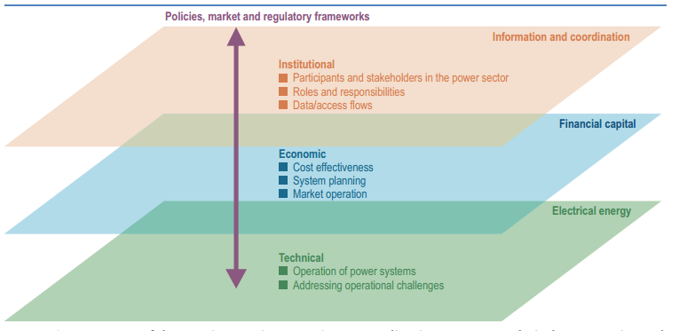Figure 1: Depiction of participating sectors and respective roles and functions in energy planning. Taken from Vithayasrichareon, P. et al. (2017), p. 35.
Miketa, A. et al. state that technical insufficiencies are in the least cases the bottleneck of energy systems and that these challenges can be overcome as long as there is the political will and sufficient resources “to invest and to change operational practices” [Miketa, A. et al. (2017), p. 12].
Energy planning within development cooperation often focuses on the expansion of energy access thereby evaluating different options of providing electricity access to an increasing amount of citizens (e.g. remote PV-storage-systems, mini-grids or distribution grid expansion) [Vithayasrichareon, P. et al. (2017), p.11]. These methods are amongst others described in Reiche, K. et al. (2016) and Tognollo, A. (2016). The report focuses on long-term energy planning regarding grid-connected power plant resources that play an increasing role especially in the Middle East and North Arfrica region (MENA) where the mere access to electricity plays a minor role in energy planning.
Figure 2 presents an overview of different tasks within integrated resource planning [Wilson, R. et al. (2013), p. 6]. In this thesis, social and environmental factors are modeled in framing conditions and quantitative input but aren't endogenously included in the model. Public review and the design of action plans that are included in integrated resource planning methodologies are thus out of scope of this thesis. Nevertheless, the thesis aims at informing decision-makers and providing underpinning insights for energy planning processes.
Figure 2 shows steps of resource planning in general which energy planning as a sub-sector often aligns to. The following chapter 2.1.1 discusses concrete tasks in energy planning in further detail and provides a categorization framework.
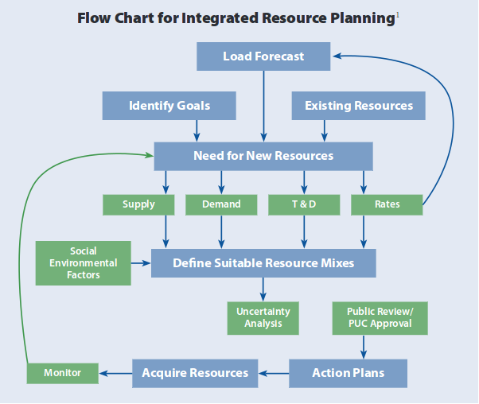Figure 2: Overview over tasks in integrated resource planning. Taken from Wilson, R. & Biewald, B. (2013), p. 6.

Tasks in Energy Planning
This paragraph outlines the most important aspects for energy planning, describing its targets, potential measures, aspects specific to VRE integration and risks. It finishes with different categorization approaches of energy planning procedures preparing an evaluation and prioritization of energy planning tasks for the Tunisian power system.

Targets
The overarching targets of energy planning are to establish a reliable and ecologically sound power supply at an affordable price [Praktiknjo, A. (2014), p. 82]. Energy systems are the biggest emitters of green house gas emissions world-wide [Pachauri, R.K. et al. (2014), p. 47]. After the Paris climate agreement in 2015 that has been ratified by over 130 countries, an increasing number of governments focuses on reducing their respective green house gas emissions by diversifying the sources of electricity generation [Vithayasrichareon, P. et al. (2017), p. 25 & UNFCCC (2015), pp. 2ff.].
The reduction of green house gas emissions from electricity generation by increasing shares of renewable energies comes at the cost of an increasing power system's need to balance inflexible electricity feed-in based on renewable energy sources putting a power system's reliability, security and stability in the focus of energy planners [Möller & Pöller, 2014]. Decreasing prices of wind and solar PV technologies provoke a shift in energy planning since these electricity sources do not only produce electricity without emitting green house gases but also at increasingly competitive and further decreasing cost [Taylor, M. et al. (2016), p. 10].
The cost-effectiveness of electricity provisions is especially important in the developing context since affordable electricity access tends to be a pre-requesite for growing economies [Zymla, B. et al. (2014), p. 70]. Especially in the MENA region policy-makers are careful to raise electricity prices because of the risk of political instabilities [Milbert, S. (2013)].
Considering energy planning, concrete objectives of achieving a reliable and secure power supply are firm capacity, flexibility, transmission capacity and stability that also imply different approaches in energy planning (see section about categorization below) [Miketa, A. et al. (2017), p. 32].
Miketa, A. et al. describe different properties related to generation adequacy and the firm capacity of variable renewable energy (VRE) resources. While the concept of “capacity credit” represents a metric for the correlation of VRE feed-in and electric demand profiles usually determined at the time of peak demand, capacity factors don't take into account electricity demand and only represent VRE availability – potentially as time-series with hourly or sub-hourly resolution. The authors describe the concept of reserve margin quantifying the needed available surplus capacity at the time of peak electricity demand. Only firm capacity can be accounted for adding to the reserve (see chapter 3.3.2 for OSeMOSYS implementation of the reserve margin).
With regard to flexibility, power systems' requirements can be evaluated apart from a long-term expansion model and given as an additional constraint to a capacity expansion optimization model thus optimizing investments for capacity and flexibility adequacy depending on the shares of VRE [Miketa, A. et al. (2017), p. 13].

Measures
There are different measures applicable for energy planners to influence the transition of their respective power system and thus to achieve the target of a reliable, affordable and environmentally sustainable power system. Which measures are part of decision-makers applicable options also corresponds to the role of the respective entity and thus to the degree of liberalization of the power market (see below in section Categorization). In more liberalized markets, a transmission system operator may only optimize power transmission in its respective planning procedures while power plant operators will optimize their respective power plant portfolio to maximize profit.
Especially in vertically integrated power markets with a single buyer utility operating transmission and distribution grids as well as the largest amount of the power plant park of a power system, the variety of measures is broader. By investing in power plant, grid and storage technologies, utilities have a significant impact on the long-term cost-effectiveness of a power system depicting the chances of a central energy planner but also the risk of e.g. misallocation of capital [Miketa, A. et al. (2017), p. 12]. Answering the questions when to invest into installing how much power plant capacity of which technology where is a prerequisite for taking these crucial investment decisions and strongly depends on the power system under assessment [Heising, K. et al. (2014)].
Apart from investment decisions into technologies, there are several other measures energy planners can take with differing complexity. For example, cross-border coordination of power system operations may significantly reduce cost and flexibility requirements of power plant parks needed to integrate VRE [Vithayasrichareon, P. et al. (2017), p. 24].
A detailed list of technical as well as economic measures for ensuring operational power system stability considering an increasing share of inflexibly varying renewable energy power plants can be found in Vithayasrichareon, P. et al. [Vithayasrichareon, P. et al.(2017), p. 38]. However, this report focuses on energy planning rather than on operational issues. Because of complementary research being carried out for Tunisia, the thesis focuses rather on investment decisions and touches questions of power system stability only considering reserve margins and firm capacity but isn't intended as a VRE integration study.

Integration of Varying Renewable Energies
There are two main reasons motivating the increasing share of renewable energy power plant capacities in the last years: Since renewable energy power plants like wind and solar PV emit negligible green house gas emissions in their operational life cycle phase (use phase) they significantly reduce a power system's contribution to climate change. Additionally, the capital cost of renewable energy (RE) power plants have significantly decreased, and are expected to continue this trend in the next years, making them a viable option to reduce a power system's reliance on fossil fuels and thus its respective dependence on global market price fluctuations [Schinke, B. et al. (2017), p. 23]. However, the inflexibly varying electricity feed-in of renewable energies necessitates new energy planning approaches as well as operational practices [Vithayasrichareon, P. et al. (2017), p. 35].
Increasing the share of variable renewable energies (VRE) in a power system's power plant portfolio may have different implications largely depending on different factors, for example the share of available storage capacities [Hirth, L. (2016), p. 221]. Other factors that are important for a reliable and cost-effective integration of VRE are “its level of deployment, the power system specifics (size, density and meshes of grid lines, controllability of power plants etc.), operational and market design, regulations and fundamentals of supply and demand.” [Vithayasrichareon, P. et al. (2017), p. 35]. Thus, long-term energy planning has to take into account key properties of VRE and specificities of the assessed power system to be able to carefully evaluate investment decisions [Vithayasrichareon, P. et al. (2017), p. 50].
Site-specifics are important for the process of site-selection since RE-feed-in series and their correlation with respective electricity demand series play a significant role for energy planning. The locational value of energy can be assessed in order to determine system integration opportunities of potential VRE sites [Vithayasrichareon, P. et al. (2017), p. 51]. The matching between VRE feed-in and electricity demand series plays a crucial role in power system planning as the authors outline. Especially PV-feed-in profiles often correlates with mid-day peak electricity demand. A regional distribution of VRE capacities into different sites and thus different weather conditions that are less correlated than those in sites close to each other can lead to increased firm capacity of renewable energy power plants because of smoothing effects especially for wind feed-in series [IRENA, 2017, p. 35]. Especially in later phases of VRE integration (see section Categorization below) aiming at alternative technology set-ups (weak-wind turbines or photovoltaic (PV) panels oriented to the west shifting peak feed-in to evening hours) can provide advantageous feed-in series from a system perspective and thus increase the system value of specific power plant technologies [Vithayasrichareon, P. et al. (2017), p. 144].
The coordination of VRE expansion and grid expansion is an important task for energy planning since in some regulatory frameworks RE power plants can be projected much faster than building new high voltage or transmission lines [Vithayasrichareon, P. et al. (2017), p. 52].
It is important to notice, that some challenges that countries with a power system in transition cope with, triggered by planned RE integration, don't directly evolve from RE integration but rather are stemming from general power system's challenges that already existed before [Suding, P. (2017), p. 4].

Categories
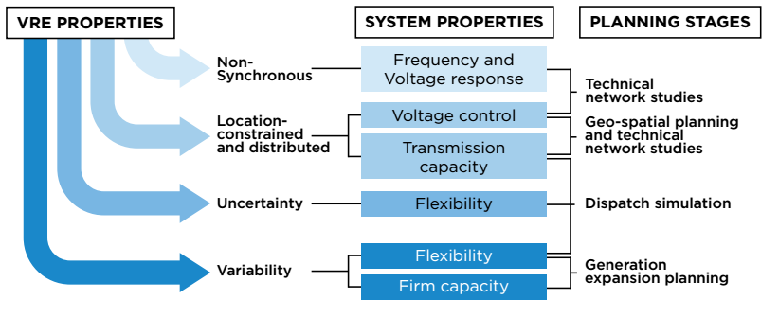Figure 3: Properties of inflexibly varying renewable energies and implications on power system properties and planning processes. Taken from Miketa, A. et al. (2017), p. 33.
Summarizing the sub-chapter about tasks in energy planning, this paragraph provides some categorizations of power systems and related tasks in energy planning. With regard to energy planning, power systems can be categorized depending on their
- market structure and respective distribution of responsibilities for operating and managing a power system (dimension 1, see Figure 4) and
- the share of inflexibly varying renewable energies (dimension 2, see Figure 6).
The market structure and distribution of planning responsibilities has strong implications on energy planning as already outlined above. As markets get more liberalized coordinated planning tends to get more complicated as unbundled electricity utilities perform planning of their respective fields optimizing their respective business-models, which may not imply overall system cost-optimality. This may imply non-optimality in technology investment e.g. in the trade-off between transmission expansion and beneficial RE sites [Miketa, A. et al. (2017), p. 30].
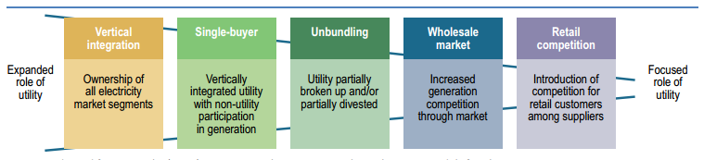Figure 4: Different ownership models in transforming power systems. Taken from Vithayasrichareon, P. et al. (2017), p. 16 cited from Castalia (2013)
In more deregulated markets, market designs, rules and regulations become increasingly important, while in vertically integrated power market structures only specific areas have to be regulated (e.g. power purchase agreements (PPAs) of independent power producers (IPPs), concessions for RE tenders, or rules for private household participation involving feed-in tariffs, net-metering or other support schemes) in regard to market rules. However, especially in single-buyer systems where grid and power plant operators may be publicly subsidized, the enforcement of a public regulatory role is crucial to ensure the integration of energy planning processes and to prohibit investments in expensive technologies. Especially with the notion of decentralizing power plant generation structures, public utilities have the legitimate fear of loosing their stakes to private households or IPPs. However, as further detailed in chapter 2.3 electricity markets in non-OECD markets tend to grow since demand increases significantly making the competition in these countries less harsh.
As some power system markets tend to get more liberalized and the responsibilities of market actors are differentiated among institutions (see below, Vithayasrichareon, P. et al. (2017), p. 16) there is an increasing need for the integration of long-term power system planning in other planning processes. This refers to planning processes on the shorter term (dispatch planning, detailed regional planning, grid planning etc.) but also to other energy sectors (heat / cold, transport, resources etc.). It comprises methodologies to include (among others) demand modeling, transmission and distribution planning and taking into account neighboring regions, balancing areas and their respective policy frameworks. However, especially cross-border arrangements fostering multilateral trade of electricity can be difficult to implement especially in regions where political tensions between neighboring countries exist [Vithayasrichareon, P. et al. (2017), ps. 51-53].
In dimension 2 the inflexibility of increasing shares of the power plant park is represented, and especially operational implications for distribution and transmission grid, as well as conventional power plant operators are drawn. While RE integration may only have effects on local grid infrastructure at relatively low shares, increasing installed capacity necessitates an increasing adaptation of the whole power system to inflexibly varying feed-in, involving reduction of cycling times of conventional power plants, increasing variability of net load and increased vertical flows between grid voltage levels, thus necessitating updates of operational practices and institutional arrangements. At high shares, RE integration affects the power system on all time-scales [Vithayasrichareon, P. et al. (2017), p. 34 & Miketa, A. et al. (2017), p. 69].
Planning of energy systems can also take place on different time-scales as shown in Figure 5 comprising different time resolutions and time horizons. While generation expansion planning covers timeframes from 20-40 years and above, technical network studies require an increased amount of detail on the time dimension and thus usually cover smaller time-periods.
Energy planning tasks considering power systems with an increasing share of VRE can technically aim at the following four points relating to key characteristics of VRE that already have been introduced as energy planning objectives above [Miketa, A. et al. (2017), p. 32]:
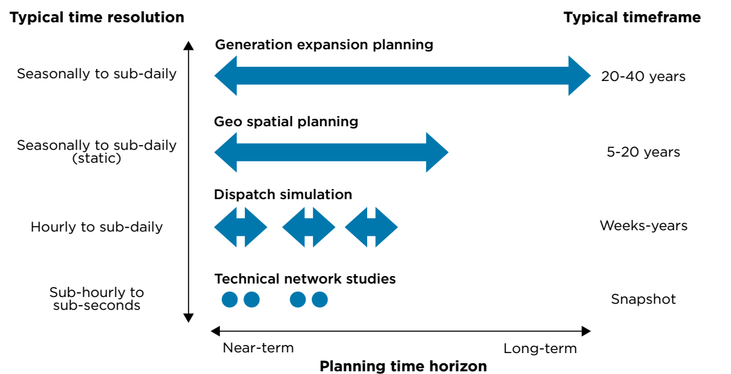Figure 5: Representation of time and respective energy system planning tools. Taken from Miketa, A. et al. (2017), p. 27.
- Firm capacity (high relevance)
- Flexibility (high relevance)
- Transmission capacity (high relevance)
- Stability (near-term / system-specific relevance)
Miketa, A. et al. formulate the need of scenarios that are utilized for long-term energy planning to describe each scenario's way of meeting power system requirements in regard to firm capacity, flexibility and transmission capacity evolving from VRE deployment [Miketa, A. et al. (2017), p. 12]. The modeling focus within the scope of the thesis lies on capacity expansion and dispatch modeling.
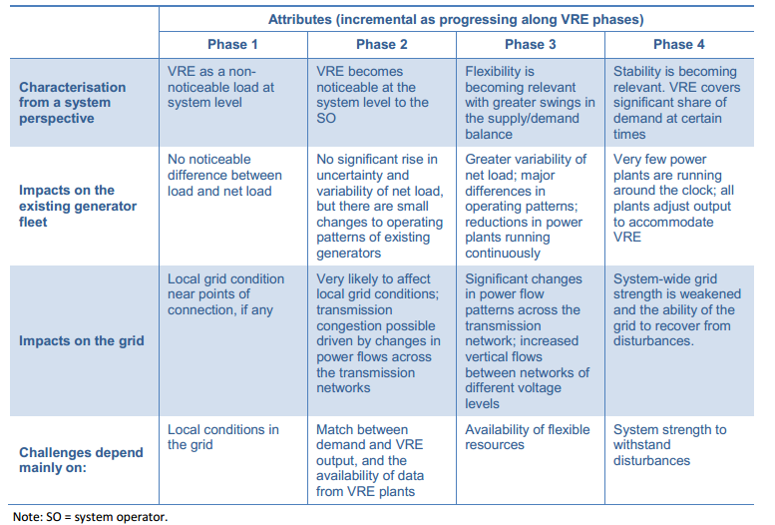Figure 6: Operational issues relevant to different phases of VRE deployment. Taken from Vithayasrichareon, P. et al. (2017), p. 36 citing Mueller, S. et al. (2017).
Figure 6: Operational issues relevant to different phases of VRE deployment. Taken from Vithayasrichareon, P. et al. (2017), p. 36 citing Mueller, S. et al. (2017).

Categorization of Tools in Integrated Energy Planning
“Given the uncertainty and complexity of the energy system, quantitative models are one of the few available tools that allow analysts to explore alternative scenarios and help guide public policy.” [Pfenninger, S. et al. (2017b), p. 211]
The following section provides descriptions of tools utilized for tasks outlined in the preceding section. It focuses on modeling techniques rather than broader interpretations of instruments, policy plans, market rules or other regulatory measures as e.g. described by Suding, P. [Suding, P. (2017), p. 5].
This section focuses on linear optimization models since these represent the majority of long-term energy planning models. Other models like stochastic models or general equilibrium models are not presented.
Long-term energy planning tools are not meant to cover each operational aspect of a power system in detail thus motivating modular designs and integrability of a modeling environment. Still, the question remains, what (also operational) aspects can be integrated in long-term energy planning models since e.g. dispatch an high resolution feed-in and load series become a necessary pre-requisite for assessing the integration of VRE [Miketa, A. et al. (2017), p. 13/26].
The section will give an overview on some differentiation criteria of energy planning models with regard to techno-economic detail, model features and scientific methods, quantitative and qualitative input assumptions, transparency and credibility, and the degree of integration and respective applicability. The section sums up with a categorization of energy system models.

Techno-Economic Structure
The detail with which different technologies are modeled in energy system models largely depends on its structural way of representing technical and economic aspects of an energy system.
Transport models treat electricity as a tradeable good, modeling the demand and supply characteristics with respect to this good. Some models assume a perfect market implying that the demand is always met by the cheapest supplier and opportunity costs of 1 kWh electricity at a decisive time-step is determined by the cost of the cheapest power plant that is still supplying the demand. An advantage of transport modeling is that detailed time- and (in some models) locational price information can be given. However, transport models don't represent electro-technical phenomenons (like a gradient in electrical potential) in the grid making it for example possible, that power gets traded in a circle between regions which will never happen in a real grid.
Optimal power flow (OPF) models account for behavior of electrical current in a more detailed way than transport models. Static grid models can be divided up into DC load flow models assuming a direct current at all times and AC load flow models accounting for differences between active and reactive power feed-in as well as voltage amplitude and angle. They are usually utilized to assess grid contingencies and the need for grid expansion [Miketa, A. et al. (2017), p. 119]. Dynamic grid models represent power systems at a much higher time resolution (usually ms) assessing the grid's capability to cope with disturbances such as line break-downs, generator failures etc.
A third group of models are production cost models representing the cost structures of individual power plants in detail while these are usually modeled exogenously in transport and OPF models. Production cost model focus on capital cost, interest rates but also on operational cost depending on different operational states like part-load states, ramping up and down costs etc. [Miketa, A. et al. (2017), p. 118].
As stated by Miketa, A. et al., technical problems can be coped with as long as the political will and the resources to invest are available. Long-term energy planning models can not incorporate all aspects of a power system in all detail [Miketa, A. et al. (2017), p. 26]. Thus, the question with regard to representing economic cost and technical detail is, how to reflect cost and technical limitations in long-term energy planning models [Miketa, A. et al. (2017), p. 43].
IEA / OECD (2016) call for a change in evaluation criteria for the integration of VRE. They propose the system value (SV) as a metric to quantify the system-friendly deployment of VRE technologies. Thus, more systemic aspects (like feed-in-load-correlation, trade-off between reduced fuel cost and potentially increased cycling cost of conventional power plants) are taken into account [IEA (2016), p. 4ff., Barbose, G. (2017), p.8]. Vithayasrichareon, P. et al. also argue that with increasing shares of VRE a system-friendly design and deployment of VRE sites becomes increasingly important and that governments incentivize system-friendly VRE design and site-selection adding to the system value rather than optimizing a power plant's operator's profit [Vithayasrichareon, P. et al. (2017), p. 22].

Model Features and Scientific Methods
Independently of the structure of a model (how it represents a power system) there are decisive model functionalities (what is represented) that may or may not be included in a model. Scientific methods like sensitivity analyses and complexity reduction techniques for (sub-)hourly time series data can yield valuable insights in how to adapt a model setup (geographic and time horizon and resolution) to a respective task at stake.
Figure 7 shows the three different model stages pre-processing, model stage and post-processing. Which model features are endogenously included in the model and which ones are treated outside the model in pre- and post-processing stages depends on the question at stake. If an energy planner is solely interested in capacity adequacy within optimal pathway scenarios, he might not need detail in hourly resolution time series. If the model-setup doesn't differentiate between regions (copper-plate) assessing the trade-off between benefits of high-quality PV sites and cost of transmission line expansion may be done solely by integrating transmission cost in CAPEX cost of a power plant type remote-pv. Thus specific project costs are harder to assess (decreased degree of freedom corresponding to number of variables) but the model will yield general insights into the system value of remote high quality PV sites [Miketa, A. et al. (2017), p. 14].
DeCarolis, J. et al. analyze the extension of linear optimization models by integrating primarily economic model features (e.g. endogenous technology learning, lumpy investment, hurdle rates, consumer choice, price elastic demands and macroeconomic feedback) finding that modelers should apply scrutiny including individual hurdler rates that may only apply to individual entities, only include consumer choice models if a high degree of understanding and availability of data is present to the modeler, price elasticities can yield valuable insights if service demand can be met by different energy sectors and differences of short- and long-term behavior is assessed, linking optimization models to macro-economic CGE models can yield insights about interdependencies between the energy sector and other economic sectors [DeCarolis, J. (2017), p. 190ff].
Avoiding unnecessary complication in the model setup and integration of model features irrelevant to the question or task at stake may lead to unnecessarily high computation times but also increased complexity of communicating the model structure, input assumptions and results to decision makers [DeCarolis, J. (2017), p. 194]
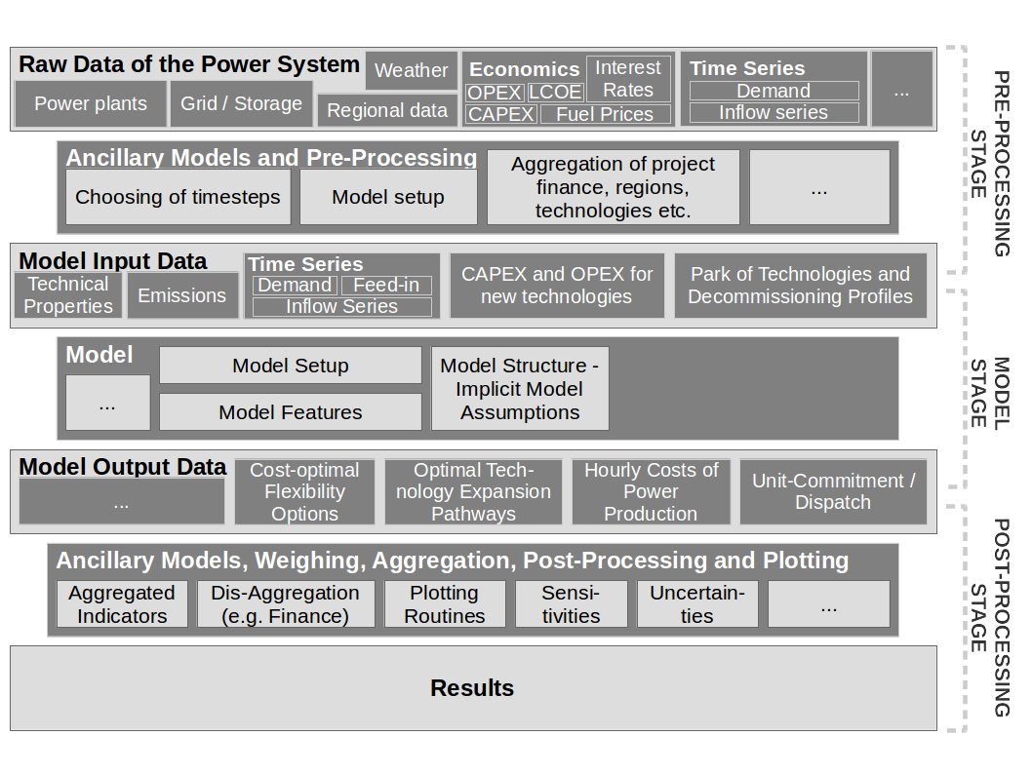Figure 7: Exemplary depiction of model stages. Source: Own depiction.
More technically, the two most crucial extensions of linear optimization models are the increase of detail in time-series to analyze correlations and power systems' behavior of (sub-)hourly electricity demand and feed-in series and the integration of flexibility constraints and costs (e.g. cycling) of the conventional power plant park.
Methods to decrease computational complexity yet representing chronological effects of VRE feed-in are described in Pfenninger, S. [Pfenninger, S. (2017b)]. The author describes different approaches like downsampling, two clustering algorithms as well as different methods of choosing time-slices like min/max wind days and weeks or weeks of average min / max residual load between wind feed-in and electricity demand. The study proposes an efficiency metric to evaluate the quality of a complexity reduction method as
(1)

Where C represents the deviation of system-wide LCOE when using the complexity reduction method assessed from 1-hourly reference case. The normalized CPU time is used as a metric for computational effort. Downsampling 1-hourly timeslices to 3-hourly timeslices significantly reduces the normalized CPU time below 56-80 % in all three scenarios (50 % VRE, 90% VRE with storage, 90% VRE without storage) but may underestimate VRE expansion in the “90%-VRE without storage”-scenario. The author argues that the smoothing effect of peaks and troughs using downsampling may strongly affect modeling results.
Pfenninger, S. also compares resulting load duration curves and respective correlations between wind and PV feed-in series finding that downsampling algorithms best represent load duration curves while clustering algorithms vary LDCs strongly depending on chosen method. Only looking at the residual load curve between wind and electricity load significantly changes the LDC of PV which isn't surprising since PV characteristics were excluded in choosing modeled timeslices. Additionally, this method may overestimate wind capacity expansion which is also obviously due to its exclusivity in choosing timeslices. Nevertheless it is the second best method efficiency wise (0.98) and with 168 timesteps significantly reduces compuational effort [Pfenninger, S. (2017), ps. 5ff.]. It is important to notice that this source assesses the impact of methods to choose timeslices for very high shares of VRE. Depicted results (Fig. 5 b, p. 9) imply that variations in system-wide LCOE are very close to each other for the 50% scenario case. Thus, choosing an appropriate method for complexity reduction only plays a major role when power systems exceed 50% of VRE as long as extreme events are accounted for. Nevertheless results and influences should be kept in mind.
Further analysis of inter-annual variability of VRE feed-in series implies the need for multiple yearly feed-in series to be able to represent its variability adequately although Pfenninger, S.] shows that including storage technologies in the model reduces the results' variability using different years. Nontheless, results show that .25-.75 percentiles range from approximately [+15%, -12%] (Offshore wind), [+4%,-12%] (PV) and [+12%,-7%] (Fossil dispatchable) in relation to the respective median values [Pfenninger, S. (2017), p. 11].
Flexibility constraints can be incorporated in linear optimization energy models as shown in Kern, J. et al. & Lambert A. et al. and in the undisclosed study by Möller and Pöller Engineering (M.P.E.) referred to by Thielmann, S. [Kern, J. et al. (2016), Lambert, A. et al. (2017) and Thielmann, S. (2017)]. These examples all assess power systems and respective flexibilities (Morocco, Chile and South Africa) within the context of development cooperation.
However, flexibility can also be assessed as constraining flexibility parameters are identified and (in pre-processing stage) and exogenously given as model input [Miketa, A. et al. (2017), p. 13].
Sensitivity analysis can be applied to test the robustness of model results, guide modelers, assessing the impact of model inputs and exclude unimportant parameters from scneario analyses [DeCarolis, J. (2017), p. 192].
Other features that can be integrated into models are more detailed project finance, investment constraints, technical detail in modeling technologies (e.g. part-load efficiencies), integration of Geo-Information Systems (GIS), Mixed-Integer implications to e.g. assure that certain minimum capacities are followed and grid transmission expansion planning.
Some studies perform further analysis in the post-processing stage to aggregate and weigh model results so as to yield insights of expansion pathways with regard to e.g. social acceptance, ecologic sustainability etc. Brand, B. et al. perform a multi-criteria decision analysis utilizing linear programming results to identify indicators in the four criteria groups with respective weights “Economic costs” (39%), “Supply security” (27%), “Socio-economic criteria” (20%) and “Ecological criteria” (19%). Weights were identified at a stakeholder workshop in Tunisia involving members of the most relevant Tunisian institutions and organizations (private and public). These weights were further allocated to thirteen sub-criteria equally distributing weights on sub-criteria in the respective categories. 13 quantities (partly semi-quantities) from the respective scenario model outputs were then calculated to identify a one-dimensional scenario-score for the scenarios five scenarios comprising of a nuclear, a coal, a VRE and a coal-VRE mix-scenario next to the business-as-usual scenario [Brand, B. et al. (2012)].
DivRes reaches the highest score followed by BAU and DivCoalRes. This result is then also tested by a senstivity analysis of the weights yielding that the results are highly robust where only at a technocratic approach (weights: economic: 40%, supply security: 40%, socio-economic: 10%, ecology: 10%) the DivCoalRes scenario ranks first. The study serves as a an examplatory case on how linear optimization tools can be integrated into a broader framework and how technology expansion can be seen and valued from different aspects outside the power system that are affected by its transformation.
In Tunisia's nowadays discussions about potential energy system transitions nuclear power doesn't play a crucial role and coal also has been rejected because of high associated infrastructural cost [Schweinfurth, A. et al. (2017), oral exchange].

Quantitative and Qualitative Input Assumptions
As already mentioned above, model features can be either incorporated endogenously in the model or integrated in the modeling process by treating them in pre- or post-processing stage. This section focuses on the model setup and thus of aggregation of time and space in the model.
Depending on energy planning questions at stake quantitative inputs can vary. The representation of time and space represent the fundamental structure of the model having quantitative (how man years are modeled, in which detail?, how many regions are modeled?) and qualitative (power is available everywhere in copperplate models, chronological characteristics of VRE feed-in may not be represented properly) implications [Miketa, A. et al. (2017), p. 13].
But also technologies are usually modeled as technology types in models spanning 20-40 years on a national or international scale and not each power plant is modeled individually thus necessitating aggregation procedures for e.g. efficiency or emission parameters of existing power plants.
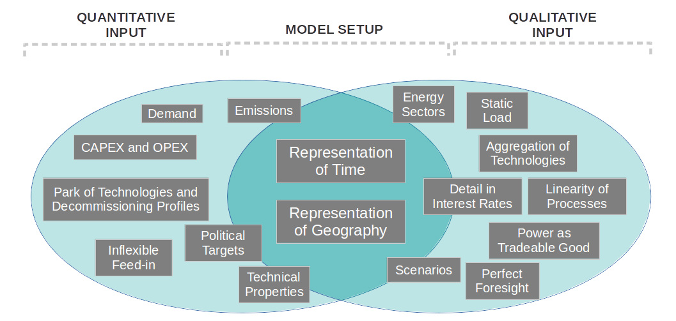Figure 8: Examplatory depiction of quantitative and qualitative model input as well as the model setup. Source: Own depiction.

Transparency, Openness of Data and Code, Communication of Input and Results and Credibility
The credibility of energy planning studies plays a crucial role, especially in the context of international development cooperation. How credible a study or a research project is, directly implies how relevant it will be in the development of future energy master plans, long-term energy planning and partly VRE deployment. Credibility can be undermined by nontransparent model structures, input assumptions, unnecessarily complicated model features and nontransparent input data (and potentially how this data was pre-processed).
DeCarolis, J. et al. mention, that it is of high importance in communicating the structure, input and results of energy system optimization models to emphasize that studies produce insights and are capable of identifying patterns within the modeled sectors rather than precisely quantifying economic effects. They underline the importance of transparency in all three aspects; model input data, model structure and well documented and written code, and outputs. Involving decision-makers in composing a model data input set and making quantitative and qualitative assumptions (see section above) and potentially in iterative processes increases the credibility and the relevance of the study to the target audience [DeCarolis, J. (2017), p. 192ff.].
The credibility of long-term energy planning studies can suffer because of a lack of detail in the representation of time. When long-term energy planning studies lack in addressing key characteristics of VRE such as short-term variations and the power system's capability to cope with it, this insufficiency can provoke decreased credibility. More detailed grid integration studies often lack the link to long-term energy planning methodologies [Miketa, A. et al. (2017), p. 19 /30]. Thus integrating chronological representation of VRE feed-in and load characteristics seems crucial for the credibility of studies assessing the integration of VRE.
Communicating linear optimization models as tools to find pareto-optimality in energy systems and to guide decision making especially with regard to the overarching target of affordability of energy services is described by Lavigne, D. [Lavigne, D. (2017)].
Creating liability and credibility by opening up data and modeling code and having straightforward and intuitive names of sets, parameters, variables and equations will be further discussed in chapters 2.2 and 3.3.2.

Applicability, Modeling Scope and Degree of Integration
The applicability of energy models and tools to specific contexts and strongly depends on the tasks for which they are utilized. For questions of national climate reduction targets for example, integrating different energy sectors (power, heat/cold, transport) yields more comprehensive results. However, a larger degree of integration within one model comes at the price of either an increased computational complexity or a decreased level of detail in the modeling components which may pose a risk to the credibility if e.g. integration of VRE is assessed (see above). Thus, the integration of different models (different time-scales, regional and technological detail) into planning frameworks seems a viable option but has so far not been very well established [Vithayasrichareon, P. et al. (2017), p. 50 & Miketa, A. et al. (2017), p. 19].
Miketa, A. et al. state, that long-term energy planning models have its limitations and aren't designed to comprehensively answer all questions in energy planning. Scenarios should clearly define parameters that can further be used for shorter term studies. [Miketa, A. et al. (2017), p. 11 / 26].

Categorizations
Concluding the sub-chapter about tools in energy-planning three dimensions of categorizing energy system models shall be presented namely
- Planning scope,
- Techno-economic detail and
- Mathematical formulation.
Regarding the planning scope of the model, Miketa, A. et al. suggest a differentiation as depicted in Figure 9 [Miketa, A. et al. (2017)]. The scope ranges from dynamic grid models with a high level of technical detail regarding electric phenomenons and a very high time resolution (ms-min) to long-term energy planning models sometimes representing one season as one timeslice. Targets and objective are shown below the respective models on the right-hand side implying model parameters that are relevant for the next level of technical detail (e.g. generation and network capacities are important for geo-spatial planning models). It is also shown that feedback from models with a high level of detail is necessary to represent in long-term energy planning models. The way how techno-economic features are represented in long-term energy planning models plays a crucial role for the credibility and adaptability of long-term energy planning models to specific energy planning tasks [not what features are represented but rather how] [Miketa, A. et al. (2017), p. 29].
Models can vary in their respective techno-economic detail as discussed in detail above. Depending on whether they represent more economic features (Transport models) or electric phenomenons (Power flow models) they can be categorized. This additional category is introduced because both OPF and transport models utilized linear programming as mathematical implementation making the assumption of linear behavior across the modeled processes.
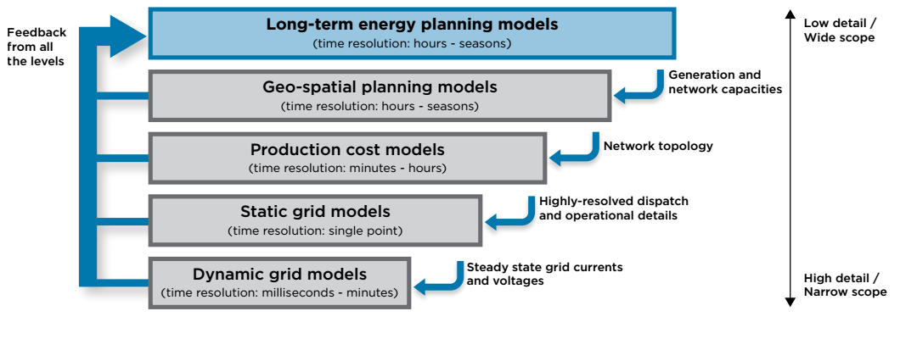Figure 9: Scope and detail of different models utilized in energy planning and its respective interactions. Taken from Miketa, A. et al. (2017), p. 31.
As touched upon above, the mathematical representation of energy system models varies and has strong implications on the way energy economical processes are represented. The most models depicted in Figure 9 utilize linear optimization for modeling real world processes. Nevertheless there are a few other model types that shall be presented shortly in this section.
Optimization models follow the logic of minimizing (cost, losses) or maximizing (value) an objective function (for a detailed implementation see chapter 3.3.2) comprising of different parts such as operational cost, capital cost, line losses etc. Linear optimization models can represent only power plant dispatch, power flow behavior, decisive cost structures, technology expansion over time or a combination of the aforementioned. By implementing these optimization models as solely linear models, they span a solution space of defined variables in which each variable can take any value within the solution space and is only constrained by its boundaries. Thus e.g. coal power plants of a few kW could potentially be build. In linear optimization power plant expansion models usually a perfect market is assumed implying that the load in each time is met by the cheapest generation technologies available until the respective constraining limit is reached. Then the next cheapest technology is chosen and so forth. This can lead to unstabilities since slight changes in cost profile (CAPEX, fix and variable OPEX) can lead to significant changes in generation expansion (penny switching).
Model type | Mathematical implementation | Sector Representation | Usual time resolution
Transport Model | LP / MILP | Power, Heat, Transport | Hourly - seasonal
Optimal Power Flow | LP / MILP | Power (partly) | Seconds - hours
GIS Models | ? | Weather, Sites, Grid Topologies | ?
Production Cost Models | LP | Power Plants, Finance | (Sub-)hourly
Macroeconomic Models | CGE | Energy, Economic, Public Policies | [Seasons - years]
Dynamic Models | Differential Equations | Power (partly) | Ms - min
Table 1: Energy models differentiated by model objectives and sector representation. Source: Own depiction.
Since this sub-chapter isn't capable of comprehensively presenting energy system models a reference to a list of models and long-term planning tools differentiated by countries can be found in Miketa, A. et al. [Miketa, A. et al. (2017), p. 120ff].

Summary and Synthesis
Chapter 2.1 provided an introduction into the main tasks and tools in energy planning. Since energy planning is strongly intertwined with other fields, tasks are very diverse. Regarding the choice of models for specific tasks in energy planning is subject to controversial oppinions. For representing the impact of VRE deployment in long-term models studying electricity generation expansion, Miketa, A. et al. state that data availability as well as modeling expertise are the most crucial factors for the choice of methods [Miketa, A. et al. (2017), p. 12]. DeCarolis et al. argue that the problem should always drive the analysis and not the other way around thus makinng clear that model choice always has to fit the specific purpose that is framed by the focus research question.
Still, the question remains, what aspects can be integrated in long-term energy planning models since e.g. dispatch and high resolution feed-in and load series become a necessary pre-requisite for assessing the integration of VRE [Miketa, A. et al. (2017), pp. 13/26].

Aspects of Open Source Energy Modeling
Different advantages of Open Source Energy Modeling and Open Source Energy Data were already touched upon in the preceding chapter 2.1.2 mainly the increase of credibility but also the exchange with other modelers within the community of how applicable models are. Especially in contexts where models are meant to be transferred to partner's or customer's responsibilities, transparency in all parts of the code, well-written and -documented code, a steep learning curve for getting acquainted with model implementation and low upfront investments become crucial.
Pfenninger, S. et al. describe current barriers and potential benefits of opening up energy modeling research. The terms open source and open data “imply that anyone can freely access, use modify, and share both model code and data for any purpose” [Pfenninger, S. et al. (2017a), p. 211].
Opening up model code, input data and made assumptions improves the quality of the research such that other energy modelers and especially stakeholders involved in the process are capable of improving modeling input data and creating a stronger review basis.
The authors suggest that opening up energy research increases the quality of collaboration between the fields of science and policy. Policy quality assurance measures can provide valuable insights especially if energy modeling is meant to drive new policies. An increased exchange between energy modelers and policy will lead to more respected outcome and thus to more credibility of energy model analyses.
Also within the field of energy modeling opening up code and data entails the benefit of burden-sharing and reduced work for e.g. preparing scripts for pre-processing, designing databases and collecting data. Open code is also more probable to be used again and improved by the community.
Last but not least transparency in energy modeling provides a basis of scientific justification that can be empathized by a broader group of participants in the public debate. Additionally insights that are funded from public sources and thus from tax payers' money should be available to anyone who is interested in it.
The main burden the authors identify, why energy research still seems to lag behind other fields are sensitivity of data (personal and commercial), the risk of embarrassment to researchers or to institutions that published models but are not involved in a particular case of flawed research, additional effort to document code, to create a repository etc. and personal and institutional inertia [Pfenninger, S. et al. (2017b), p. 211ff.].
Concluding, the authors call for three main points that remain for future improvement:
- Reduction of redundance and duplication of work
- Subsequently bringing together work from the top down and the bottom up and
- incentivize open and transparent research.
Vithayasrichareon, P. et al. state that especially due to fast changes in policies, technologies and business-models in the energy sector, energy models have to be adjustable to changing boundary conditions. This includes (among others) integrating the role of stakeholders' decisions in energy system analyses depicting the need for implementations that are modular and can work together with other sets of models and software [Vithayasrichareon, P. et al. (2017), p. 50].
DeCarolis, J. et al. put forward the risk of nontransparent model input assumptions especially focusing on hurdler rates since these values have strongly influence model results and outcome and are often used as “means of tweaking model results to yield a technology portfolio desired by the modeler” [DeCarolis, J. et al. (2017)].
Cao, K.-K. Et al. present a framework in which the transparency of the design of scenario studies can be evaluated comprising of the overarching criteria
- General Information
- Empirical Data
- Assumptions
- Model exercise
- Results and
- Conclusions and recommendations.
Although some of the criteria and steps may not be performed within the scope of the thesis, it is envisioned to use the 20 criteria-holding list as a guarantor for the quality and transparency of the scenario design [Cao, K.-K. Et al. (2016), p. 8].
Concluding, a cite of Pfenninger, S. shall be used:
“Thus, in many cases, the most important aspect is the quality or transparency of input data, rather than the novelty of the modeling methodology.”
It is envisioned that all scripts, all data (that can possibly be published), the utilized database structure and the adjustments to the OSeMOSYS code are made freely available thus contributing to the ongoing process of opening up energy research.

Energy Modeling in Development Cooperation and in Tunisia
After the most important insights about energy planning in general were given in chapter 2.1 and chapter 2.2 gave a short summary of latest findings in the field of open source energy modeling, this chapter depicts the specificities of energy planning and energy modeling in development cooperation. It doesn't specifically deal with roles in development cooperation but rather identifies recent trends and issues for partner countries' governments and respective energy systems. As stated above, off-grid electrification will not be part of this chapter. The chapter builds the underpinnings for choosing the main tasks of energy planning for the Tunisian case study.
Zymla, B. et al. provide insights on energy planning related questions from the perspective of the German development cooperation agency GIZ. They list characteristic differences between OECD and non-OECD energy systems mainly
    - (partly sharply) increasing electricity demand in non-OECD countries,
    - the necessity to improve supply security and sector efficiency of the power sector and thus a much higher investment demand in non-OECD countries compared to OECD countries and
    - in general high VRE potentials in non-OECD countries.
Especially the first two factors lead energy planners and decision makers in non-OECD countries to prioritize the increase in secure capacity and cost efficiency above other targets such as low-CO₂-emitting power plant options. The authors state that for different reasons despite of a higher VRE potential compared to OECD countries this potential isn't exploited in the most cases to the most cost-optimal way. They state that VRE can play an economically valuable role if thorough assessments of individual energy systems are carried out in order to identify most viable VRE options for the power plant park and grid set-up [Zymla, B. et al. (2014), pp. 70ff.].
The authors state that scrutiny should be applied, transferring methodologies and models to non-OECD countries that are still under development even in markets and energy systems they were developed for in the first place. This stems from fundamental differences depicted above [Zymla, B. et al. (2014), p. 71].
However, they identify the advantage of emerging energy markets that competition is far less sharp compared to OECD countries since the market is faster growing thus implying that there might be less resistance by established actors to allow VRE markets to develop [Zymla, B. et al. (2014), p. 72].
Of course, this raises the question of structural reform such as liberalization of wholesale and retail electricity markets which would lead to higher efficiencies but would presumably evoke a greater resistance in single-buyer institutions. This question is out of the scope of this thesis.
Miketa, A. et al. states that technical solutions for voltage and frequency stability on the short-term are available at relatively modest cost which only significantly increase at high levels of VRE penetration [Miketa, A. et al. (2017), p. 32]. Since VRE capacities growing beyond 50% are not part of scenarios under assessment this statement motivates the modeling focus of this thesis as being capacity adequacy and supply security as well as secured capacity within a transport model with a fairly low (hourly) time resolution rather than high-resolution frequency and voltage stability assessments.
In general sector coupling in non-OECD countries hasn't been advanced to an increasing degree. Thus modeling only the power sector within the scope of this thesis seems a feasible option. Nevertheless, the abstract yet straight forward form of OSeMOSYS makes the integration of other sectors in the existing framework possible.
Tunisia is chosen as a case study country for different reasons. Tunisia has an electrification rate of 99% motivating energy planning methodologies since the majority of Tunisian citizens are directly affected by increases or decreases in electricity prices. Tunisia has a high estimated technical and economic VRE potential [GIZ (2013)]. Its government has the aim to increase power generation from VRE to 30% and installed capacities to 35% (corresponding to 3815 MW) by 2030 mainly by adding PV, Wind and CSP capacities [ANME (2015)].
From a methodological point of view the data availability is quite high (load profiles, power plant lists etc are available) and it was possible to establish a communication to a Tunisian research group at the Ecole National d'Ingénieurs de Tunis (ENIT). Furthermore, GIZ has already carried out studies estimating VRE potentials.

Recent Works Assessing the Tunisian Power System
Recent works using energy system analysis’ methods to study the Tunisian electricity sector and future developments focus on RE potential estimations or on assessing renewable energy pathways within broader sustainability assessment frameworks [Brand, B. et al. (2014), GIZ (2013)].
Lechtenböhmer et al. calculate installed capacities, hourly dispatch and the electricity generation mix for Tunisia using a linear optimization model. The authors differentiate between different scenarios such as BAU, a coal-expansion scenario, a nuclear expansion scenario, a renewable energies scenario and a mixture between coal and renewables. They also weigh results of the model in the four categories Economic criteria (“Critères économiques – coûts”), “Supply security” (“Sécurité d'approvisionnement”), “Local integration” (“Intégration locale”) and “Environment” (“Environnement”). Its important to notice that supply security in this source refers to supply of energy carriers rather than electricity supply and is calculated based on the primary energy demand for each power plant technology. The authors also model CSP technologies and cost assumptions fit quite well in nowadays market and cost developments [true also for natural gas?]. A single-node optimization model is utilized and authors don’t differentiate between utility-scale and rooftop PV. The authors integrate external costs of 19-44 €/MWh for conventional power plants (OCGT, CCGT and coal) but also for VRE (1.3-6.5 €/MWh) in their calculations and find that including externalities the scenario integrating nuclear power is the most feasible from an economic point of view with 94 €/MWh followed by the high VRE scenario with 96 €/MWh [Lechtenböhmer et al. (2012), p. 219]. In all other three dimensions (energy carrier supply security, environmental and local integration) the high VRE scenario excels compared to the other scenarios.
Brand, B. et al. use a linear optimization model for the dispatch of exogenously given Tunisian power plant expansion scenarios to qualitatively identify general costs and benefits of different power plant expansion pathways. Scenarios are very similar to those of Lechtenböhmer, S. et al. [Lechtenböhmer, S. et al. (2012)]. Results from the optimization model are integrated in a multi-criteria analysis framework including expert interviews for the quantification of weighing factors of the modeling results. The respective DivRes scenario is identified as the one being most beneficial which holds true even under variation of used weighing factors for almost all sets of weighing factors under sensitivity analysis showing overall advantageous impacts of renewable energy expansion in Tunisia.
Detoc, L. descriptively presents the Tunisian electricity sector, recent legislative ambitions, planned VRE and energy efficiency projects, grid infrastructure and electricity prices. Since the report has been reviewed by central actors of the Tunisian electricity market such as the Societé Tunisienne d'Electricité et du Gaz – Energie Renouvelables (STEG-ER), the Agence National pour la Maitrise de l'Energie (ANME) and Terna (the Italian transmission grid utility) it provides valuable insights in project specifics (such as some technical detail of wind turbines of current farms). It also provides an overview on key factors for the success of the Tunisian energy strategy in the categories regulatory framework, grid expansion, regulation, the FTE, Decentralization of the Energy Management and citizen energy responsibilities taken from the Agence National de la Maîtrise d'Energie.
Schinke, B. et al. put forward a criteria framework for evaluating stakeholders' views on different energy technology expansion pathways within the MENA Select project. The project combines techno-economic modeling with a multi-criteria analysis and stakeholder interviews and workshops. The aim of the overarching project MENA Select is to establish a data-base containing information for complex trade-offs within the energy systems in order to avoid power system lock-ins. It works “[…] on the intersection between electricity generation technologies, sustainable development and society [...]”. So far, only results from a workshop in Morocco have been released. Working Package 2 whose report has been published, aims at evaluating techno-economic energy system modeling with regard to sustainable development objectives as well as societal preferences in order to identify “potential stakeholder support or conflict”. The authors put forward a list of 11 criterions that are based on stakeholder interviews and are evaluated based on multiple indicators (quantitative and qualitative) per criterion. Each criterion is applied to each power generation technology. The most relevant for the scope of this thesis shall be briefly described.
In “Criterion 1: Use of Domestic Energy Sources” the authors put forward two indicators:
- current domestic potential of technology's energy carrier to decrease energy import dependence
- future domestic potential of technology's energy carrier to decrease energy import dependence by 2040/2050
The statistical evaluation of expert interviews' results for Morocco shows a strong preference towards renewable energy technologies, medium potential for hydro power plant technologies and only low potential for nuclear, coal gas and oil power plant technologies with averages below 2 on a scale between 1 and 5 for today's potential. For future potential to decrease import dependence gas is evaluated even higher than hydro. The total spread of minimum and maximum expert judgments is high (between 1 and 4 for hydro and coal and between 1 and 5 for gas and nuclear). All experts agree that oil power plants have no potential in decreasing import dependence neither today nor in the future. For CSP and PV future potential to decrease import dependence is evaluated very high with median values being at the maximum of the scale and averages being at 4.35 and 4.6. For wind onshore the median lies at 4 and the average slightly higher at 4.35 at the same level of CSP.
The report's “Criterion 4: Technology Knowledge and Transfer” describes potential for education (indicator 1) and international industrial cooperation (indicator 2). Both indicators are qualitative. Results for Morocco show low potentials in the first indicator for all conventional power plant technologies and nuclear and below medium potential for all other technologies. The highest educational potential is assumed to be drawn from utility scale PV technologies. For the second indicator nuclear and oil power plant technologies' potentials are evaluated to be low and all other technologies' potential to be medium with values for renewable technologies evaluated slightly higher (averages between 2.39 and 2.63) than coal and gas power plant technologies (averages 2.05 and 2.17 respectively). Potentials (educational as well as international cooperation) for evaluating systematic and energy planning tasks may be included in each technology's contribution but isn't explicitly evaluated.
Describing their “Criterion 5: Electricity System Cost” Schinke, B. et al. describe the two indicators
- LCOE (quantitative) and
- additional integration cost based on uncertainty / variability and distance / location (qualitative) [Schinke, B. et al. (2017)]
The authors motivate the second indicator as internalizing “technical externalities” of different power plant technologies with increasing share such as grid reinforcements or additional cost for forecasting techniques (not mentioned by the authors). They choose not to quantitatively describe external effects because of a lack of methodological standards of integration costs and a lack of available data. Studies and assumptions considering grid expansion costs for integrating wind, PV and CSP power plants have been carried out within the framework of the Desertec Industrial Initiative (DII) [Godron, P. et al. (2012)] but are undisclosed showing a common critical spot of energy system analysis within international cooperation. Data about technical system costs is usually strongly secured and usually not available to research groups.
Interestingly Schinke, B. et al. don't consider decentralized PV in their WP 2 report although societal factors are assumed to play a crucial role as well in the pre-conditions for households to install PV panels as in the consequences of a country-wide PV integration of rooftop capacities.
Godron, P. et al. analyze three different business cases for renewable energy technologies in their study carried out within the framework of the Desertec Industrial Initiative (Dii) in cooperation with STEG-ER. The study calculates GIS-based theoretical potential based on GHI, DNI and wind speed values as well as area coverage classes. The theoretical potential for the three technologies are lowered by utilization factors of 33% for sparsely vegetated areas (all three technologies) and transitional woodland shrub and natural grasslands (PV and CSP) and sclerphyllous vegetation (CSP). These analyses yield total utilizable areas of approximately 23000 km2 for CSP, 34000 km2 for PV and 7200 km2 for wind resulting in theoretical production potentials of approximately 1400 TWh for CSP, 3500 TWh for PV and 330 TWh for wind. Even though the authors directly compare this potential to Tunisia's power demand of approximately 15 TWh and since area potentials are not very likely to be the most limiting factor in future RE expansion, this comparison only serves illustrative purposes. The author's also relativize the section announcing future review [Gordron, P. et al. (2012)].
The authors give detailed information on power plant parts related costs although only single types of the given power plants are assessed (e.g. only PV power plants with tracker are assessed that are unlikely to be installed by private households due to increased investment costs). The authors also give a detailed description of finance breakdowns for RE projects in Tunisia including detailed cost analysis and give assumptions for project finance for each technology as well as for transmission lines. In the business-case section the authors also provide detailed cost assumptions on CAPEX and OPEX of grid connection costs of the 12 power plants (4 Wind, 6 PV, 2 CSP) under assessment in the business cases broken down in station cost, line cost, transformer cost, O&M cost and losses.
The LCOE cost for CSP range between 185 and 274 € / MWh with the values at the lower end assuming a co-firing of CSP and natural gas and the upper end values including cost for transmission capacities for export to Italy. The authors calculate a business case where PV and wind are combined in one project site (values given for Tataouine and Bir'Mcherga) and give demand overlap values finding that both technologies complement each other with maximum demand overlap values reaching up to 96% with slightly over 40% demand satisfaction in a 60% PV and 40% Wind scenario. This corresponds to a scaling of the power plants towards peak load and not energy consumption. Revenue needs for PV and wind combinations range between 105 and 120 €/MWh still needing some support until reaching power revenues around 90 €/MWh given as rule-of-thumb-value for the MENA region. Since cost are assumed to have dropped significantly since 2012 at least for wind and PV technologies the combined wind and PV business case is expected to be profitable as of nowadays.
The authors suggest in their introductory summary fuel savings amounting to net present value (2012-€) savings of 1.9 billion € by installing 1000 MW of PV, CSP and wind capacities. However they don't give total system cost values or comparisons for different power plant expansion pathways but rather evaluate specific power plant projects.
So far no multi-nodal optimization models are known that optimize unit-commitment and power-plant expansion in one optimization step in the context of the Tunisian power system.
Thus, a comparison between decentralized and utility-scale PV expansion embedded in a systemic electricity system model has not been studied and this thesis is aiming at providing insights for policy-makers to fill the research gap.

Derivation of Main Tasks for the Tunisian Energy System
This chapter summarizes findings from chapter 2.3 and prepares the following parts of the thesis. Detoc, L. mentions a variety of keys to the Tunisian energy strategy that refer to decentralization of power system planning in Tunisia and local stakeholder participation. Since the assessment of local VRE integration is out of the scope of the thesis, these aspects are not considered here.
Based on IEA's categorization in the four phases of VRE integration, Tunisia is assumed to be in phase 1 with only local impact of VRE installations on the grid. As the Tunisian Solar Plan evolves and goals related to installed capacity of VRE are reached, Tunisia will meet additional challenges necessitating more in-depth studies of technical issues but also of market reform, subsidy schemes and employment effects.
Table 2 Summarizes the main overarching tasks for energy planning in Tunisia. The assessment of Tunisia's flexibility needs and sources is not considered as top priority since the Tunisian power plant park is already relatively flexible. This task will however gain importance in the decades to come and may play a major role on a local scale. Assessments of technical needs to reinforce the national grid on different grid levels are of high priority although challenges from VRE integration are assumed to only be tangible in local grids in the current situation.
Tasks 3 and 4 are strongly interrelated. Task 3 describes the overall power system's capability to integrate VRE that strongly depends on the current grid status, investor's requirements for return-on-investment and public support schemes. Task 4 goes more into detail asking for the optimal shares of different VRE technologies. While hydro run-on-river and pumped storage potentials as well as sustainable bioenergy potentials are assumed to be very limited, the focus lays on the optimal allocation between utility-scale PV, rooftop PV and onshore wind.
Task 5 aims at assessing demand growth in detail referring to both the magnitude of electricity demand as well as the relation between mid-day peak and evening peak. Local characteristics may also play a major role in this task since the load curve may vary significantly between urban and rural regions also depending on the industry structure. Determining the system value involves internalizing costs and benefits of different technologies. So far Godron, P. et al. seem to integrate the most factors in their techno-economic assessments of different power plant projects in this regard also taking into account costs of grid extensions. The total system cost reduction potential of integrating VRE power plant technologies is another way of putting forward this task and strongly depends on the development of variable cost of existing power plants – mainly natural gas prices –, investment cost developments of VRE and financing cost for VRE projects.
Regarding the market structure Tunisia has a single buyer structure with some private participation in power plant operation of IPPs. Because of scarce investment resources it is probable, that the role of IPPs will increase in the near future especially in the realm of VREs. Considering rooftop PV this trend has already taken off with the PROSOL-ELEC subsidy scheme.
Considering employment opportunities assessments' results strongly depend on technology-specific employment capabilities. This is part of e.g. the MENA Select project in its Criterion 4.
Tasks 9 and 10, the development of supply schemes and adequate policy frameworks are both part of GIZ's projects. Supply schemes for VRE may follow the successful example of PROSOL-ELEC. The most relevant issue regarding successful implementation of utility scale PV and wind power plants will be Tunisian government's willingness for feed-in and revenue securities.
This thesis is not capable of evaluating local VRE integration potentials or conditions since a contact to Tunisian colleagues has only been established very late in the Thesis' process. Also tasks with a very technical focus such as tasks 1 and 2 and with the need to have local data (task 5) are out of scope of this thesis for similar reasons. Tasks 3 and 4 will be assessed in the case study report. Task 6 is considered to be one of the most important to energy planners in Tunisia but at the same time strongly depends on highly uncertain input data (mainly the natural gas price but also financing cost of VRE projects). Task 7 seems highly political since STEG's secured stakes provides fundamental income and security to a lot of their employees and its workers union is very influential. A potential trend towards a more decentralized market structure would have to engage all stakeholders and to redistribute gains in system value fairly to stakeholders. Task 8 seems to already be covered by other projects. Tasks 9 and 10 seem to require a close work with decision makers and stakeholder in Tunisia to assure the inclusion of all stakeholders. Thus, they are not considered in the case study. However, this study's results also aim at providing fundamental insights into market developments thus preparing potential consulting services by GIZ. Task 11 is out of the scope of the thesis and will not be evaluated in the case study.

Nr | Field |  | Task | Influencing factors (hypothesis) | Priority in TN context | Focus Field
1 |  |  | Assessment of power system's flexibility demand and potential sources | Conventional power plant park, grid status and topology, ... | 2 | Tec
2 |  |  | Assessment of grid reinforcement needs | Grid density, disparity between load and supply centers | 1 | Tec
3 |  |  | Assessment of total VRE integration potential | Correlation of load and feed-in, grid status, flexibility of conventional power plants | 1 | Tec, Econ
4 |  |  | Assessment of magnitude of different VRE options in cost-optimal expansion pathways (technology choice) | Capacity factors, load-feed-in-correlation, potential | 1 | Tec, Econ
5 |  |  | Assessment of demand growth and factors affecting demand growth and shape | GDP, company structure and sectors | 2 | Tec, Econ, Soc
6 |  |  | Assessment of system value of VRE projects / Assessment of cost reduction potential of VRE integration | Price of natural gas, investment cost of VRE, financing costs | 1 | Econ, Soc, Tec
7 |  |  | Assessment of chances and risks of wholesale and retail market liberalization | - | 3 | Econ
8 |  |  | Assessment of employment opportunities of different power plant technologies | Technology-specific employment potentials, share of respective technologies | 1 | Soc, Econ
9 |  |  | Assessment of supply schemes for VRE | Available budgetary resources | 2 | Pol, Econ
10 |  |  | Development of adequate policy framework | Political targets (VRE, GWP reduction,…), degree of decentralization, envisioned degree of privatization | 1 | Pol
11 |  |  | Assessment of reduction cost of global warming potential for different technology options | Assumptions regarding CO2-emission cost, costs for efficiency measures | 1 | Ecol
Table 2: Overview of main tasks in energy planning in Tunisia. Sectors: Blue: Technical, Yellow: Economic, Red: Social, Magenta: Policy, Green: Ecologic. Source: Own depiction.

Methodology and Demarcation
Chapter 2 gave an overview over most important tasks and tools, provided some categorization approaches, summarized latest trends in arguments for open source energy modeling and presented the most recent scientific work about the Tunisian electricity system utilizing linear optimization models. This chapter describes the methodological approach of the thesis.
Chapter 3.1 introduces by describing the methodological framework in which linear optimization and OSeMOSYS as specific framework will be applied on the case study of Tunisia. Proceeding, chapter 3.2 introduces the modeling environment with its database, interfaces, routines and brief descriptions of the utilized solver and hardware setup. Linear optimization in general is introduced in chapter 3.3 followed by an introduction of the Open Source Energy Modeling System (OSeMOSYS), describing some specifics in detail to provide insights in OSeMOSYS' actual implementation.
In the following, chapter 3.4 puts forward criteria for scenario creation and develops the scenario structure of the Tunisian case study.
Concluding the methodological part, chapter Error: Reference source not found confines the scope of the thesis and gives some examples of assessments and questions that are out of the scope of this thesis.

Embedding Modeling into Methodological Framework
Describing applications and limitations of linear programming in energy planning for development cooperation, this thesis is set out to detect the degree of appropriateness and applicability of linear optimization models in energy planning. This thesis focuses on the (potentially extensible) modeling of the electricity sector. For the identification of tasks that may relate to other sectors but can nonetheless be answered in a modular manner for the electricity sector respectively, an overarching methodology is put forward in this chapter. chapter 3.1.1 gives a brief overview over the methodological structure and framework incorporating but not being limited to the Open Source Energy Modelling System (OSeMOSYS). Following, chapter 3.1.2 identifies quantitative and qualitative incluencing factors that affect solutions to the specified tasks and assigns them to being within or outside the modeling scope.

Structure of Methodology
Models in general and linear optimization models specifically are subject to qualitative and quantitative input assumptions (chapter 2.1.2.3). Energy system models search to quantaitatively describe a specific section of the energy system with the means of purely linear processes excluding non-linear quantifiable processes (such as learning curves) as well as qualitative input factors. At the same time models focus on certain aspects of the energy system so that quantitative factors that are potentially described linearly are outside of the modeling scope.
The three categories of influencing factors
    - quantitative factors included in the modeling scope,
    - quantitative factors outside of the modeling scope and
    - qualitative factors will be described for the identified tasks in the following chapter 3.1.2
For some qualitative factors, efforts have been made to form quantitative evaluation methods (e.g. consumer preferences). These factors are considered qualitative in this thesis.
Quantitative factors that are inside the modeling scope will be evaluated with regard to their model outputs sensitivity for the different tasks. The effect of quantitative factors that could potentially integrated in OSeMOSYS but are outside the modeling scope of this thesis (such as ramping constraints, storage, regional differentiation and imports and exports) will not be evaluated in detail but referred to in the interpretation and evaluation of results. Qualitative factors will very briefly be descriped in the interpretation where they are relevant to the “real world”s capacitiy expansion decisions or total system cost.
Increasing spatial resolution for the case study country would be very interesting especially to evaluate differences of PV sites and their respective compatibility with the power system. However, this is out of the scope of the thesis.
Especially for potential future power systems where VRE shares reach beyond 30% of electricity production, more detailed power plant dispatch has to be analyzed. After identifying optimal expansion pathways with a fairly low number of Timeslices (seasonal peak load days plus previous and next day for four seasons in each year) in the first model runs a model run will be carried out identifying the dispatch of a potential power system in 2040 utilizing the power plant park found in the first model run for a whole year (8760 hours). Even though flexibility constraints and storage are not included in the model the dispatch runs are expected to yield valuable insights regarding the load and feed-in patterns for a power system with relatively high shares of VRE and their respective contribution.

Tasks under Assessment and Respective Influencing Factors
This chapter presents three tasks from energy planning that were identified in chapter 2.3.2 as well as their respective most influential factors differentiated in the categories given in chapter 3.1.1.
Number | Task 1: Assessment of magnitude of different VRE options in cost-optimal expansion pathways (technology choice)
Quantitative Factors included in the modeling scope
1 | Capital cost of different VRE options
2 | Capacity factors
3 | Correlation of feed-in and load patterns
4 | Firm capacity of different VRE options
Quantitative Factors outside of the modeling scope
5 | Power plant flexibility constraints (ramping)
6 | Transmission grid requirements (non-linear)
7 | Load development (shape)
8 | Quantitative stakeholder related factors (prices, subsidy schemes etc.)
9 | Evaluation of VRE potential (theoretical, technical, economic)
10 | Employment potentials
Qualitative Factors
11 | Regional differentiation
12 | Consumer preferences
13 | Conflicts of interest of the utility and private households
14 | Regulatory framework, support schemes and degree of power market liberalization
15 | Ecological factors
16 | Political stability
Table 3: Influencing Factors of Task 1: Relation of installed capacities of different VRE options. Source: Own composition.

Number | Task 2: Assessment of cost reduction potential of VRE integration
Quantitative Factors included in the modeling scope
1 | Cost development of natural gas
2 | Capacity factors
3 | Correlation of VRE feed-in and load patterns
4 | Capital cost of VRE options
Quantitative Factors outside of the modeling scope
5 | Non-linear technology advances
6 | CO₂ prices
7 | Transmission and distribution grid requirements (non-linear)
8 | Flexibility / storage
9 | Macroeconomic factors
Qualitative Factors
10 | Import dependency
11 | Subsidy schemes
12 | Regulatory framework
13 | Macroeconomic factors
14 | Degree of power market liberalization
Table 4: Influencing factors of Task 2: Potential of VRE integration to reduce overall power system cost. Source: Own composition.
Table 5 identifies the quantitative influencing factors into quantitative input values for the case study's model runs.
No | Task | Sector | Influencing Factors | Quantitative Model Input | Main uncertainty
1 | Assessment of magnitude of different VRE options in cost-optimal expansion pathways (technology choice) | Technical | CAPEX and correlation between feed-in and load of different VRE options | CAPEX_wind_onshore, CAPEX_PV_Utility_scale, CAPEX PV_decentralized, matching of feed-in and load profiles | Development of shape of load, Feed-in profiles
2 | Assessment of cost reduction potential of VRE integration | Economic | Natural gas price, external costs of VRE integration | OPEX of gas-fired power plants, CAPEX of VRE | Future development of natural gas prices
Table 5: Tasks for assessing limitations of linear optimization in energy planning for development cooperation. Source: Own composition.

Modeling Environment
The following chapter introduces the modeling environment that is developed and utilized for the purpose of this thesis. It serves as a depository of pre-processed modeling data and scenarios making the calculations transparent. At the same time it enables the modeler to carry out calculations assessing the sensitivity of results (total system cost, installed capacities) to slight changes in input parameters.
Figure 10 shows the most relevant parts of the modeling environment. Raw data from publications and GIZ studies and projects gets manually pre-processed and prepared for the import into the database. Data and informations are stored in tables (chapter Error: Reference source not found) that get summarized and prepared to views (chapter Error: Reference source not found). Extraction routines (see chapter 3.2.2) retrieve data from the views, prepare it and write it to a single OSeMOSYS input-file where all information is stored in a transparent way. The OSeMOSYS optimization is run utilizing the text-input files and writes its results to a csv-file. Input and output files are the basis for plotting routines depicting the data and thus making it easily understandable.
Other projects have utilized databases also for the purpose of storing raw or only limitedly pre-processed data e.g. Open Power System Data. However storing raw data and preparing it for model input is related to much more programming and database time expenses. Since the thesis doesn't intend to solely examine and develop modeling environments but puts a second focus on the case study modeling the redundant work of setting up a raw-energy-data database was excluded from the scope of this thesis.
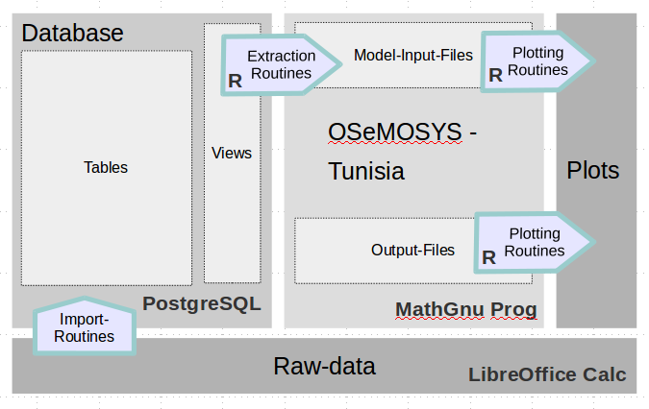Figure 10: Schematic depiction of the modeling environment
The term modeling environment in this thesis is used similarly to Miketa, A. et al.'s term “modeling tools” although it doesn't comprise of any graphical interfaces to manage input data. (Miketa, A. et al. (2017), p. 20)

Database
The database that is developed and utilized within the scope of this master thesis serves multiple purposes. It provides a structure to clearly store data (see 4.1 for more details on data) modeling the case study country's power system. Secondly, in connection with the extraction routines, it enables the modeler to run multiple model runs varying decisive input parameters and testing model results on their respective sensitivities to chosen input parameters. Thirdly it enables the community to check input data and chosen assumptions making the reproduction of results possible. Furthermore it enables the modeler to extend the model or to integrate it within other models.
A PostgreSQL Relational Database Management System (RDBMS) is chosen for the purpose of structuring all data utilized in the modeling process. PostgreSQL as a tool has the advantage of being freely available and accessible, providing a strong community and third party support. A lot of free tools are available for working with PostgreSQL databases. It has a lot of pre-stored functionalities and datatypes (such as polygons for GIS-applications or time-related data-types) making it a suitable solution for the given purpose. As mentioned above, extensibility of the model and the modeling-environment is one of the main aspects, thus motivating a free and easily extensible tool. For accessing the database pgAdmin III is used in version 1.20.0 Beta 2 from August, 10th, 2015. The database is stored offline on the personal laptop.
During the course of the thesis the database structure was set-up from scratch and ammended multiple times. All SQL scripts are given in the respective folder on the data disc.

Structure
The structure of the database is shortly described in this chapter. For the full schema see Appendix. The database consists of tables that can functionally be allocated to one of the four following elements showing how they function
      - Scenarios
      - Values
      - Mappings
      - Modeling tables
The expression “Scenario” doesn't have the same meaning in the database as it has in the case study. A DB-scenario only defines the subset of given values and mappings that is taken into account for the creation of the current input-file.
The scenarios are the basic names for describing a sub-set of certain values. For example the table “scenario_power_plant_cost” comprises of the names of the scenarios describing different cost developments of power plant capital and operational expenditures.
Value-tables inherit values like installed capacity in MW, normalized hourly values of electricity demand or capacity factors for PV and wind feed-in or fix and variable operational or capital cost in 2016-€. Mappings allocate scenario and value tables to one another making it easy to append connections, e.g. between a new scenario and an already existing capacity factor timeseries. Modeling tables in the end don't hold data but rather let the modeler choose scenarios, technologies that are modeled or timeslice definition.
Tables and views can also be allocated depending on what information is stored in the tables. There are 10 categories that the tables can be divided up into:
- Demand
- Fuel
- Power-Plants
- Geography / areas
- Storages
- Modeling
- Time
- Policy
- Grid
- Emissions
The two described ways of categorizing the tables and views of the PostgreSQL database assists the amendment, variation and browsing of the database. Figure 12 shows an excerpt of the database containing all power plant-related tables to illustrate functional categories. The category modeling tables isn't included in the depiction.

Tables
The database consists of 88 tables representing the above mentioned categories. In this paragraph a few detailed insights shall be given on how the relations between the tables are built up. This is done considering the three modeling oriented categories time-representation, representation of space and representation of policy targets.
Representation of Time
The starting point of the database representation of time information was a modelers need to flexibly choose the detail of representation of time for her or his needs. There are two basic time dimensions that correspond to the “two optimization aims” in a linear optimization model like OSeMOSYS:
- The time-resolution of the modeled years (e.g. in a period from 2016 to 2050 does the model represent all 34 individual years or in which resolution are the base years chosen?) corresponds to the expansion planning and plays a major role for the discounting of costs related to the power plant expansion
- The time-resolution within each modeled year corresponding to the dispatch of the power plant park necessary to fulfill the given electricity demand profiles in each timeslice.
Figure 11 shows how the set-up for the modeling base years is stored in the database.
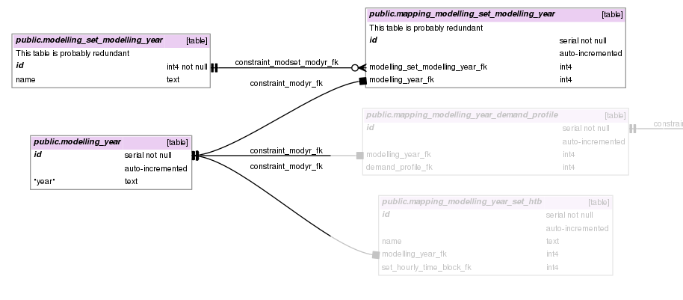Figure 11: Representation of modeling base years in the database. Irrelevant tables are shaded. Source: Own depiction.
The table modeling_year consists of all modeling years that may be chosen as base years. In the table modelling_set_modelling_years sets are defined given a certain name. The table mapping_modelling_set_modelling_year allocates modeling years to predefined sets. This configuration makes a choice of certain base years very easy.
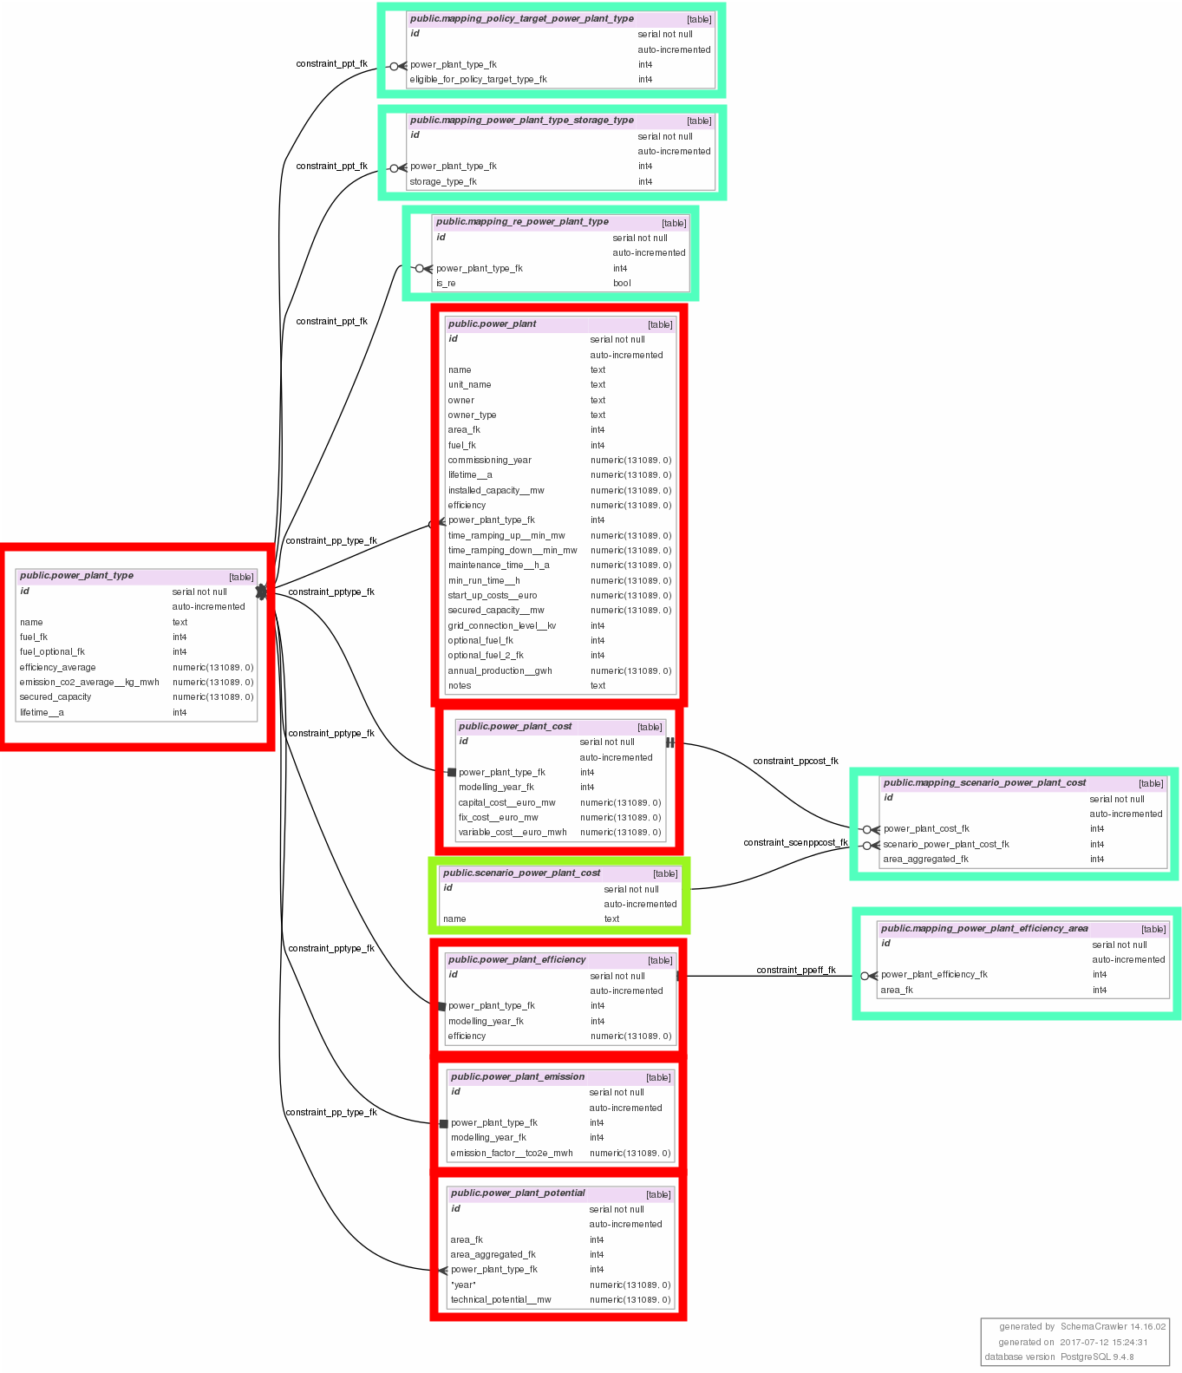Figure 12: Depiction of tables containing information about "power plants". The scenario table is framed lime green, value tables are framed red and mappings are framed in mint. Source: Own depiction.
Complexity reduction is needed because of computational limitations (Pfenninger, S. (2017)) and thus not every hour of every year within the modeling horizon can be modeled. Figure 13 shows potential methods of sub-annual time representation that reduce the computational needs. In method A (Timeslices A) hours are aggregated to blocks (e.g. 8h-blocks) reducing the overall amount of modeled timeslices. This method has the disadvantage that dynamic processes like the changes in VRE-feed-in and needed compensations by the power plant dispatch can only be modeled with less detail. Especially for assessing the role of varying renewable energies this method doesn't seem adequate.
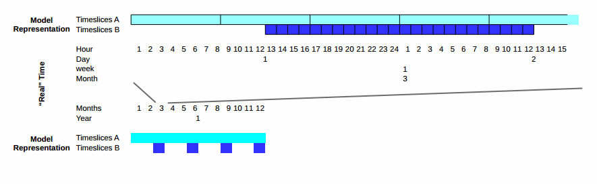Figure 13: Comparison between two ways of modeling time. Timeslices A represent downsampled timeslices where the whole year is represented by 1095 8h-timeslices. Timeslices B show an hourly resolution where only decisive time intervals throughout the year are modeled and others are left out.
Method B on the contrary doesn't reduce the resolution of the model but focuses on modeling only decisive intervals that have to be chosen on the basis of different criteria [Pfenninger, S. (2017)] by the modeler. This method follows the logic that the shape of the load and the VRE-feed-in is similar for certain times in the year and only varies across e.g. seasons.
The database has to be capable of storing both methods and thus the following structure is utilized shown in Figure 14.
Representation of Space
Representation of space is fairly straight-forward in the database. Areas can be defined and aggregated via area_aggregated and the respective mapping tables. Area scenarios are defined that comprise of aggregated areas and can be identified with a granularity addition enabling the modeler to model a certain region e.g. a country in different geographic granularities. Figure 15 depicts the database representation of model geography.
The figure also shows interdependencies of the area table with other tables that are area-specific e.g. the discount rate or power plant and storage efficiencies (blurred). These interdependencies also show that the specific model implementation in OSeMOSYS had some influence on the database design.
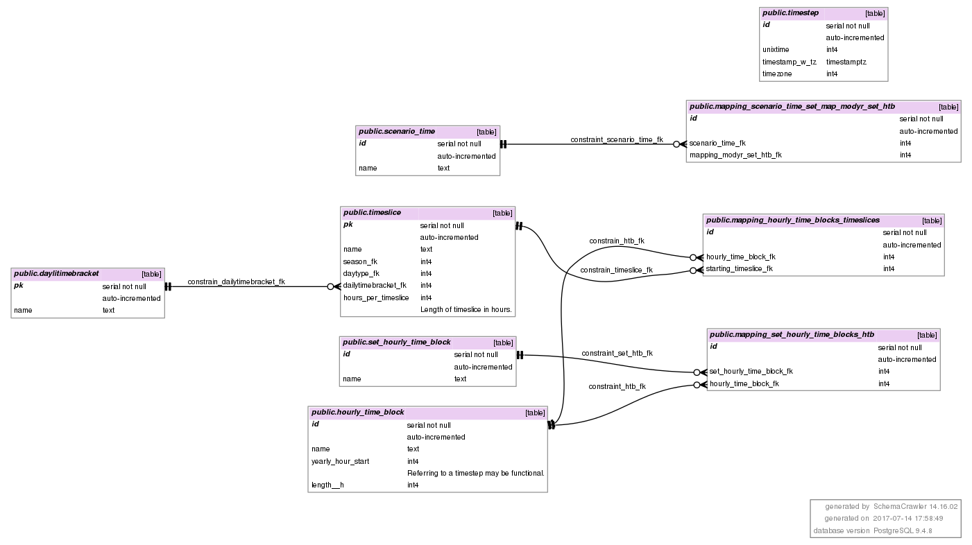Figure 14: Time representation in the database. Timeslices are allocated to seasons (not shown), daytypes (not shown) and dailytimebrackets. Each timeslice is than mapped to an hourly time block. These again are cumulated into sets of hourly timeblocks that represent the sub-annual representation of time in the model. These sets are again mapped to individual modeling years (not shown) that comprise a time scenario. Timesteps that are shown in the top right corner are the "real-life" representation of time also including timezone information. They are utilized for load and capacity factor series (not shown).
Representation of Policy Targets
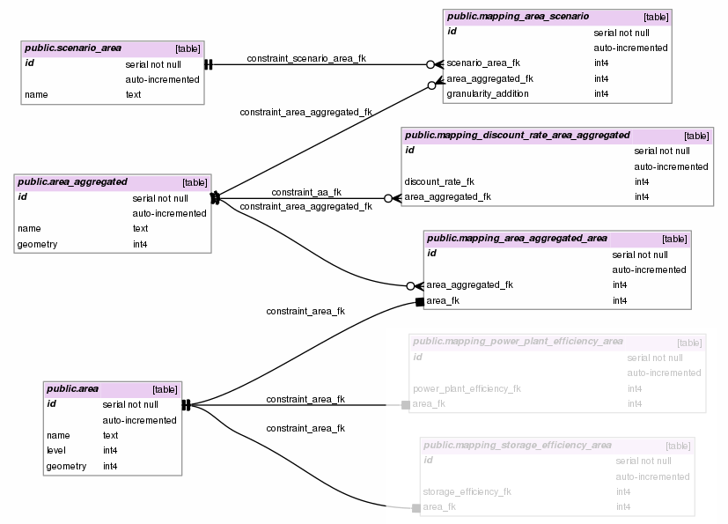Figure 15: Representation of spatial properties of the model.
The modeling of policy targets plays a crucial role in modeling for energy planning since different politically desirable options can be exogenously given as an input and thus their respective influence on total system cost, the expansion of storages and power plants and prices evaluated. This is not a trivial task since political targets can be formulated in various ways. Considering power plant expansion, they can be absolute (MW) or relative (%). In the second case they can refer to the share of installed capacity within the same year (intra-annual relativity) or to a defined base year (inter-annual relativity).
Figure 16 Shows related tables in the database. Scenarios can be given in the table scenario_policy_target that is connected via mapping_scenario_policy_target to the table policy_target_value. As outlined above policy targets can be of different types. The table policy_target_type is shown in Figure 17. Policy targets may but don't have to refer to either power plant types or to fuels.
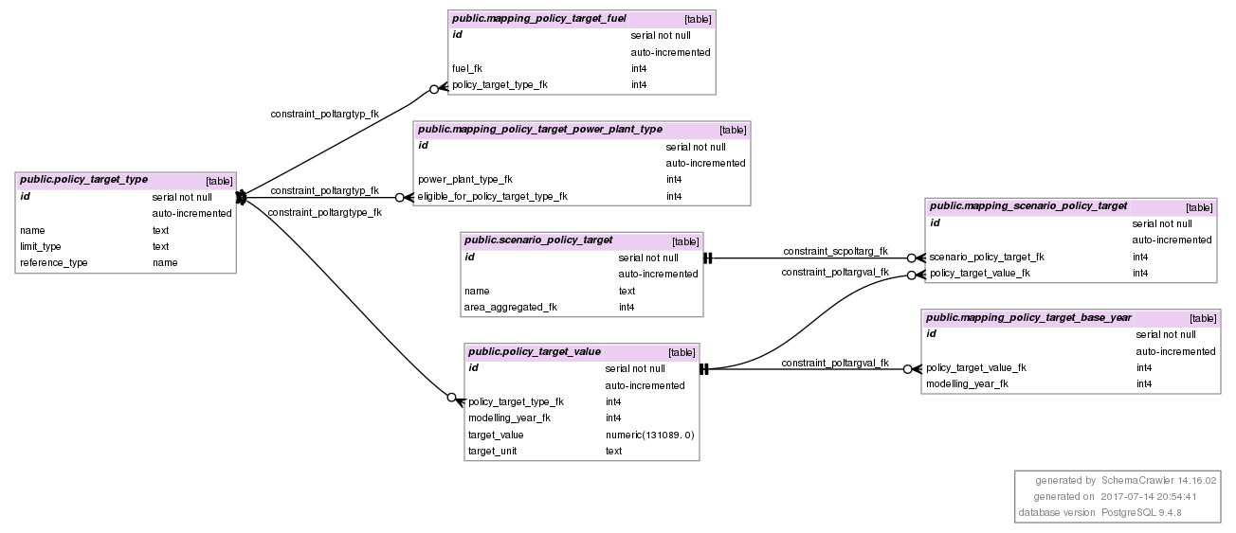Figure 16: Database representation of policy targets. Related tables area, modelling_year, power_plant_type and fuel aren't shown.

Views
There are 20 views in the database representing the 10 categories described in chapter 3.2.1.1. Especially information about power plants and storages are represented by multiple tables since they consist of information about existing technologies, about technology cost developments and about efficiency developments in different years and different regions.
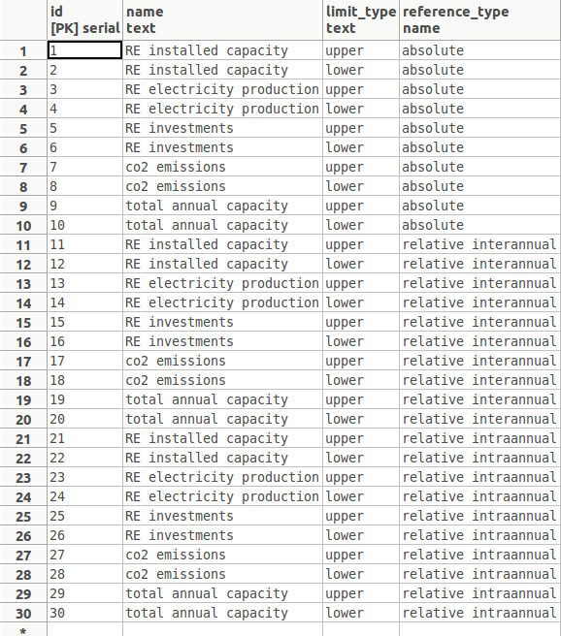Figure 17: Content of the database table policy_target_type. Source: Own depiction.

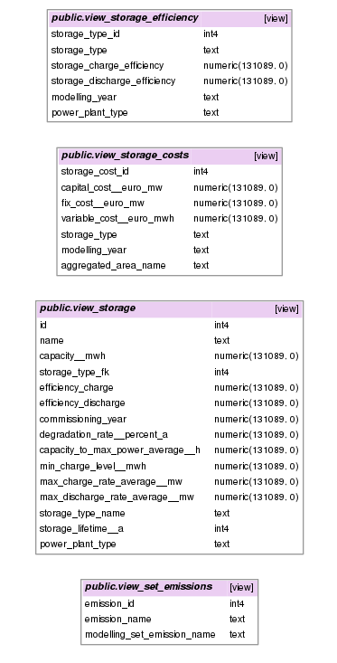
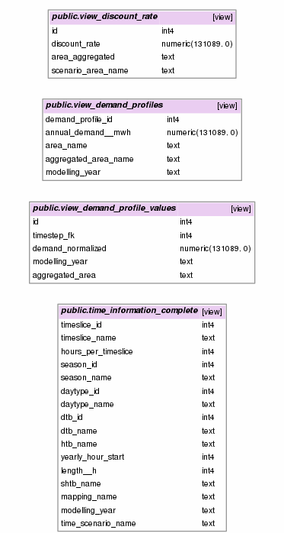
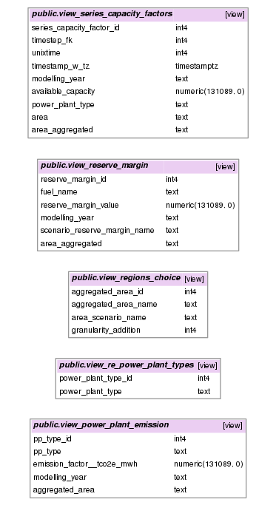
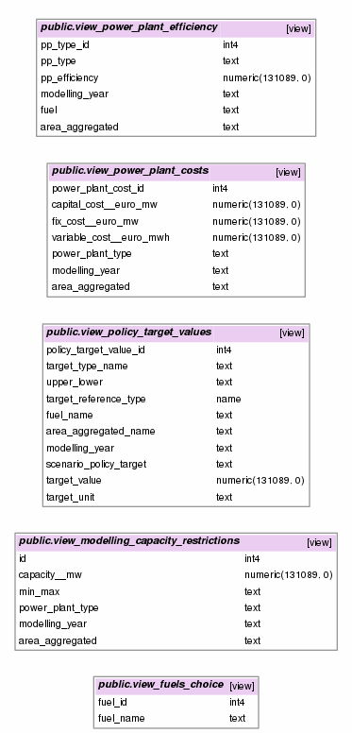Figure 18: Depiction of Database views for as interface to the extraction routine. Source: Own depiction.

Potential Improvements of the Database
In its current form, there are two major shortcomings of the database that could be improved for future applicability:
    - Integration of units
    - Estimation of data quality
The first aspect is especially important as modelers may calculate e.g. energy units in PJ instead of MWh. The conversion between the units in use has to be defined in the model input file in the parameter CapacityToActivityUnits. In its current form it is set to 8760 as conversion between MW (running for a full year) and MWh but explicitly in the extraction routine which is not very elegant but works. For further improvements see chapter 6.

Extraction Routine
As shown in Figure 2 the extraction routine connects the database to the OSeMOSYS modeling framework in preparing input files that are written in the MathGnuProg syntax and relate to the same names of parameters (see chapter 3.3.2).
The extraction routine and supplemantory functions are implemented in R as well as the plotting routines (next chapter). The API RStudio (in its version 1.0.153) that is developed by RStudio, Inc. and licensed under the terms of verion 3 of the GNU Affero General Public License is utilized. Two versions of the extraction routine have been written with one referring to the singlenode model and the second one preparing a multinode model. Only the first one (OSeMOSYS_create_input_fromDB_singlenode_snapshot.R) will be described in this chapter.
The purpose of the extraction routine is to take the data from the views of the PostgreSQL database and prepare an input file for the OSeMOSYS framework. A lot of the actual code thus copes with formatting questions, trimming, converting between data types and filling in commentary text that is in the most part taken from the UTOPIA case study [Howells, M. et al. (2011)] in its downloadable version from beginning 2017 that has now been migrated to GitHub (https://github.com/KTH-dESA/OSeMOSYS/blob/master/Developments/OSeMOSYS_fast/utopia.txt).
For this purpose the packages “DBI”, “RpostgreSQL” and “data.table” as well as the self-written functions “write_matrix_to_file.R”, “write_array_to_file.R” and “phaseout.R” are called. The scripts of the functions are available on the data disc.
The script of the extraction routine is also given in the Appendix. It is structured corresponding to the order of the parameter definition given by the UTOPIA case study file. Naming variables and parameters was tried to be carried out with as least abbreviations as possible. Where there are abbreviations, they are explained in the code at their first occurrence.
The code could reach a higher degree of automatisation where text is not written explicitly in the script file and more of the trimming and formatting processes are carried out by user defined functions. However, the form of the script gives the modeler the possibility to directly adjust comments etc. in the script file without a high degree of digging into function definitions.

Plotting Routines
Plotting is carried out utilizing the package ggplot2(). There are two scripts being OseMOSYS_plot_input.R and OseMOSYS_plot_output.R for depiction of all parameters (input) and the values of optimization variables for the optimal solution.
GGplot2 provides a comprehensive set of pre-configured designs. With the developed plotting routines the depiction of the following input and output parameters is assisted:
Depiction of Input:
- Time slices
- Plotting of demand profiles (split up into seasons and modeling years)
- Plotting of assumed undiscounted capital, fix and variable cost developments for all power plant technologies
- Capacity factor profiles for VRE (split up into seasons and years)
Depiction of output:
- Total annual capacity (bar plot for each power plant technology in each modeling year, differentiated in capacities that were already available in the first modeling year and newly built capacities)
- Annual fuel production by technology
- production profiles for each technology in each timeslice
The plotting routines make it possible to get a quick overview over model run's results making them easily accessible and comprehensible.

Solver
Although there is some doubt that GLPK is the fastest performing solver for linear programming problems [Bitar, F. (2017)], Gearhart, J. L. et al. (2013) find that it is quite fast compared to other open-source linear programming solvers such as lpsolve or MINOS. The ratio of geometric means of solving times for postulated lp problems when compared to solutions by CPLEX was 9.4 compared to 177 and 167.1 for lpsolve and MINOS respectively. Furthermore relative errors in the objective functions were in the dimension of 1e-8 compared to CPLEX solutions and in the order of 1e-3 compared to published optimal solutions. GLPK in its version 4.55 is used in this thesis.
Especially when expanding modeling scope to more complex models by integrating other sectors, expanding the model to multi-node modeling or including conditionalities in the values of the variables (MILP) using a commercial solver should be considered.
Further information about the GLPK solver can be found in Free Software Foundation, Inc. (2010).

Hardware and Computational Restrictions
All modeling has been carried out on a personal laptop with the following properties
Producer | Lenovo
Model | G560
Year of production | 2010
CPU | Intel® Core™ i5 CPU M 450 @ 2.40GHz × 4
Memory | 3,7 GB
Operating System | Linux ubuntu 15.10 – 64 Bit
Table 6: Description of utilized Hardware System. Source: Own composition.
A linear optimization problem with 165976 rows, 152076 columns and 447421 Non-zeros before pre-processing and 73736 rows, 61412 columns and 215134 non-zeros after pre-processing where the size of the triangular part was 57017 was solved in 483.6 seconds utilizing approximately 301.8 MB. The model takes into account four season-days for each modeling year for 6 modeling years (2015-2040). There are 14 technologies utilized including onshore wind, PV utility-scale and decentralized as well as CSP that is split up into the three technologies CSP collector, CSP gas firing and CSP steam turbine.

Model Description
“OSeMOSYS is thus accepted in the scientific community as a standardized model which can be modified if needed (it is open-access) but does not have to be modified in order to work properly.” [Lavigne, D. (2017), p. 163]
“Unlike long established energy systems (partial equilibrium) models (such as MARKAL/TIMES (ETSAP (Energy Technology Systems Analysis Program), 2010), MESSAGE (IAEA (International Atomic Energy Agency), 2010), PRIMES (NTUA (National Technical University of Athens), 2010), EFOM (Van der Voort, 1982) and POLES (Enerdata, 2010)), OSeMOSYS potentially requires a less significant learning curve and time commitment to build and operate. Additionally, by not using proprietary software or commercial programming languages and solvers, OSeMOSYS requires no upfront financial investment. These two advantages extend the availability of energy modeling to the communities of students, business analysts, government specialists, and developing country energy researchers.” [Howells, M. (2011), p. 5850]
The core of the modeling environment comprises of the linear optimization modeling framework OSeMOSYS. The following chapter will give a brief introduction and overview of linear optimization and consecutively describe the structure and the most important modeling features of OSeMOSYS.
Representing power systems with linear optimization methods has strong implications on which factors and processes of a power system planning process can be represented and which can't. Generally there are different ways in which model assumptions can deviate from real power systems.
First there are structural differences between real power systems and the models of power systems. Thus e.g. long-term costs that are the basis for power plant expansion and unit-commitment decisions may not be the only reason why a plant is commissioned but only one next to political, individual or socio-economic reasons. Links to other sectors (mobility, heat/cold etc.) are usually not taken into account.
Secondly uncertainties evolve because future developments are modeled that can not be validated. Especially the development of the annual electric load, load profiles (see chapter 4.1.2), fuel prices and capital expenditures are subject to uncertainty. They are treated in this thesis by scenarios that span possible pathways for the aforementioned quantities assuming that the real load and cost developments lie within the spanned intervals.
Thirdly, there are uncertainties evoked by aggregations of data with a high geographical and temporal resolution. This step is necessary due to limited computational capacities (see chapter 3.2.5) to ensure feasible computation times. By aggregating e.g. power plants within a region differences in their feed-in or ramping behavior are ignored.
Fourthly real power system quite often don't behave optimally due to different reasons. A power system in a single-buyer market may not be dispatched optimally but as a consequence of a range of processes and personal motivations of involved stakeholders.
Regardless of this broad list of limitations of linear power system modeling it can provide valuable insights in technology expansion and respective total system cost. This is especially important for power system planners because costly investments can be avoided. At the same time a regulatory authority has a well-advised basis for the evaluation of planned technology expansion. Also, the effect of different flexibility options can be evaluated and the cost-optimal dispatch of a power system can be analyzed subject to given boundary conditions.
In this paragraph only the methodology of linear optimization in general and specifically OSeMOSYS is described. Concrete numbers for different parameters are given in chapter 6.

Limitations of Linear Optimization Models
The electricity demand and its development over time is modeled as exogenous parameter. Thus macroeconomic effects such as a change of electricity demand enduced by a change of GDP are not part of the model. However changes in annual load as well as in the load profile (i.e. absolute value of minimum load, relation between minimum and mid-day peak load and relation between minimum and evening peak load) are taken into account by scenario calculations.

OSeMOSYS
The Open Source Energy Modeling System OSeMOSYS is a widely used and peer-reviewed tool utilized by institutions such as UNDP and the World Bank. It is capable of modeling demands and supplies of end- and intermediate products (such as gasoline or electricity) and their conversion in different energy sectors (electricity, heat/cold, mobility).
OSeMOSYS is implemented in MathGnuProg under an Open Source-License opening it up to modelers and advisory bodies and making it also attractive for teaching purposes [Lavigne, D. (2016)]. It is designed to be very transparent in the sense that the names for sets, variables and equations (and inequalities) are not abbreviated making it easy to learn about the functionalities.
Although vast descriptions and manuals of OSeMOSYS exist this chapter provides some insights in its basic structure, methodology and implementations. The syntax in this paragraph is meant to aid the reader by marking OseMOSYS-terms in italic.
OSeMOSYS utilizes timeslices as its smallest time unit which can be used to implement sub-hourly profiles to blocks consisting of several hours. In the implementation of the case study one timeslice is being used for each modeled hour in order to model implications of fluctuating renewable energy feed-in.
The model in abstract represents energy carriers and energy conversion processes. Energy carriers are called fuels but also comprise of e.g. electricity. Conversion processes can be everything from power plants and resource importing entities to heaters, cars and other providers of energy services (that are modeled as fuels as well). Fuels can be demanded either annually or specified for each timeslice. The third entity in OSeMOSYS are storages deviating from the colloquial meaning of storages as they only model reservoirs in OSeMOSYS and don't include storage parameters as charge or discharge efficiencies. These are modeled in corresponding technologies which are mapped to storages (more detail given in chapter Error: Reference source not found and especially in Equation 11).
The objective function of OSeMOSYS is the minimization of total discounted cost as shown by Equation 2. See below in chapter 3.3.1.2 for the composition of TotalDiscountedCost.
(2)
The first sub-chapter 5.3.1.1 introduces the OSeMOSYS structure of sets, parameters and variables and outlines examples excluding the representation of economics and storages that are described in further detail in chapters Error: Reference source not found and 3.3.1.2. chapter 3.3.1.1 introduces the most relevant equations and boundary conditions limiting the values of the modeling variables.
A full description of OSeMOSYS utilizing the UTOPIA case study is given in [Lavigne, D. (2017), p. 163ff.].

Structure of Sets, Parameters and Variables
OSeMOSYS consists of 12 sets, 52 parameters and 70 variables. In this paragraph the most important sets, parameters and variables are described. For further detail on the OSeMOSYS structure please refer to [Moksnes, N. et al. (2015)].
Sets are the most basic entities of OSeMOSYS and define the model's basic structure. All sets defined in OSeMOSYS are given below in Table 2.

Set-Name | Examplatory Elements | Letter in model | Description
YEAR | 2010, 2015, 2020,... | y | Modeling Years within the time horizon
ALL_YEARS | 2010, 2011, 2012 | ay | All years within model horizon for calculating total cost
TECHNOLOGY | Biomass, Wind Onshore, OCGT,... | t | Power plant technologies
TIMESLICE | Sp1, Sp2,…, Su1,Su2,... | l | Timeslices that are modeled in each modeling year.
FUEL | Natural Gas, Electricity | f | All energy carriers (wind and sun aren't considered energy carriers)
EMISSION | CO2 | e | Only CO2-emissions are considered
MODE_OF_OPERATION | 1, 2 | m | Differentiation between charge and discharge of storages
REGION | Tunisia_1, Tunisia_2,… | r | Modeling Regions
SEASON | 1, 2, 3, 4 | ls | Spring, Summer, Fall, Winter
DAYTYPE | 1 | ld | Potential differentiation between weekdays and weekends. Neglected here.
DAILYTIMEBRACKET | 1, 2, 3, 4 | lh | Time-brackets of a day: Morning, Mid-Day, Evening, Night
STORAGE | Pumped Hydro, Battery | s | Definition of the storage reservoirs. The conversion from potential or chemical energy in power is considered in TECHNOLOGY
Table 7: Sets of OSeMOSYS as utilized in the case study. Source: Own composition.
All parameters and variables depend on individual elements of the sets given in the second column of table XX. If a parameter or variable depends on three different sets it has a value (in the case of parameters assigned or object to variation in the case of variables) for every combination of the set elements of the three sets. The parameter SpecifiedAnnualDemand for example depends on the three sets REGION, FUEL and YEAR. Modeling one region with two fuels for 5 modeling years yields 10 parameter values. This number of parameters (and variables) increases exponentially the more set elements are given. Defining parameters is still user-firendly since a large number of parameter values can be assigned using default values.
Parameters and variables that are only defined for a certain modeling year are depending on the set YEAR. Most parameters and variables in OSeMOSYS depend on the modeling year. Some of the more obvious are CAPEX, fix and variable OPEX, the annual electricity demand and the remaining installed power plant capacities remaining from capacities that have been installed before the modeling period. Parameters and variables that consist of time-series like electricity demand series or capacity factor series for renewable energy feed-in additionally depend on the set TIMESLICE since they are hourly series.
The most important parameters that depend on TECHNOLOGY are CAPEX, fix and variable OPEX, the paramater ResidualCapacity, CapacityFactor for the different renewable power plant technologies and expansion restriction parameters (TotalAnnualMaxCapacity and TotalAnnualMinCapacity).
Because of the abstract structure of the model considering energy carriers and converters of energy carriers power plant efficiencies are given in the parameter InputActivityRatio that defines the ratio between the input of a conversion technology (e.g. natural gas for an OCGT power plant) and its activity (power production of an OCGT power plant). This parameter is also depending on the set MODE_OF_OPERATION making it possible to define different charge and discharge efficiencies for storages.
Special focus is put on meeting peak demand in the corresponding timeslice. The parameter TechWithCapacityToMeetPeakTS allocates technologies to the ability to meet peak demand for the corresponding fuel (in this model only electricity since no natural gas demand other than from natural gas firing of power plants is modeled). The parameters ReserveMarginTagFuel, ReserveMargin and ReserveMarginTagTechnology define a security margin for the power production and allocate eligibility of power plants to meet the reserve margin. Parameters defining an upper or lower limits for specific power plants or investments enable the model to represent forced technology expansion due to political targets.
The variables in OSeMOSYS are categorized in demand, storage, capacity, activity, costing, reserve margin, RE generation target and emission variables. OSeMOSYS differentiates between RateOfDemand and Demand to account for electricity demand at a precise moment (unit: MW, variable: RateOfDemand) and electricity demand within a whole timeslice (unit: MWh, variable: Demand). Both are connected via the parameter YearSplit that defines the length of a timeslice. For a more detailed description of YearSplit please refer to [Moksnes, N., 2015, page 11]. This differentiation in RateOfX and X also applies to the variables Acticity, TotalActivity, Production, ProductionByTechnology, Use and UseByTechnology.
The variable Production incorporates the total fuel production of each fuel (electricity and natural gas) in every modeling region, timeslice and modeling year. Its value has to always be higher than the sum of demand, use and the difference of export and import and is calculated based on different intermediary variables by taking into account the variable RateOfActivity (for each region, timeslice, technology, mode of operation and year), the parameter OutputActivityRatio (for each region, technologiy, fuel, mode of operation and year) and the parameter YearSplit (for each timeslice and year). Depending on six sets the variable Production is of central significance for the modeling results.
The variable NewCapacity contains capacity additions for eacht region, technology and year. It is the basis for calculating accumulated capacity additions and capital costs as well as the salvage value and object to capacity addition lower and upper limits.

Summary of Most Important Equations and Boundary Conditions
Variables are subject to equations and boundary conditions that define and confine possible variable values. They usually include input parameters or variables that are restricted by parameters and are applied over combinations of set elements. Because OSeMOSYS consists of 94 different equations and inequalities in this chapter only a few equations are shown ensuring capacity adequacy, that the energy balance is met and exogenously given RE generation targets.
Capacity Adequacy
Ensuring that sufficient power plant capacity is installed in each modeling year capacity adequacy equations are central to power plant expansion modeling. Equation 3 adds newly installed capacities to remaining capacities. Equation 4 all new capacities of a year excluding capacities that have been built within the modeling horizon but have already been decommissioned for example a PV plant with a lifetime of 20 years that was built in 2015 will be decommissioned in 2040.

s.t. CAa2_TotalAnnualCapacity {r in REGION, t in TecHNOLOGY, y in YEAR}:
(3)

ResidualCapacity is exogenously given as a parameter depending on REGION, TECHNOLOGY and YEAR.

s.t. CAa1_TotalNewCapaCity {r in REGION, t in TECHNOLOGY, y in YEAR}:
(4)
NewCapacity is a central variable quantifying the power plant expansion additional to remaining capacities and is among others used to calculate total discounted capital cost and salvage values. The parameter TotalCapacityAnnual also ensures that the output of each power plant in each timeslice (for each region and year) never exceeds its installed capacity multiplied by the respective capacity factor.

Energy Balance and Capacity Adequacy
Power plant dispatch is modeled and constrained in the energy balances that are given below (equations 5-9). The first three equations connect rates (power) to corresponding energy values (energy). Equation 9 guarantees that power that is exported from a region is likewise imported to the target region. The last equation of this block implements the power demand sufficiency constraint that has to hold true for every region, timeslice, fuel and year.
s.t. EBa7_EnergyBalanceEachTS1 {r in REGION, t in TECHNOLOGY, f in FUEL, y in YEAR}:
5)

s.t. EBa7_EnergyBalanceEachTS2 {r in REGION, t in TECHNOLOGY, f in FUEL, y in YEAR}:
(6)

s.t. EBa7_EnergyBalanceEachTS3 {r in REGION, t in TECHNOLOGY, f in FUEL, y in YEAR}:
(7)

s.t. EBa7_EnergyBalanceEachTS4 {r in REGION, rr in REGION, t in TECHNOLOGY, f in FUEL, y in YEAR}:
(8)

s.t. EBa7_EnergyBalanceEachTS5 {r in REGION, t in TECHNOLOGY, f in FUEL, y in YEAR}:
(9)
The reserve margin is implemented in three reserve margin constraints using the variables RateOfProduction and as mentioned above TotalCapacityAnnual.

RE Production Target
OSeMOSYS incorporates the functionality to exogenously set renewable energy production targets since this is a field of major interest. Of the five RE Production Target constraints only the last two are given below in equaionts 10 and 11. The other three sum up the annual RE production, assure that only technologies tagged in a tag-variable contribute to the target and adds up the total demand for fuels with a RE tag in each region and year. The latter statement implies that RE targets can only be given for each year and not fuel-specific. Since only the power sector is under consideration in this analysis this doesn't impair the analysis' quality. Equation 10 implements the main constraint and thus ensures that the total production of tagged fuels exceeds the target for RE production.

s.t. RE4_EnergyConstraint {r in REGION, y in YEAR}:
(10)

Equation 11 prepares the output of the annual fuel use by technology in regard to RE contribution targets. The variable UseByTechnologyAnnual isn't used elsewhere in the code.

s.t. RE5_FuelUseByTechnologyAnnual {r in REGION, t in TECHNOLOGY, f in FUEL, y in YEAR}:
(11)

Representation of Economics in OSeMOSYS
The objective function of OSeMOSYS is to minimal overall system cost. 17 out of 70 variables and 20 out of 94 equations and inequalities assess economic values, and boundary conditions of which the most important are calculation of discounted CAPEX and OPEX for power plant expansion and dispatch, calculating the cost of storage expansion and calculating salvage values of power plants and storages at the end of the model period. This paragraph summarizes the model implementation and calculation of the aforementioned entities.
The variable NewCapacity defines the capacity expansions for each technology in each region for each modeling year. Technology specific annual capital investments and annual operating costs are calculated as given in Equation 12 and 14 respectively. The implementation of discounting is shown for capital investment in Equation 13.
CC1_UndiscountedCapitalInvestment:
(12)
CC2_DiscountingCapitalInvestment:
(13)
OC3_OperatingCostsTotalAnnual:
(14)
Total discounted cost is calculated for each model region, technology and model year as given by Equation 15 and total discounted cost for all technologies and storages for each model region and model year as shown in Equation 16.
TDC1_TotalDiscountedCostByTechnology:
(15)
TDC2_TotalDiscountedCost:
(16)

Extension of OSeMOSYS to Time Snapshots
As stated by Miketa, A. et al. typically time and spatial resolutions are too low to assess VRE impact [Miketa, A. et al. (2017), p. 13]. This also applies to OSeMOSYS.
As described above and in Lavigne, D. & Moksnes, N. et al., OSeMOSYS in its actual version (from 2015-08-27) models the year in a timeslices appraoch (Timeslices A in Figure 3) thus applying a downsampling-approach where there are differentiations in seasons, daytypes and dailytimebrackets but the chronological characteristic of VRE is not accounted for. Thus, within the scope of this work, OSeMOSYS is extended to model not all days of a year by downsampling but rather the most significant time intervals in an hourly resolution (Timeslices B in Figure 3).
The parameters that are timeslice-dependent and thus have to be adjusted are
- YearSplit {l in TIMESLICE, y in YEAR}
- SpecifiedDemandProfile {r in REGION, l in TIMESLICE, f in FUEL, y in YEAR}
- CapacityFactor {r in REGION, t in TECHNOLOGY, l in TIMESLICE, y in YEAR}
- and the three mapping parameters Conversionls, Conversionld and Conversion lh allocating timeslices to respective seasons, daytypes and dailytimebrackets.
To account for the times in the year that aren't modeled, a dummy-timeslice “Du” is introduced having the length
(17)
The snapshot methodology as well as choosing decisive model years excluding certain years in between necessitate adjustments to the calculation of costs. While capital expenditures are assumed to only occur in the modeling years (qualitative/structural assumption), operational expenditures have to be calculated not only for the modeling years but also for the years in between assuming equal operational expenditures in the four consecutive years. This accounts for fix and variable OPEX so it is assumed, that the total annual OPEX also arise in the years following the model years up until the next model year (for 2016-2019 the OPEX from 2015 are assumed). An additional set (ALL_YEARS) is added to the basic OSeMOSYS formulation for this purpose (equation 18).
(18)
In a similar manner variable OPEX within a year are assumed via a weighing factor described in equation 19.
(19)
This approach assumes that OPEX in the whole year are the same as in the modeled snapshot which holds as a first assumption. Variable names calculating annual values in the original formulation are changed to snapshot variables and marked (#changed). All definition equations of respective variables and respective constraints are adjusted as well.
The variables OperatingCostAllYears, DiscountedOperatingCostAllYears, AnnualVariable-OperatingCost and SnapshotTechnologyEmission are added. The added constraints OC3b and OC4a show the implementation in OSeMOSYS.
OC3b_OperatingCostsTotalAllYears {r in REGION, t in TECHNOLOGY, y in YEAR, ay in ALL_YEARS: ay-y < 5 && ay-y >= 0}:
(20)

OC4a_DiscountedOperatingCostsTotalAllYears {r in REGION, t in TECHNOLOGY, ay in ALL_YEARS}:
(21)

Scenarios and Sensitivity Analyses
As stated by DeCarolis, J. et al., the main focus of research on the basis of energy system optimization modeling is the “identification of patterns across ESOM model runs under uncertainty” [DeCarolis, J. et al. (2017), p. 192]. Especially because the scope of linear optimization models is limited and relevant factor may not be modeled endogenously but rather given as an exogenous constraint to the linear optimization model, varying input parameters is important. During this thesis this refers especially to the main influencing factors identified in chapter 3.1.1 and chapter 3.1.2.
Furthermore, parametric and structural uncertainties can be distinguished [DeCarolis, J. et al. (2017), p. 192]. While parametric uncertainties can be coped with within the scope of energy system analysis using linear optimization models, structural uncertainties refer to e.g. the fact that a purely linear model may choose to build 3 kW of a hard coal power plant if it leads to the cost-optimal power plant expansion mix. In this thesis, structural uncertainties also identified above as qualitative influencing factors that are out of the scope of the model are described. They are one of the most relevant limitations of linear optimization models to energy planning.
DeCarolis, J. et al. point towards the risk that model results may be driven by highly uncertain discount rates. Even though discount rates have a huge influence on model results, OSeMOSYS in its current form that is applied in this thesis doesn't support technology-specific interest rates. Even though this is a downgrade towards the representativeness of modeling results of the case study it eradicates the problem mentioned by the authors.
Miketa, A. et al. mention that site-selection highly influences system compatibility of VRE power plants. Although VRE feed-in data has a fairly low accuracy in the case study, this effect can already be observed comparing different feed-in profiles depending on respective site-selection (compare Table 15, Table 16 and Figure 23) [Miketa, A. et al. (2017)].
In the case study of this thesis the most influential factors of respective tasks will be subject to a maybe not comprehensive but yet presumably insightful sensitivity analysis.
Scenarios are able to cope with both structural and parametric uncertainty. Considering the first one, they introduce decisive modeling elements (such as new technologies, another dimension of differentiation such as regional differentiation etc.) in the analysis. Even though regional differentiation utilizing a multi-node model was envisioned within the course of the thesis, this can not be carried out within the time scope.
Uncertainties regarding nowadays and future values of input parameters such as natural gas prices capital expenditures (and respective magnitudes of cost break-downs) can be subject to scenarios such as “low demand increas”, “BAU” and “high demand increase” scenarios and similar approaches to natural gas price developments.
Since the focus of this thesis doesn't lie on the development of scenarios and other research groups carry out much more sophisticated research in this area, in this thesis only the two variables “annual electricity demand” and “natural gas price” will be varied.
Uncertainties regarding the development of capital expenditures of VRE technologies will be treated in task-specific sensitivity analyses.
Scenario assumptions for natural gas price developments stem from a study by ESMAP and WBG from 2017 and are shown below.
Scenario / Year | Current Policies (BAU) | New Policies | 450 | Low Oil Price
2015 | 19.61 | 19.61 | 19.61 | 19.61
2020 | 17.45 | 16.97 | 16.37 | 13.46
2025 | 21.71 | 20.29 | 18.33 | 16.50
2030 | 26.98 | 24.35 | 20.56 | 20.22
2035 | 28.34 | 25.56 | 20.02 | 22.93
2040 | 29.76 | 26.92 | 19.48 | 25.97
Table 8: Scenarios for the development of the natural gas price in Tunisia. Source: Converted to 2016-€/MWh from 2014-USD/tep-pcs (tonne équivalent pétrole – pouvoir calorifique supérieur (tonnes of oil equivalent – Higher Heating Value)). Benbarka, A. et al. (2017), p.56.
Scenario assumptions for load scenarios are shown in Table 9.
TWh | Scénario de d'efficacité énergétique | BAU | Scénario de référence
2015 | 18.2 | 18.199 | 18.2
2020 | 21.7 | 23.227 | 23.3
2025 | 24.9 | 29.644 | 29.8
2030 | 30.1 | 37.834 | 38
2035 | 36.5 | 43.331 | 48.5
2040 | 44.1 | 49.626 | 61.8
Table 9: Scenarios for the development of the annual electricity demand in Tunisia. Low demand scenario is developed starting off from 2015 electricity demand as given by STEG (2015) and applying growth rates as suggested by ANME (2015), energy efficiency scenario. The same holds true for the high load scenario except growth rates from ANME's reference scenario are taken. Main differences of the BAU scenario to the latter are the growth rates of the years 2035 and 2040. Source: Own composition based on ANME (2015) and own assumptions.

Modeling Case Study: The Tunisian Power System
After chapter 3 described the most relevant structural chances and limitations of linear optimization in general and OSeMOSYS specifically, chapter 4 applies OSeMOSYS on the country case of Tunisia. Some research has been carried out researching the Tunisian power system and also VRE integration potentials within the scope of the Desertec Industrial Initiative and independent research (see chapter 2.3). Thus, data for Tunisia is available from these studies as reference even though some of the studies are outdated with respect especially to technology costs. Where this is the case they still provide a useful reference case and are amended by other more recent research in the region such as Kern, J. et al. (2016) and Breyer C. et al. (2017). Additionally, a validation session for the most crucial quantitative and qualitative assumptions has been carried out with GIZ Tunisia employees [Schweinfurth, A. et al. (2017)].
While chapter 4.1 puts forward the basic set of quantitative input data, its assembly, validity and sources, chapter 4.2 describes the calibration of the model on the basis of the basic data set. chapter 4.3 goes on assessing the three tasks chosen in the previous chapters including assessing the sensitivity of results towards most influential factors. Wrapping up case study calculations chapters 4.4 and 4.5 present and interpret the results.

Input Data Set
This chapter presents the basic input set of data that was used for model calibration. A crucial role play the load and feed-in series (chapters 4.1.2 and 4.1.3) as well as the cost data (chapter 4.1.4).

Power Plants
The broad details of Tunisian power plants are fairly well documented (installed capacities, locations, fuel types). Considering efficiencies, the documentation gets thinner which doesn't pose a problem since power plants are aggregated corresponding to their respective power plant type. Table 10 Gives an overview over the most important properties of Tunisian power plants. The total installed capacity values have been validated with numbers from a current STEG presentation from May 2017 [Ibrahim, A. (2017)]. The power plant No. 47-50 display the difference in detailed power plants to the validation numbers.
A more detailed spatial modeling was envisioned at the state where the list was compiled thus additional locational information (such as governorate and coordinates) are given in the full list. Also individual decommissioning years are taken into account stemming from individual plants going offline.
Table 11 and Table 12 summarize the most important properties of power plants modeled in this case study.
Table 10: Extract of the power plant list for existing power plants in Tunisia. Source: Own composition based on multiple sources given in table.
Residual Capacities (MW) | 2015 | 2020 | 2025 | 2030 | 2035 | 2040
CCGT | 2137 | 2137 | 1578 | 1578 | 1080 | 1080
Hydro RoR | 62 | 62 | 62 | 62 | 62 | 62
OCGT | 1623.4 | 1102 | 722 | 484 | 240 | 0
PV Dec. | 32 | 32 | 32 | 32 | 32 | 0
PV US. | 0 | 0 | 0 | 0 | 0 | 0
Steam Turbine | 678 | 354 | 354 | 0 | 0 | 0
Wind Onshore | 432.6 | 432.6 | 413.32 | 379 | 189 | 0
Table 11: Residual power plant capacities for the Tunisian power plant park. Source: Own composition based on data given in Table 10.

Power Plant Type | Operational Lifetime [Years] | Efficiency 2015 | Efficiency 2040 | Emission Factor 2015 | Emission Factor 2040
CCGT | 40 | 58 | 61 | 0.35 | 0.33
CSP | 40 | 38 | 40 | 0.53 | 0.51
Hydro RoR | 100
OCGT | 40 | 30 | 40 | 0.67 | 0.51
PV Dec. | 20
PV US. | 20
Steam Turbine | 40 | 38 | 40 | 0.53 | 0.51
Wind Onshore | 20
Table 12: Properties of newly built power plants. For CSP, efficiencies and emissions are given for the steam turbine if it was purely running on gas. RoR: Run-on-River, PV Dec.: PV Decentralized, PV US.: PV Utility-Scale. Source: Own assumptions.
Furthermore the following is assumed:
    - It is assumed that all Tunisian power plants are capable of burning natural gas instead of heavy or light fuel oil (Fueloil or Gasoil). Fueloil and Gasoil power plants aren't modeled within the scope of this thesis.
    - A planned maintenance time of 100 h/a is chosen as a default value for all power plants. Planned maintenance only gets relevant when calculating the dispatch of a whole year.
    - The possibility to burn a secondary oil in the power plants like Diesel Oil, Gasoil, Fueloil, Distillate etc. as it is given at power plants with an aggregated installed capacity of over 2 GW will not be part of the modeling since it is assumed that the cogeneration is negligible from a systemic perspective
    - Generic lifetimes are used depending on the power plant type as shown in Table 12
    - The commissioning year of all power plants where the real commissioning year is unknown is set to 1990 due to lack of further information

Load Data
As stated by Miketa, A. et al. choosing temporal model steps has a significant relevance to modeling results especially as the impact of integration of VRE is assessed. Daily and seasonal variations between demand and feed-in patterns have to be taken into account in order to be able to capture potential VRE contributions to firm capacity. Preferably feed-in and load data for multiple years should be included in order to account for inter-annual variations as also stated and thoroughly analyzed by Pfenninger, S. (2017).
Since hydro dam and biomass power plants play a negligible role in Tunisia no inflow profiles will be modeled and thus electricity demand and VRE capacity factor series are the only time dependent parameters. In the model four seasons will be differentiated: Summer, Winter, Intermediary and Ramadan. Modeling Ramadan as its own season was suggested in a correspondence with a reseach group from ENIT and appeals since during Ramadan electric demand patterns change.
Load Data is taken from a GIZ-Tunisia project where the half-hourly load values for the years 2008-2010 of the national Tunisian electricity demand are available. The load duration curves for the profile downsampled to hourly values is given in Figure 20 showing an increase in electricity demand during the years but furthermore an even steeper increase in the peak load from 2465 MW in 2008 to 3010 MW in 2010. Peak load times were July, 8th in 2008 (13:00), August, 26th in 2009 (13:00) and July, 23rd in 2010 (12:00).
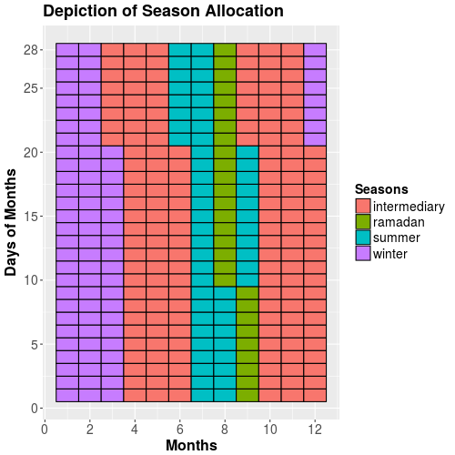Figure 19: Depiction of the four modeling seasons and respective allocations of days. For depiction reasons only the first 28 days of each month are shown. Source: Own composition.
Figure 21 shows the daily peak demands (mid-day in red and evening in blue) as well as the lowest demand (green) for every day in 2010. Weekends are characterized by significantly lower mid-day peaks while they don't affect evening peaks nor minimum demands as much. As shown in Figure 19, Ramadan ranged from August, 10th to September 09th in 2010. It can that during this time, evening peaks tend to be slightly higher than would be expected. Also beginning and end of Ramadan are characterized by very low demand.
Choosing of timesteps for modeling has to take into account not only demand patterns but also VRE feed-in and thus residual load. This will be further described in the following chapter.
Electricity demand development for Tunisia is a major uncertainty in the analysis. For 2015 the national demand published by STEG is taken (18.199 TWh). For the consecutive years (2020-2040) assumed annual growth rates are shown in Table 13.
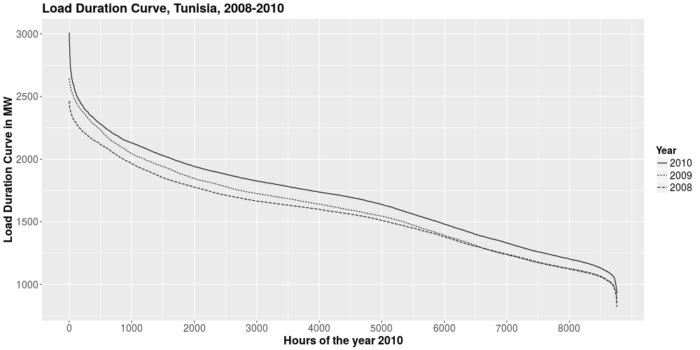Figure 20: Load Duration Curves of the national electric load in Tunisia for the years 2008-2010. Source: Own depiction on the basis of data by GIZ.
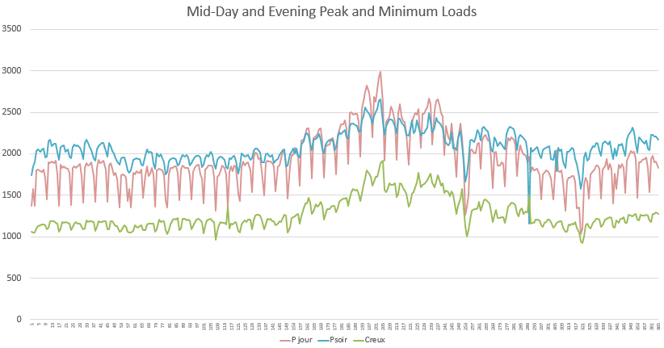Figure 21: Mid-day peak, evening peak and lowest electricity demand for national electricity demand in Tunisia for each day in 2010. Source: Own depiction on the basis of data from GIZ.

Time Period | Annual Electricity Demand Growth in % | Source
2015-2020 | 5 | ANME (2015), reference scenario
2020-2025 | 5 | ANME (2015), reference scenario
2025-2030 | 5 | ANME (2015), reference scenario
2030-2035 | 2.75 | STEG (2010)
2035-2040 | 2.75 | STEG (2010)
Table 13: Assumptions regarding electricity demand development. Source: Own composition on the basis of ANME (2015) and STEG (2010).

All values in GWh | STEG / energy & meteo systems (2013) | ANME (2015) | Own Values
Year | STEG / energy & meteo systems (2013) | ANME (2015) | Own Values
2015 | 16980 | 15900-16100 | 18199 (STEG, 2015)
2020 | 23060-24020 | 18800-20700 | 23227
2025 | 30290-33030 | 21600-26500 | 29644
2030 | 38910-43800 | 26200-33800 | 37834
2035 |  |  | 43331
2040 |  |  | 49626
Table 14: Annual electricity demand for Tunisia for the years 2015-2040. Values by STEG, energy & meteo systems and ANME as well as assumed values for modeling. Source: Own composition based on the sources given.
Table 14 shows the assumed electricity demand development for this case study. Assumed values are lower than the range given by ANME because the actual 2015 national electricity demand exceeded ANME assumptions. Still annual growth rates are chosen on the basis of ANME and assumed to decrease for the time period 2030-2040. In a first approach it is assumed that the peak load increases with the same rate as the total annual load [ANME (2015)].

Feed-in Data
In order to provide a national feed-in profile for PV and wind respectively, simulated hourly feed-in time series profiles are extracted from the website http://renewables.ninja for coordinates based on sites where projects by STEG are in the planning phase and will be carried out until 2020 [Pfenninger, S. et al. (2016), Staffell, I. et al. (2016) & Pfenninger, S. et al. (2017c)]. Because of lack of further precise coordinates these are mostly assumed based on the following map by [STEG (2017), p. 11].
Table 15 provides the coordinates for synthesizing a national PV and a national onshore wind feed-in profile. The coordinates are based on Figure 22 and on potential estimations by GIZ.
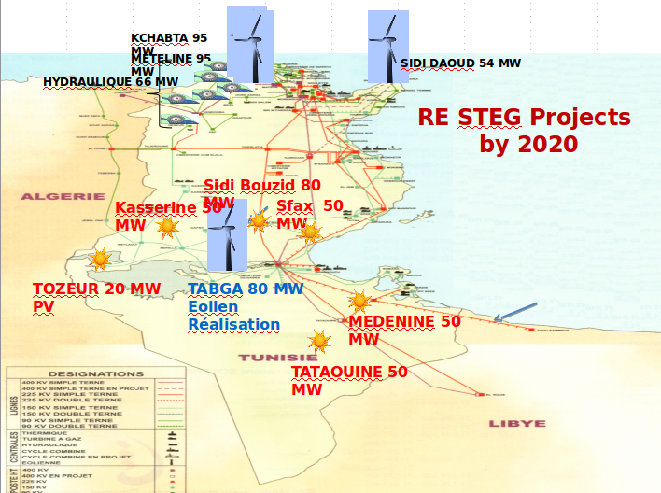Figure 22: Prospects of STEG RE sites based on Ibrahim, A. (2017).
Normalized hourly profiles are aggregated with a weighing factor corresponding to the planned installed capacities at the respective sites to synthesize a potential national hourly feed-in profile for both technologies.
Table 15: Coordinates of potential PV and Onshore Wind power plant sites. Sources: Own composition based on sources given in column 5.
A second methodology for aggregating the normalized feed-in profiles is used based on sites selected in GIZ with precise coordinates for comparison [GIZ (2013), p. 57]. The duration curves of both methodologies for both technologies are given in Figure 23.
Annual capacity factors for both methodologies and both technologies are shown in Table 16.
Annual Capacity Factors in MWh / MW | PV | Onshore Wind
STEG (2017) | 1801 | 3296
GIZ (2017) | 1772 | 3229
Table 16: Annual capacity factors of synthesized and weighed feed-in profiles from Pfenninger, S. et al. (2017c) weighed on the basis of two different sources for site selection.

The aggregated duration curve for wind feed-in series based on sites selected by STEG for 2020 projects is somewhat smoother, implying a slightly less variable wind feed-in. For both technologies, site selection by STEG slightly increases the annual capacity factor for 2014 weather data (Table 16). Please note that Figure 20 shows absolute load values (MW) on the y-axis while Figure 23 shows normalized capacity factors (kWh/kW).
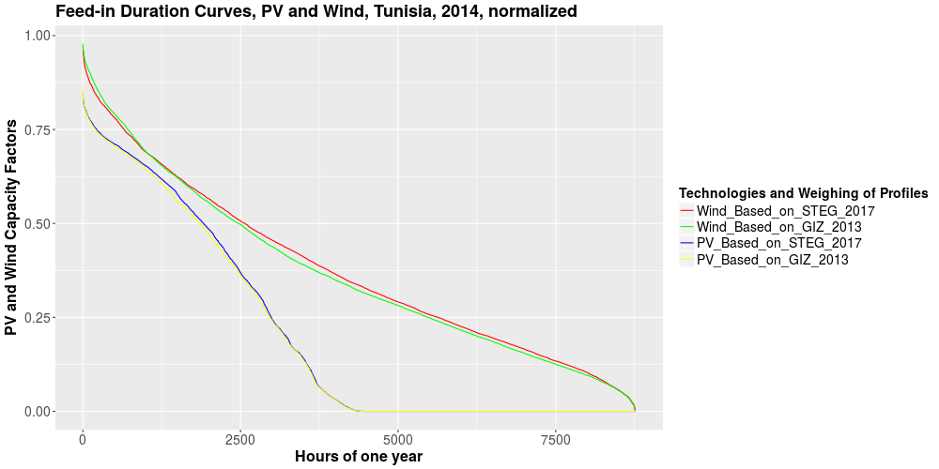Figure 23: Duration curves for PV and wind feed-in time-series simulated for 2014 weather data capacity-weighted by different sites and respective potential capacities. Source: Own composition based on information by GIZ (2013) and Ibrahim, A. (2017).
For reasons of overview and testing of variability exemplary weeks of the feed-in profiles are shown in Figure 24.
In order to choose timesteps especially relevant for modeling the Tunisian electricity sector, a residual load curve will be synthesized. Normalized feed-in profiles will be chosen from the given PV and wind feed-in profiles based on STEG's 2020 projects (red and blue graphs in Figure 23). To calculate absolute electricity PV and wind feed-in from normalized profiles, planned 2025 installed capacities based on ANME (2015) – the Tunisian Solar Plan – are taken representing 1305 MW wind capacity and 943 aggregated PV capacity (centralized and decentralized).
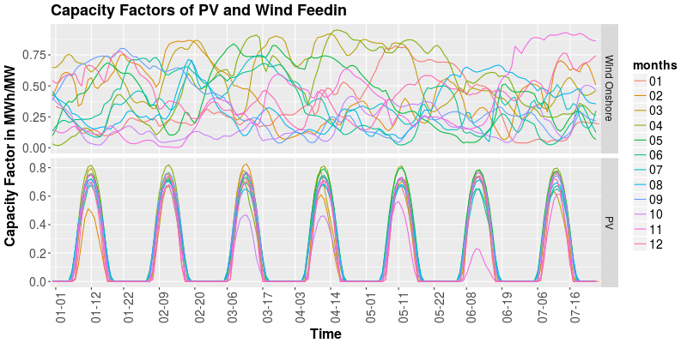Figure 24: Overview on feed-in series for wind onshore and PV for the first week of each month. Source: Own depiction, synthesized data based on Pfenninger, S. et al. (2017c).
Figure 25 depicts the synthesized composition of a residual load profile. The figure shows the load duration curve for the load profile from 2010, synthesized wind and PV feed-in duration curves for installed capacities based on the Tunisian Solar Plan and the evolving residual load profile. It can be noted that in a few hours of the year the LDC reaches negative values indicating a higher PV and wind feed-in than the national Tunisian load. The residual load duration curve is slightly steeper but has a more regular shape. Although this synthesized residual load profile only depicts a modeled residual load in this case PV and wind feed-in contribute to lowering peak demand by approximately 800 MW.
For the calibration of the model only the four days where maximum load in that season occurs (all mid-day peaks) are taken into account regardless of potential PV and wind feed-in. Table 17 Gives an overview of the chosen days.
Season | Month | Day | Lowest Load (MW) | Peak, Mid Day (MW) | Peak, Evening (MW)
Summer | 7 | 23 | 1885 | 2986 | 2658
Winter | 12 | 28 | 1277 | 1980 | 2225
Intermediary | 6 | 10 | 1402 | 2310 | 2250
Ramadan | 8 | 20 | 1720 | 2670 | 2490
Table 17: The four days with peak demand for each season. For the intermediary season there are two days with the same peak demand (June, 10th and June, 11th). June 10th is chosen because the evening peak is 32 MW higher. Source: Own composition based on data by GIZ.
 | Modeled “full load hours” in MWh / MW |  |  | Capacity factors
Tech-nologies | Seasonal Peak Days (96 hours) | Seasonal Peak Days plus two adjacent days (288 hours) | Full Year 2014 (8760 hours) | Seasonal Peak Days (96 hours) | Seasonal Peak Days plus two adjacent days (288 hours) | Full Year 2014 (8760 hours)
PV utility sclae | 21 | 61 | 1801 | 0.219 | 0.212 | 0.206
PV de-centralized | 21 | 61 | 1801 | 0.219 | 0.212 | 0.206
CSP collector field | 21 | 61 | 1801 | 0.219 | 0.212 | 0.206
Wind Onshore | 38 | 112 | 3296 | 0.396 | 0.389 | 0.376
Table 18: Full load hours and capacity factors for different time modeling methodologies. Source: Own depiction.

Cost Data
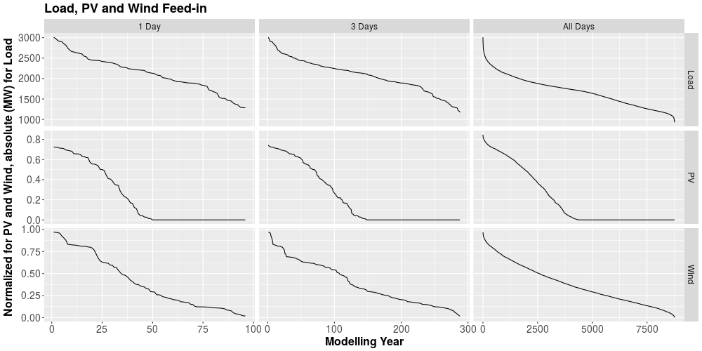Figure 25: Comparison of Load, PV and Wind duration curves for the days in each season where maximum load occurs (left column), this day plus the two surrounding days (middle column) and the duration curves for the whole year. Source: Own composition on the basis of GIZ (2010) and Pfenninger, S. et al. (2017c).
The cost data is among the most sensitive data for the three chosen tasks since all of these refer to economic costs in some way and aim at optimizing total system cost. The cost data has been compiled based on ANME (2015), Breyer, C. Et al. (2017), Brand et al. (2014), Godron, P. et al. (2012), Klose, T. et al. (2013), STEG (2015) and Waissbein (2016).
For the utilization of cost data in the model, all data shown in this chapter is calculated to 2016-€ as described in the following. In order to account for both, the difference in value of a single currency in between years on the one hand and the difference in values of different currencies (mostly US-Dollar) on the other hand exchange and inflation rates had to be taken into account. The formula that was utilized for calculating 2016-€ is given by equation 22.
Figure 27 shows capital expenditure cost (including financial cost) for the three natural gas power plant technologies under assessment in this case study. The costs were discussed and validated by GIZ Tunisia staff at the validation session in June 2017. By the time of the validation session, the modeling horizon was still sought to be 2050 which was decreased to 2040 afterwards. Some graphs in this chapter will still contain numbers reaching up to 2050.
Currencies | Year | Exchange Rate | Source | Remarks
€/USD | 2008 | 0.683 | https://photos.state.gov/libraries/france/5/irs/erates.pdf | Annual average of exchange rates
€/USD | 2009 | 0.719 | Ibid. | Annual average of exchange rates
€/USD | 2010 | 0.785 | https://www.irs.gov/individuals/international-taxpayers/yearly-average-currency-exchange-rates | Annual average of exchange rates
€/USD | 2011 | 0.748 | ibid. | Annual average of exchange rates
€/USD | 2012 | 0.809 | Ibid. | Annual average of exchange rates
€/USD | 2013 | 0.783 | Ibid. | Annual average of exchange rates
€/USD | 2014 | 0.784 | Ibid. | Annual average of exchange rates
€/USD | 2015 | 0.937 | Ibid. | Annual average of exchange rates
€/USD | 2016 | 0.94 | Ibid. | Annual average of exchange rates
Table 19: Exchange rates utilized in this thesis to calculate all costs in 2016-€. Source: Own composition based on sources given in the table.

Years | Inflation Rate in % | Source | Remark
€ 2008 → € 2016 | 11.03 | http://fxtop.com/en/inflation-calculator.php?A=1&C1=EUR&INDICE=EUCPI2005&DD1=01&MM1=01&YYYY1=2014&DD2=01&MM2=01&YYYY2=2016&btnOK=Compute+actual+value | From 1.1.2008 to 1.1.2016
€ 2010 → € 2016 | 8.32 | Ibid. | From 1.1.2010 to 1.1.2016
€ 2012 → € 2016 | 3.14 | Ibid. | From 1.1.2012 to 1.1.2016
€ 2014 → € 2016 | 0.06 | Ibid. | From 1.1.2014 to 1.1.2016
€ 2015 → € 2016 | 0.23 | Ibid. | From 1.1.2015 to 1.1.2016
Table 20: Inflation rates for calculating 2016-€ utilized in this thesis. It has to be noted that all inflation rates were taken as specific rates between January, 1st of each year. This may lead to significant errors when costs are documented in certain annual values but no precise date is given. However since the minority of authors document specific days for the value of the currency in which they calculate prices this methodology seems to be feasible. Source: Own composition on the basis of source given in the table.
(22)

Figure 26 depicts documented costs for onshore wind projects with different spatial references. In yellow triangles cost assumptions from the MOREMix project carried out by DLR and GIZ in 2015-2016 are shown. The red diamonds show numbers from STEG. The assumed cost development covers both the range given by STEG (although it is rather conservative in that range) but also lies within numbers for Europe. The CAPEX for onshore wind assumed here are slightly lower than in the MOREMix project.
Utility scale PV cost assumptions regarding its CAPEX are depicted in Figure 28. Kern, J. et al. (2017) give ranges for PV capital costs that are shown in red diamonds in the figure. The cost assumed in this thesis lie higher than the maximum CAPEX given by Kern, J. Et al. (2017) thus accounting for cost assumptions given by STEG for the specific Tunisian case.
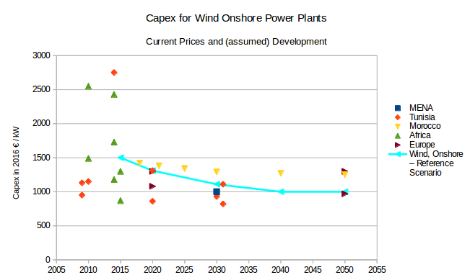Figure 26: Documented cost and assumed capital expenditure for wind onshore power plant technology. Source: Own composition on the basis of Breyer, A. et al. (2017), Brand, B. et al. (2014), STEG (2014), Kern, J. (2017) and IRENA (2014).
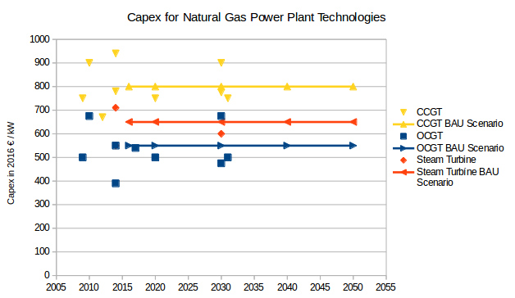Figure 27: CAPEX cost as described by other sources and assumed development of capital expenditure for natural gas power plant technologies. Source: Own Composition based on data from Breyer, A. et al. (2017), Brand, B. et al. (2014), STEG (2014), Kern, J. (2017) and Godron, P. (2012).

As stated in chapter 3.3.1.2, OSeMOSYS only provides the possibility to input capital cost in k€/MW, fix OPEX in k€/(MW*a) and variable OPEX in k€/MWh. Units can be chosen by the modeler. A separate input of fuel cost is only implicitly possible by inserting a supply-technology for natural gas and given it the variable cost corresponding to the natural gas price. However, here fuel cost are calculated within variable cost of fossil fuel power plants.
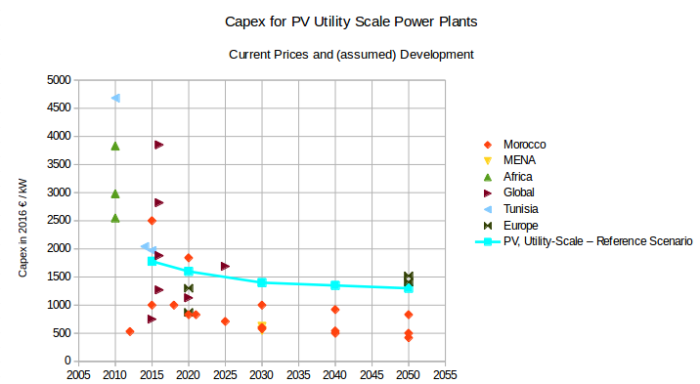Figure 28: Documented cost and assumed CAPEX development for PV utility scale. Source: Own composition on the basis of Breyer, A. et al. (2017), Brand, B. et al. (2014), STEG (2014), Kern, J. (2017) and IRENA (2014).
In 1000 2016-€ | 2015 | 2020 | 2025 | 2030 | 2035 | 2040
CCGT | 15 | 15 | 15 | 15 | 15 | 15
CSP | 60 | 60 | 60 | 60 | 60 | 60
Hydro RoR | 40 | 40 | 40 | 40 | 40 | 40
OCGT | 8 | 8 | 8 | 8 | 8 | 8
PV Dec. | 12 | 12 | 12 | 12 | 12 | 12
PV US. | 12 | 12 | 12 | 12 | 12 | 12
Steam Turbine | 12 | 12 | 12 | 12 | 12 | 12
Wind Onshore | 25 | 25 | 25 | 25 | 25 | 25
Table 21: Fixed cost for different power plant technologies. Source: Breyer, C. et al. (2017), Kern, J. et al. (2016) and IRENA (2014).
In 1000 2016-€ | 2015 | 2020 | 2025 | 2030 | 2035 | 2040
CCGT | 800 | 800 | 800 | 800 | 800 | 800
CSP | 4230 | 3930 | 3810 | 3570 | 3300 | 3000
Hydro RoR | 1570 | 1570 | 1570 | 1570 | 1570 | 1570
OCGT | 550 | 550 | 550 | 550 | 550 | 550
PV Dec. | 2630 | 1750 | 1460 | 1170 | 1090 | 1000
PV US. | 1780 | 1600 | 1500 | 1400 | 1350 | 1300
Steam Turbine | 650 | 650 | 650 | 650 | 650 | 650
Wind Onshore | 1500 | 1310 | 1210 | 1110 | 1055 | 1000
Table 22: Capital cost assumptions for different power plant technologies. Source: Own Composition based on multiple sources and validation session.
In 1000 2016-€ | 2015 | 2020 | 2025 | 2030 | 2035 | 2040
CCGT | 0.0355 | 0.0313 | 0.0379 | 0.0459 | 0.0482 | 0.0505
CSP | 0.0525 | 0.0468 | 0.0566 | 0.0684 | 0.0718 | 0.0753
Hydro RoR | 0 | 0 | 0 | 0 | 0 | 0
OCGT | 0.0681 | 0.0572 | 0.0665 | 0.0777 | 0.0773 | 0.0771
PV Dec. | 0 | 0 | 0 | 0 | 0 | 0
PV US. | 0 | 0 | 0 | 0 | 0 | 0
Steam Turbine | 0.0516 | 0.0459 | 0.0557 | 0.0675 | 0.0708 | 0.0744
Wind Onshore | 0.1 | 0.1 | 0.1 | 0.1 | 0.1 | 0.1
Table 23: Variable operational expenditures as assumed in this thesis. Source: Own composition based on Breyer, C. et al. (2017), Kern, J. et al. (2016) and IRENA (2014).
All assumptions regarding capital costs and operation and maintenance costs are shown in Figure 16 with capital cost in the top facet, fixed O&M cost in the middle and variable cost (including fuel cost).

Modeling Preparation and Calibration
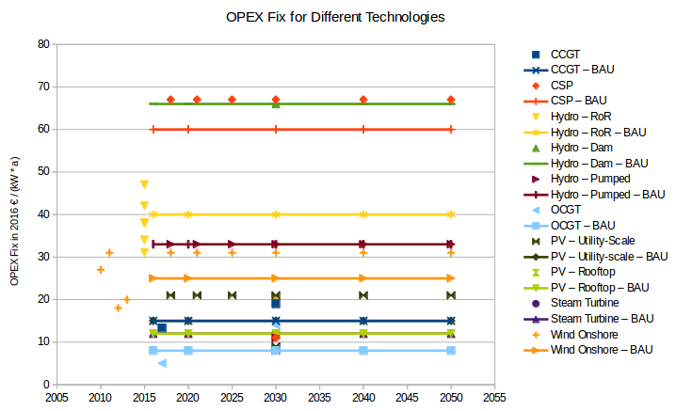Figure 29: Documented and assumed fixed operational expenditures for different power plant technologies. Utility-scale PV fix OPEX: 15 €/(kW*a), PV-decentralized fix OPEX: 12 € / (kW*a). Source: Own depiction on the basis of Breyer, A. et al. (2017), Kern, J. (2017) and IRENA (2014).
In order to assure that the model under assessment is capable of describing processes and developments of the Tunisian power system (power plant expansion and dispatch) realistically it has to be calibrated. DeCarolis, J. Et al. (2017) state that calibration is „an iterative process of refinement to ensure plausible results.“ [DeCarolis, J. Et al. (2017), p. 191]. This iterative nature is also applied throughout the course of this thesis with the starting point being a comparison between two power plant dispatchs at examplatory days (STEG: 2012-07-11, own model: modeled days given in Table 5).
Figure 31 depicts the national power plant dispatch of the Tunisian power system differentiated in specific power plants. „IPP“ refers to the power plant Rades II that is operated by the independent power producer Carthage Power Co SARL (CPC) under a power purchase agreement (PPA) with STEG and is a CCGT power plant.
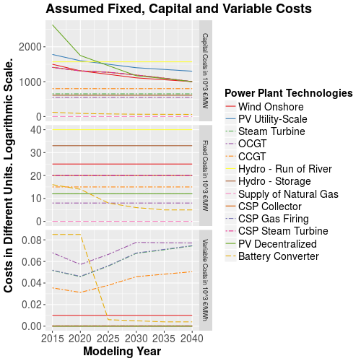Figure 30: Depiction of all costs of power plant technologies assumed. Source: Own composition.
Figure 32 depicts the results of model run MR1_0i_calibration. Four seasonal days with maximum electricity demand within the respective season were taken as a basis for the calculation. It can be seen that in 2015 the steam turbine power plants are not utilized to the degree that they are in the depiction from STEG. OCGT power plants are hardly ever utilized due to their low efficiency. This shows a limitation of the optimization model. Since technical flexibility aspects are not integrated, every power plant type can cycle up and down at any speed (see below in the full year model runs in task 1 XXX figure reference). The additional cost of reduced cycling and higher fluctuations of natural gas power plants' output is not calculated in the model and thus it only represents a certain part of the real Tunisian power system.
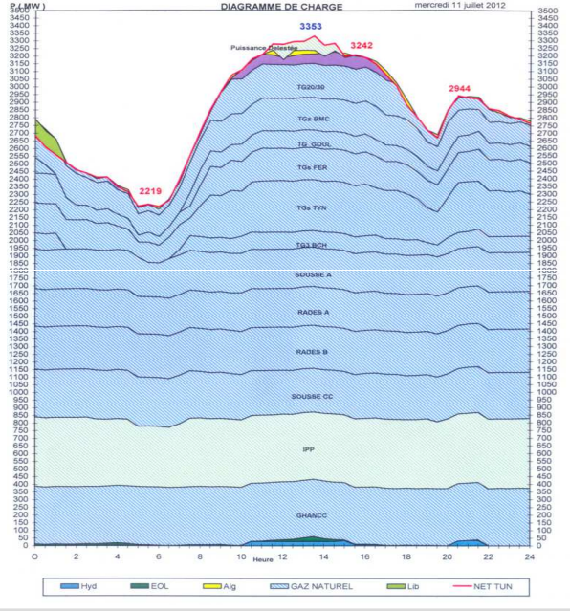Figure 31: National power plant dispatch in Tunisia for July, 11th, 2012 which was the day with the annual peak electricity demand. On the very bottom there are hydro and wind feed-in. The three power plants above (GhanCC, IPP and Sousse CC) are the CCGT capacities of Tunisia. IPP refers to the Rades II power plant that is operated by Carthage Power Co sarl. (CPC). Following there are the three big steam turbine plants Sousse A, Rades A and Rades B with a cumulated capacity of approximately 1 GW. The flexible OCGT plants can be seen starting from the end of Sousse A upwards. On top of the power plant dispatch, power export and import from and to Algeria can be seen as well as two unspecified electricity sources that seemingly have a PV feed-in characteristic. Source: STEG (2014).
Figure 33 shows the assumed electricity demand development within the modeling timeframe based on Tunisia's national electricity load profile from 2010. Absolute annual load values develop in compliance with assumptions shown in Table 13 and Table 14.
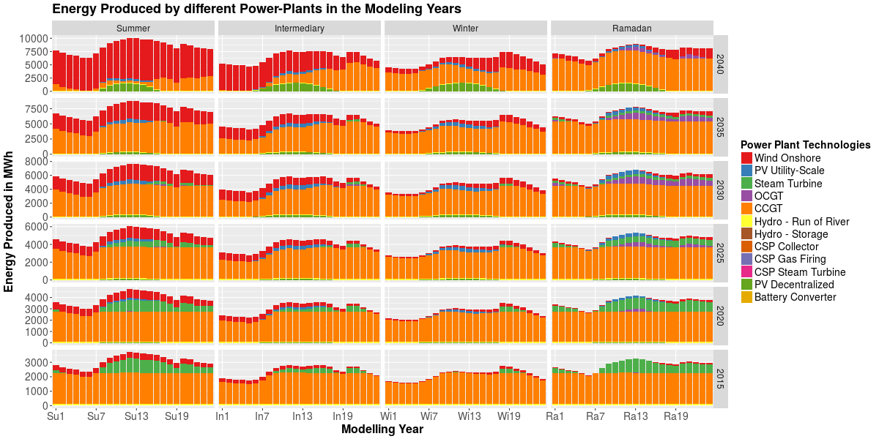Figure 32: Output of model run MR1_0i. Electricity production profiles for each power plant technology in each Timeslice for the four seasonal days where maximum electricity demand occurs (in 2010 national profile). Source: Own depiction.
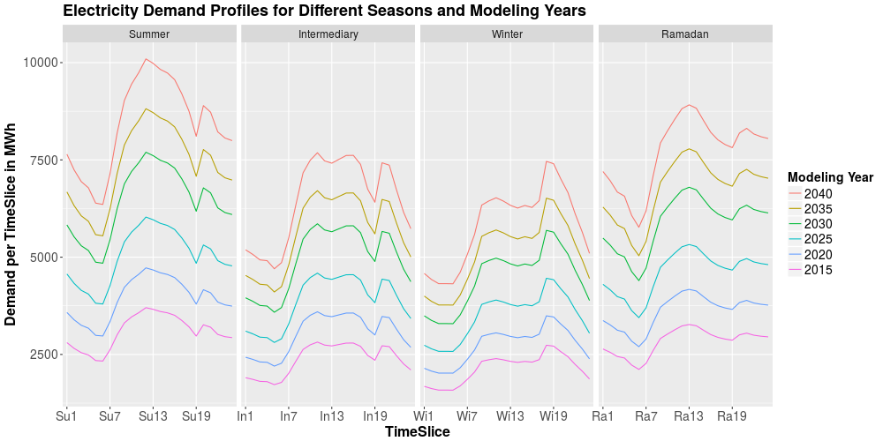Figure 33: Depiction of model input for model run MR1_0i. Assumed electricity demand development based on data by GIZ and own assumptions regarding annual demand development.
Figure 34 shows the model output with regard to the installed capacities of different power plant technologies. They are differentiated between residual capacities left over from before the beginning of the model period and added capacities by the cost-optimal power plant expansion carried out by the model. The figure shows that the two major technologies whos capacities are expanded are CCGT power plants and onshore wind power plants. Utility scale PV is only expanded in accordance with externally given minimum expansion targets (Tunisian Solar Plan) until 2030 and not further expanded afterwards. Decentralized PV is expanded in correspondence with RE targets until 2030, no further expansion is carried out in 2035 and then a high expansion of above 1500 MW is carried out for the modeling year 2040 which is probably due to its assumed sharply decreased costs of 1000 €/MW in 2040. Wind is continuously expanded above exogenously given VRE targets. From year 2035 to 2040 the installed wind capacity more than doubles from almost 3 GW to almost 8 GW installed capacity due to the same effect described for the case of decentralized PV. Its capital costs decrease to the same value of 1000 €/MW in 2040. Because of higher capacity factors for wind during the modeling period (see Table 18).
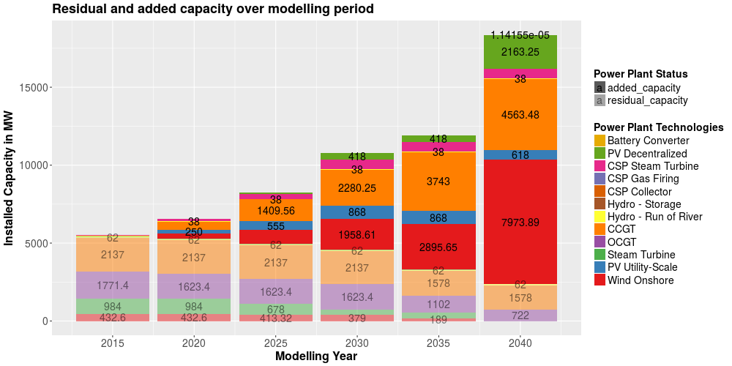Figure 34: Depiction of model output for MR1_0i. Installed capacities of different power plant technologies differentiated in residual and newly added capacities. Source: Own composition.
Figure 35 depicts the produced electricity of different technologies during the modeled snapshot. CCGT is the major source of electricity production. Electricity production from wind power plants continuously increases independently from exogenously given VRE targets. The increase step in capacity from 2035 to 2040 is also mirrored in the electricity production that increases from 118 GWh in to over 300 GWh in 2040. There is some electricity production from PV utility scale reaching 18 GWh in 2030. Decentralized PV production has a major contribution to the electricity mix in 2025 and 2040 the latter of which also mirroring steep installed capacity increases due to assumed cost decreases. In opposition, CCGT production decreases from 2035 to 2040 from 420 GWh in 2035 to slightly above 300 GWh in 2040. In the years until 2030 steam turbine produce some electricity but as can be seen in Figure 34 capacities aren't expanded and thus only residual capacities are utilized. OCGT plants are not expanded as well but higher residual capacities are still available towards the end of the modeling period resulting in some but almost negligible contributions in the years 2030-2040. Hydro power production in year 2030 strongly exceeds installed capacities (100 MW equals maximum 9600 MWh production within the modeling scope) suggesting power plant production in the Dummy Timeslice.
Below in Figure 36 hourly dispatch for the four days in the respective seasons are shown for all modeling years. The presumption that hydro production in 2030 stems from hydro production within the Dummy Timeslice can be confirmed based on Figure 36 where electricity production in the 96 Timeslices never exceeds capacity limits (it is able to do so because the Dummy Timeslice lasts for the rest time of the year – 8664 hours and electricity production from hydro isn't modeled via capacity factors).
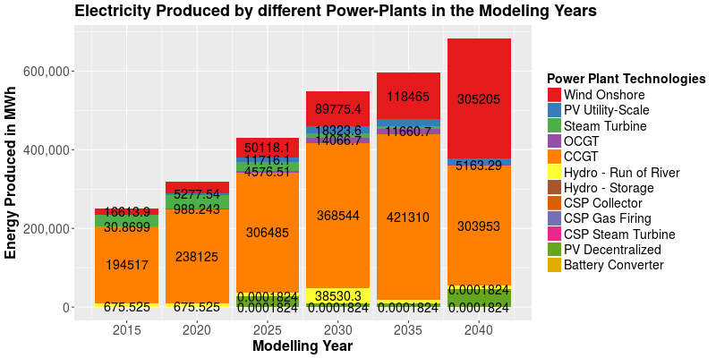Figure 35: Depiction of model output for MR1_0i. Power Plant Production in the modeled snapshot (four seasonal days). Source: Own composition.
The figure also shows how OCGT and steam turbine production during mid day peak times get replaced by decentralized and utility scale PV production to some degree while low wind days (such as seen in Ramadan) in 2040 OCGT turbines are still utilized for the evening peak which mainly stems from assumed residual OCGT capacities of 722 MW in 2040.
The main reason for the differences between technology production profiles resulting from the model runs in opposition to the power plant dispatch by STEG (Figure 31) stems from Tunisia's CCGT capacity expansions during the period 2012-2015. STEG's annual report form 2015 shows installed capacities amounting to 789 MW in 2013 and more than doubling up to 1639 MW in 2015. ONE (2016) suggests an installed capacity of 2110 MW of CCGT in 2015 [ONE (2016), p. 21]. In this study values given above (Table 11) are assumed amounting up to 2137 MW of CCGT installed capacity. The difference to the installed capacities in 2012 are one of the main reasons of the difference in the power plant dispatch from the given dispatch from STEG for the year 2012. However, another issue that will play a role in the case study is the missing modeling of ramping constraints that can already be presumed from Figure 36 but will be shown more severely below.
Ammendments regarding the dispatch during the Dummy Timeslice are given in chapter 3.3.1.3. Further model preparations are shown utilizing 3 days per season with two days adjacent to the seasonal peak load days in MR1_1 to MR1_1c.
Figure 36: Depiction of model output for model run MR1_0i. Hourly production of each power plant technology in each year and season. Source: Own decomposition.
Time-dependent model input of MR1_1 is shown in Figure 37 and Figure 38. Since the day of peak electricity demand in summer in the year 2010, July, 23rd is a friday the peak demand as well as the total demand on the consecutive day, Saturday decreases. Demand profiles for the three other seasons are fairly stable.
In Figure 38 capacity factor series are shown based on Pfenninger, S. et al. (2017c). The inter-seasonal variability is not very strong. Surprisingly Winter and Summer peak feed-ins are almost on the same level at ~0.7.
Figure 39 shows the expansion of new power plant capacities. In opposition to all other scenarios, the CSP steam turbine is forced into the power system reaching further behind the targets of the Tunisian Solar Plan. This leads to increased cost. Also even the forced CSP steam turbine capacities don't evoke an expansion of the CSP collectors or CSP gas firings in order to make use of the installed capacities.
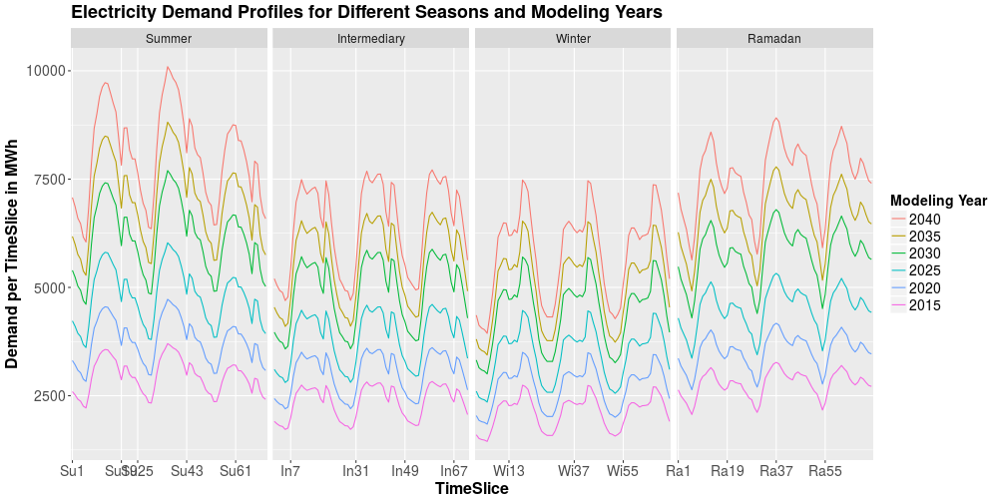Figure 37: Depiction of model input for MR1_1. Absolute demand profiles for 72 hours around seasonal electricity demand peak differentiated in seasons and modeling years. Source: Own composition.
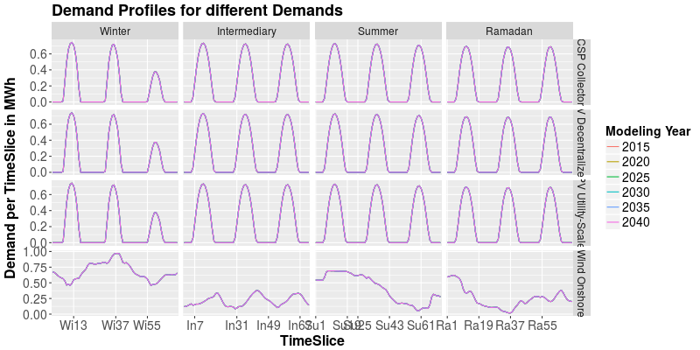Figure 38: Depiction of model input for MR1_1. Series of capacity factors for different seasons and technologies. Source: Own composition based on Staffell, I. et al. (2017).
It can also be noted that wind capacities dramatically increase to 6 GW, decentralized PV expands to over 1.5 GW which is especially due to a strong increase in the last model year (2040). Utility scale PV is not expanded beneath the minimum forced capacity, aas described above. Decentralized PV and utility scale PV are assumed to have the same fixed cost (12 k€ / (MW*a)) and no variable cost. The only differentiating factor is the relation of capital cost. While decentralized PV is assumed to be very expensive in 2015 (2630 k€ / MW for decentralized PV vs. 1780 k€/MW for utility-scale PV) its cost decrease is assumed to be more rapid than for utility scale PV (decreasing to 1000 k€/MW in 2040 vs. 1300 k€/MW for utility-scale PV).
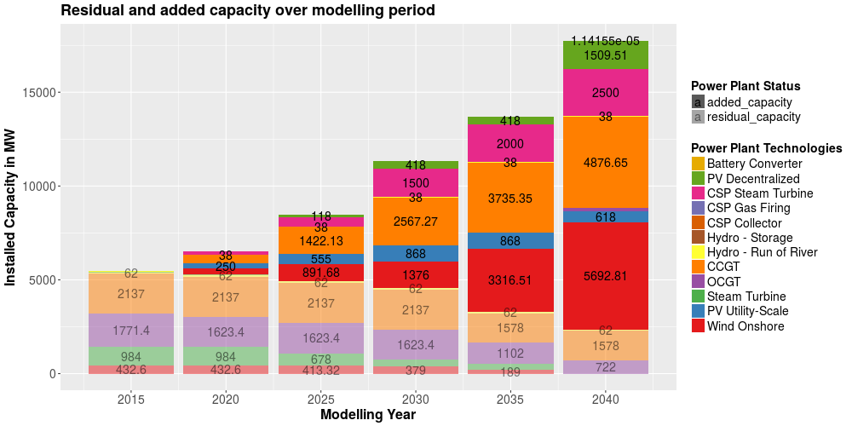Figure 39: Depiction of model output for MR1_1. Installed capacities for all power plant technologies. Source: Own composition.
This assessment shows the need to on the one hand assess capital cost of the two technologies more deeply considering e.g. different interest rates and costs for risks and on the other hand to increase the spatial resolution of the analysis towards distribution (low and medium voltage) grids where the potential PV plants are connected to. Also, as the capacity factor series shown in Figure 38 seems to be implausibly similar even throughout the seasons, more valid (and validated) feed-in profiles should be utilized.
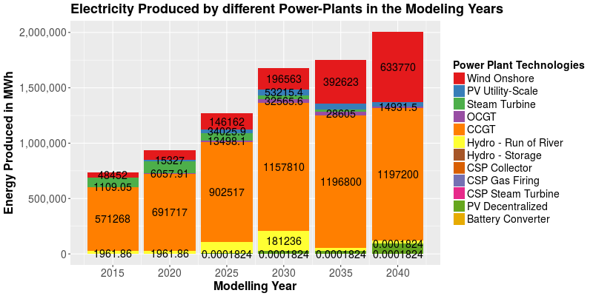Figure 40: Depiction of model output of MR1_1. Electricity production by power plant technologies and modeling years. Source: Own composition.
The implausibly high hydro feed-in in the years 2025 and 2030 (maximum production would be 28800 MWh for the snapshot) stem from the RE target of 30% in 2030 as described above.
The vast majority of power production shown in Figure 40 stems from the cheapest option – CCGT that accounts only to roughly 6.5 GW of almost 18 GW total installed capacity but produces more than half of the electricity production of Tunisia revealing VRE's influence of lower capacity factors to the ratio installed capacity to produced electricity.

Model Runs
A decisive syntax is used to identify different model runs. An overview over the different model runs can be found in Table 30 (Appendix).

Task 1: Assessment of Magnitude of Share of Different VRE Options in Cost-Optimal Expansion Pathways
As noted by Brand, B. et al., one of the key uncertainties in within power systems in the MENA region is the magnitude of different VRE technologies [Brand, B. et al. (2015)]. Since there have been a lot of works regarding the comparison between onshore wind and PV integration potential the latter has not been differentiated by any of the sources mentioned in chapter 2.3.1. Usually commercial or utility scale PV power plants tend to have lower specific financing costs since risks are lower. However the successful program PROSOL-ELEC in Tunisia providing grants to households in order avoid large upfront investments shows that when these additional costs of risks can be diminished rooftop PV has a big potential. In Tunisia, the feed-in to the grid by rooftop-PV systems is strictly regulated by a standardized PPA limiting the amount of electricity that can be fed into the grid to 30% of the overall annual consumption.
Despite the assessments that installing a PV panel using this net-metering scheme under PROSOL-ELEC pays off more the higher the consumption is from the start and thus benefits high consumption households the most the program is one of the first ones in Tunisia to carefully increase the share of decentralized power plants.
Input parameters to the first model run with regard to cost, load profiles and feed-in series for VRE technologies are the same as for the calibration model runs MR1-0 already depicted in Figure 30, Figure 37, Figure 38. The demand is linearly scaled assuming that the peak demand increases with the same rate as the total annual demand. However, Figure 33 shows that the demand curve gets more variable because of this tendency. Peak load occurs in summer with a high mid-day and a fairly low evening peak suggesting a high degree of correlation with PV feed-in profiles. The peak day in Ramadan shows a slightly smoother curve than in summer but with similar characteristics. The load profile in the intermediary season (end of spring in this case) shows a very wide mid-day peak and an evening peak that is almost as high. For the load in winter a stronger evening peak can be observed because air-conditioning isn't used during the winter days as much as in summer. Both the height of the evening peak and the total daily power consumption are significantly lower in winter than in summer.
The Tunisian VRE targets given in the Tunisian Solar Plan in its version from 2015 are assumed to be exogenously set constraints.
 | PV Utility Scale | PV De-centralized | CSP | Wind Onshore | Electricity Production from VRE
Unit | MW | MW | MW | MW | % (of MWh)
2015 | 0 | 30 | 0 | 245 | 4
2020 | 250 | 155 | 0 | 775 | 14
2025 | 555 | 302 | 150 | 1305 | 24
2030 | 868 | 642 | 450 | 1755 | 30
Table 24: Tunisian targets of VRE power plant capacity expansion and part of electricity production at the national electricity production. Source: ANME (2015) and Detoc, L. (2016).
Results for the first model run are shown in the following.
Figure 41 shows the optimal expansion pathway for different power plant technologies for the input parameters described and depicted above. Some trends from calibration model runs are reoccuring. Wind and decentralized PV are expanded in large quantities in the modeling year 2040 although the increase from 2035 to 2040 is not as sharp as before the model calibration. Hydro expansion is limited to 100 MW (based on the validation session [Schweinfurth, A. et al. (2017)]) and the potential is fully tapped. CSP technologies are expanded to the minimum degree forced by the political target of the Tunisian Solar Plan. The same holds true for utility scale PV. CCGT and wind are the main power plant technologies with 4.9 and 5.7 GW installed capacities respectively.
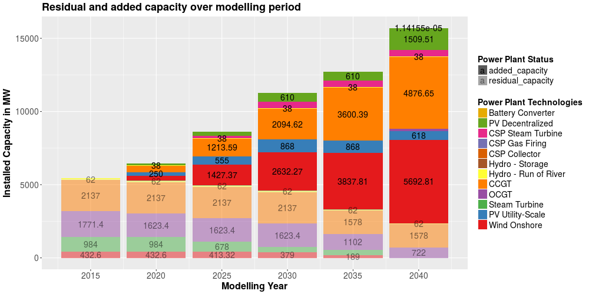Figure 41: Depiction of model output for MR1_1c. Installed capacities in the modeling years differentiated in residual and added capacities as well as different power plant technologies. Source: Own composition.
Figure 42 depicts electricity production within the modeled snapshot based on the installed capacities given in Figure 41. Electricity production from onshore wind power plants is constantly increasing from almost 50 GWh in 2015 to reach 633 GWh by 2040. Utility-scale PV capacities are utilized especially in 2030 (34 GWh) where a 30% VRE electricity constraint is set but also in 2035 and 2040 with the remaining capacities. Steam turbine and OCGT power plants contribute in some way to the electricity production but get consecutively replaced by utility scale PV as residual steam turbine capacities phase out until 2030 and VRE capacities increase. Electricity production from CCGT power plants doubles from almost 60 GWh in 2015 to slightly below 120 GWh in 2040 during the snapshot.
The power plant dispatch is given in detail for each Timeslice in Figure 43. In the years 2015 to 2025 the power plant dispatch is mainly shaped by the natural gas power plants with mainly electricity production from CCGT (ranging from XXX to XXX) but also some contributions from steam turbine and OCGT power plants especially in Summer (Ramadan was also in Summer in 2010 – compare Figure 19) when electricity demand exceeds CCGT capacities. The role of residual OCGT capacities is decreasing throughout the modeling scope but they are nontheless still contributing to a fairly low degree in 2040's Summer and Ramadan dispatch.
The role of electricity production from onshore wind significantly increases throughout the modeling scope. While it remains fairly low in the modeled days of the intermediary season and Ramadan (the capacity factor series is quite low here – compare Figure 38), it supplies up until 100% of electricity demand in winter due to low demand and high feed-in.
PV feed-in contributes to the electricity mix and smoothes the load duration curve especially in summer where peak demand occurs at mid-day. Significant contributions can be seen in 2040 where total PV installed capacity amounts to over 2 GW. Regarding the technology choice between utility scale and decentralized PV feed-in the model chooses decentralized PV feed-in before utility scale feed-in in 2040. Before both options are not part of the cost-optimal power plant technology choices and capacities are only increased due to exogenously given VRE targets. Since variable costs of both technologies are assumed to be negligible and fix costs are assumed to be of the same value, only capital costs define which technology is chosen. Decentralized PV capital costs are assumed to fall beneath utility scale capital cost between 2020 and 2025.
Cycling times of CCGT power plants are significantly reduced in the cost-optimal dispatch in the years beneath 2030 due to lower costs of VRE options. Especially when wind feed-in is high this can lead to situations in 2040 where CCGT power plants are not part of the cost-optimal dispatch. In 2040 CCGT power plants are used to fill the gaps of VRE feed-in. Nevertheless, as shown in Figure 42 they still amount to the majority of electricity supply.
Regarding the ramping of natural gas power plants that are not modeled, Figure 43 shows that critical ramping times occur for example in summer 2040 where CCGT are dispatched with around 3000 MW at night and a dispatch increase to around 6000 MW within 3 hours. Kern, J. et al. (2017) assume ramping rates of up to 30 MW/min for newly built CCGT power plants showing that model results are still in the range of technical possibilities especially for power plants in 2040 which can be assumed to be more flexible than nowadays CCGT power plant technologies. Still, a full year should be modeled to thoroughly assess cycling times and ramping rates for found installed capacities in the cost-optimal power plant dispatch.
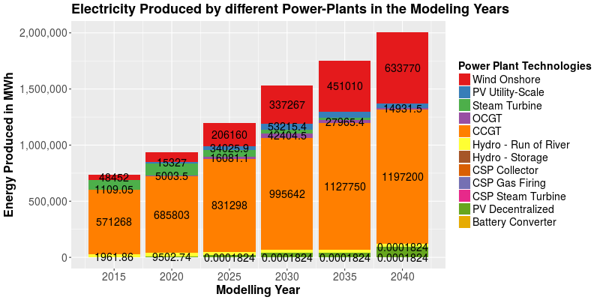Figure 42: Depiction of model output of MR1_1c. Electricity production during the modeled snapshot for each technology in the modeling years. Source: Own composition.
To analyze main differences between power plant expansion of wind onshore, utility-scale PV and rooftop PV, OSeMOSYS is capable to differentiate between feed-in profiles and capital cost developments. As stated above, feed-in profiles taken from Pfenninger, S. et al. (2017) seem not to fully represent the variability of real VRE power plants feed-in profiles (compare Figure 24). Also regional differences such as correlations between VRE feed-in and the regional load can not be analyzed with the singlenode model utilized in this thesis. However, the effect of capital cost, that is the main driver of expansion decision amongst different PV options as well as the low demand and high demand scenarios are assessed below.

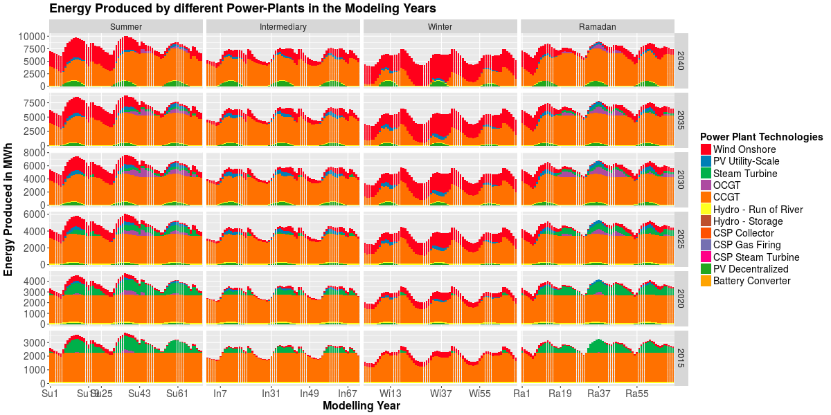Figure 43: Depiction of model output for model run MR1_1c. Power plant dispatch for 3 days each season. Source: Own composition.

Figure 44, Figure 45 and Figure 46 show the results of a literature study of capital expenditures for the three VRE options. Most of the data for Tunisia is by Brand, B. et al. and STEG [Brand, B. et al. (2014) & STEG (2014)]. Data for the MENA region is taken from Breyer, C. et al. [Breyer, C. et al. (2017)]. Data for Morocco where similar patterns regarding capacity factors of VRE occur, is given by Kern, J. et al. [Kern, J. et al. (2016)]. Where data or forcasts by STEG are available (such as shown in Figure 44 for the years 2008, 2020 and 2031), provided minimum values will be taken. Maximum values will be assumed lower than STEG's assumptions since these are cost estimates from 2014 and as Taylor, M. et al. state, costs for rooftop PV in Tunisia have fallen from its high costs of 5165 €/kW in 2010 to 2442 €/kW in 2014 and were assumed to continue its decline to 1972 €/kW in 2015 (costs converted to 2016-€ from 2015-USD/W).
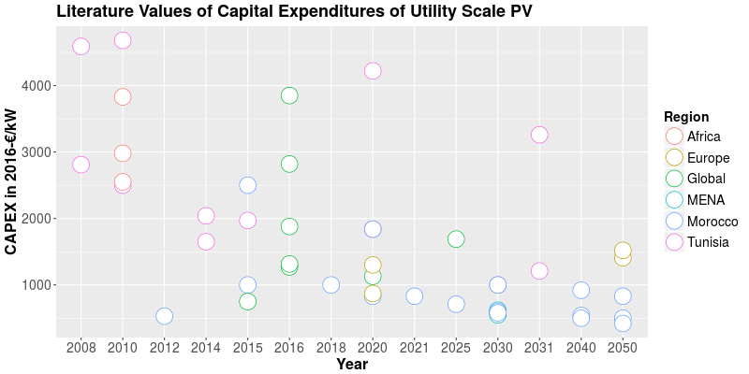Figure 44: Literature values for Capital Expenditures of utility-scale PV power plants in different regions. X-axis is not continuous. Sources: Breyer, C. et al. (2017), Kern, J. et al. (2016), Brand, B. et al. (2014), STEG (2014), Taylor, M. et al. (2016b), Feldhaus, P. et al. (2010).
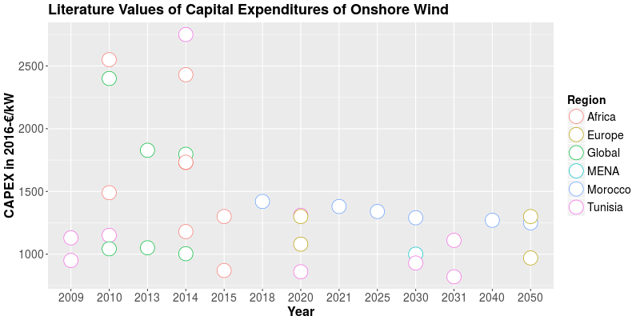Figure 45: Literature values for Capital Expenditures of Onshore Wind power plants in different regions. Sources: Breyer, C. et al. (2017), Kern, J. et al. (2016), Brand, B. et al. (2014), STEG (2014), Taylor, M. et al. (2015), Taylor, M. et al. (2016b), Feldhaus, P. et al. (2010).
For decentralized PV, data from Tunisia for the years 2010-2015 is shown in Figure 46 based on a presentation by Gager, E. Prospects for the development of decentralized PV in the MENA region are available from Breyer, C. et al. and Kern, J. et al (for Morocco). These are assumed as they appear to plausibly extend the decreasing trend in investment cost for decentralized PV.
Assumed extreme values are given in Table 25. The sensitivity runs are carried out by adjusting only the CAPEX development for one of the three VRE technologies. This is repeated for each column from Table 25.
Regarding different levels of annual load, the following values will be utilized for sensitivity analysis utilizing a ratio of the snapshot electricity demand to the annual electricity demand of 0.04 based on Table 9.
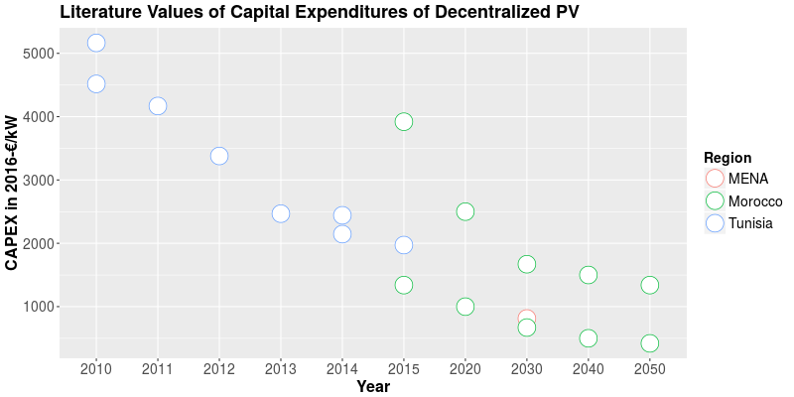Figure 46: Literature values for Capital Expenditures of decentralized PV power plants in different regions. X-axis is not continuous. Sources: Gager, E. (2016), Breyer, C. et al. (2017), Kern, J. et al. (2016), Taylor, M. et al. (2016b).
Cost in k€/MW | Wind |  | PV Utility Scale |  | PV Decentralized
Cost in k€/MW | Lower Value | Upper Value | Lower Value | Upper Value | Lower Value | Upper Value
2015 | 910 | 2000 | 2325 | 4410 | 2000 | 3920
2020 | 860 | 1400 | 1840 | 4220 | 1000 | 2500
2025 | 840 | 1250 | 1530 | 3740 | 830 | 2100
2030 | 820 | 1110 | 1210 | 3260 | 670 | 1670
2035 | 800 | 1020 | 950 | 2850 | 570 | 1580
2040 | 800 | 1000 | 700 | 2500 | 500 | 1500
Table 25: Assumed lower and upper limitations for CAPEX of onshore wind, utility-scale PV and decentralized PV. Source: As above and own assumptions.
Modeling Year | Low Demand Scenario | BAU | High Demand Scenario
2015 | 735.4 | 735.4 | 735.4
2020 | 876.8 | 938.5 | 941.4
2025 | 1006.1 | 1197.7 | 1204.0
2030 | 1216.2 | 1528.6 | 1535.4
2035 | 1474.7 | 1750.7 | 1959.6
2040 | 1781.8 | 2005 | 2497.0
Table 26: Assumed electricity demand in GWh within the modeled snapshot. Based on Table 9. Source: Own composition.
Results of the sensitivity analysis are shown in Figure 47 for the installed capacities and Figure 48 for the electricity production. Both figures depict the results only for the VRE power plant technologies and CCGT as these are the technologies of interest. Effects of electricity demand differences are negligible for the expansion of either of the PV technologies up until 2040 where higher demands yield higher decentralized PV expansion. Installed CCGT capacities are directly affected by differences in electricity demand in a quite linear manner. Since there is a 30% constraint of electricity from renewable sources, the magnitude of electricity demand directly affects wind onshore capacities in that year while it has almost no effect on installed wind capacities in the consecutive modeling year 2035.
In the extreme case of lower onshore wind CAPEX being as low as 920 €/kW in 2015, cost-optimal rapid capacity expansion occurs between 2020 and 2025 increasing wind capacities from almost 1 GW to above 6 GW and remains fairly stable from there on. A similar dynamic can be seen looking at decentralized PV expansion in its lower CAPEX model run although capacities start increasing from 2030 on and reach maximum potential in the consecutive modeling year 2035. Utility scale PV seems to not be cost-competitive even under the low CAPEX assumption which is fairly conservative. Even prices of 950 €/ kW seem not to outweigh low capacitiy factors and onshore wind increases in both utility scale and decentralized PV low CAPEX cases.
Almost the same patterns can be described in the case of electricity production except for stronger variations in the electricity production from CCGT capacities.
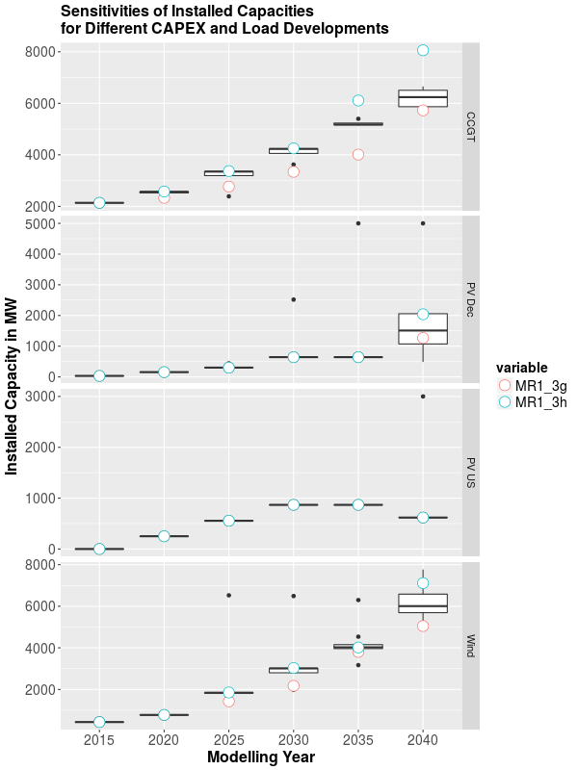Figure 47: Boxplot of results of the sensitivity analysis. Installed capacities differentiated by modeling years and technologies. MR1_3g represents the low demand scenario, MR1_3h the high demand scenario. The figure is based on the eight model runs MR1_3a-h. Source: Own composition.
Regarding different interest rates of Utility-scale PV, decentralized PV and onshore wind power plant projects, Waissbain, O. et al. argue that differences in interest rates regarding different VRE power plant options are small compared to the overall amount of interest rates mirroring different types of risk. Since OSeMOSYS is not capable of applying technology-specific interest rates in its utilized form in this thesis the statement bei Waissbein, O. et al. is taken as an assumption. Nevertheless it seems plausible that differences exist in financing costs especially between utility scale projects (PV and onshore wind) and household-driven decentralized PV installations. Detailed cost production models (as described in 2.1.2.1) are needed in order to analyze effects of different interest rates on overall system cost of different VRE technology options.
However, it has to be stated that some main drivers especially of decentralized PV expansion lie out of the scope of linear optimization since consumer preferences are not always aligning to cost-optimal pathways. The successful expansion of rooftop PV panels within the PROSOL ELEC program illustrates this analysis.
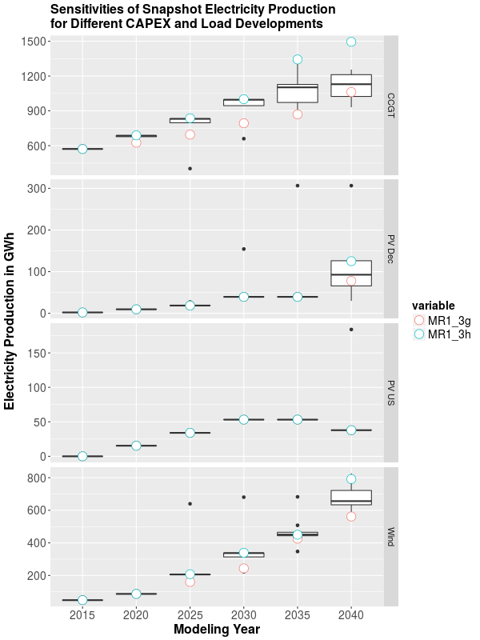Figure 48: Boxplot of results of the sensitivity analysis. Electricity Production differentiated by modeling years and technologies. MR1_3g represents the low demand scenario, MR1_3h the high demand scenario. The figure is based on the eight model runs MR1_3a-h. Source: Own composition.

Task 2: Assessment of Cost Reduction Potential of VRE Integration
In order to assess the economic benefits of integrating VRE capacities, two potential power plant expansion scenarios will be assessed. In the BAU scenario, todays power plant park will be modeled with equal ratio of installed capacities to assumed 2040 load as nowadays. In the BAU scenario, VRE expansion beneath nowadays' levels will be exogenously prohibited.
Year |  | Unit | Value
2015 | Steam Turbine | MW | 678
2015 | OCGT | MW | 1623
2015 | CCGT | MW | 2137
2015 | Annual electricity demand | TWh | 18.9
2040 | Steam Turbine | MW | 1779
2040 | OCGT | MW | 4259
2040 | CCGT | MW | 5608
2040 | Annual electricity demand | TWh | 49.6
Table 27: Input assumptions for MR2 BAU scenario. Source: Own composition.
In a second scenario the expansion targets and objectives regarding electricity production from VRE of the Tunisian Solar Plan will be exogenously set and further expansion of cost-optimal power plant capacities allowed (TSP+).
Model runs MR2_1b (BAU) and MR2_1c (TSP+) will be carried out for the 4 seasonal peak days and respective surrounding days (12 days total per modeling year) in order to provide for firm capacity constraints.
Figure 50 shows the model output for the BAU scenario with fixed capacities corresponding to Table 27 for 2040. Power plant capacity expansion in other modeling years are cost-optimal. VRE expansion is constrained to nowadays capacities. Steam turbine and OCGT power plant capacities are expanded starting from 2035 in the depicted expansion pathway owed to discounting. These capacities are not cost-optimally utilizable in the power plant dispatch and thus they are expanded at the end of the model period in order to lower their discounted NPV. Onshore wind capacities are replaced with new capacities as soon as residual capacities phase out and are thus kept at expansion maximum (433 MW).
Figure 49 Shows power plant dispatch of MR2_1b. Forced natural gas power plant capacity expansion results in almost exclusive electricity production from CCGT. In the years 2035 and 2040 forced steam turbine and OCGT capacities contribute to some degree to the snapshot electricity production. Onshore wind and hydro electricity production are fully dispatched.
The hourly dispatch for MR2_1b BAU is not presented here since it doesn't yield further insights and operational practices for 2040 capacities of both scenarios are discussed in detail further below.
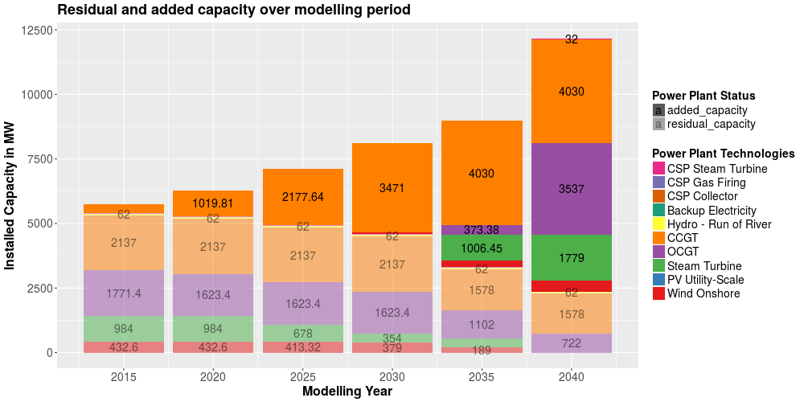Figure 50: Depiction of model output for MR2_1b BAU. Installed capacities. Source: Own composition.
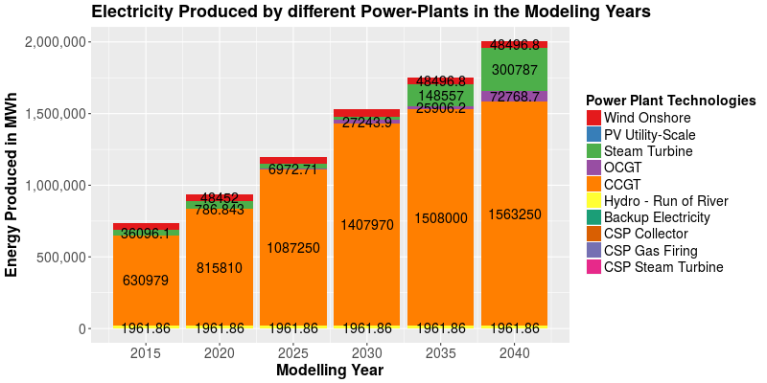Figure 49: Depiction of model output of MR2_1b BAU. Snapshot electricity production. Source: Own composition.
In the following, results of model run MR2_1c are presented in Figure 51, Figure 52 and Figure 53. VRE capacities are expanded reaching further behind policy targets given by the Tunisian Solar Plan. Onshore wind power plants are expanded to reach its full given potential by 2040 indicating its high cost-effectivenes within the given power plant mix. Utility-scale PV is not competitive under the cost that are assumed. From year 2035 onwards decentralized PV is competitive and expanded to reach almost 2.5 GW in 2040. CSP capacities are not expanded at beneath exogenously set targets.
Electricity production during the modeled snapshots is shown in Figure 52. In 2030, the VRE target of 30% of electricity production is reached by mostly wind (83%). Utility scale (8%), hydro power and decentralized PV (both 4%) contribute to some degree. The VRE installed capacity in 2040 is at approximately 60% while VRE contribution to snapshot electricity production is at 53%. Contributions of steam turbine and OCGT power plants are fairly low due to disregarding flexibility constraints.
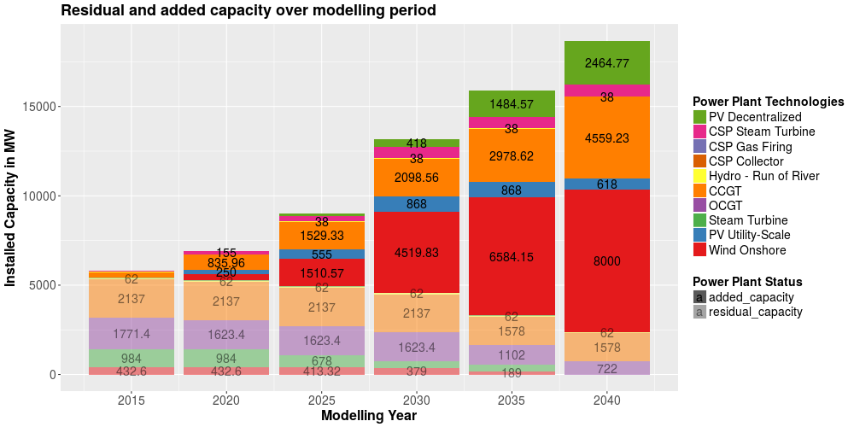Figure 51: Depiction of model output of model run MR2_1c TSP+. Installed capacities. Source: Own composition.
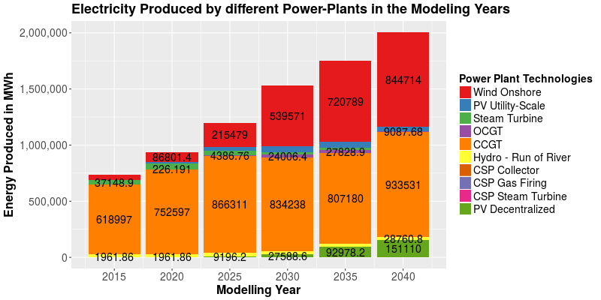Figure 52: Depiction of model output of model run MR2_1c TSP+. Snapshot electricity production. Source: Own composition.
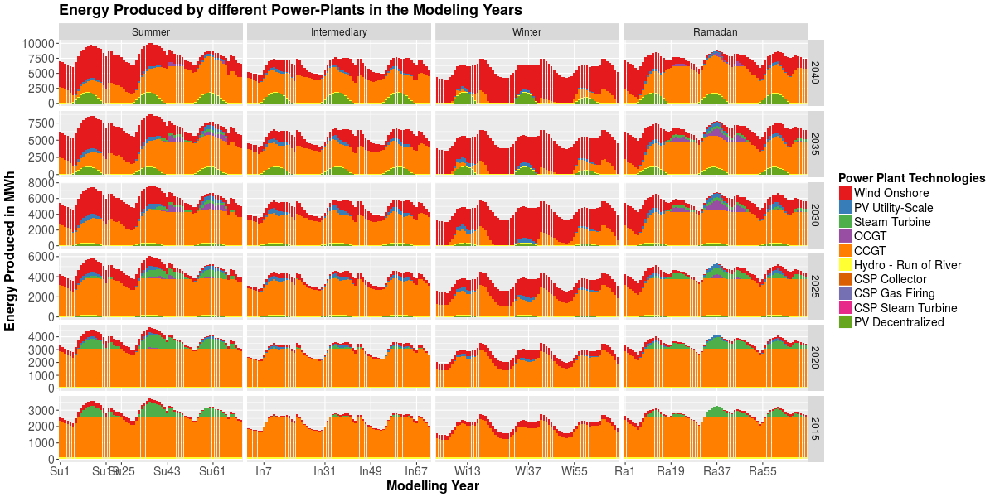Figure 53: Depiction of model output for model run MR2_1c TSP+. Hourly power plant dispatch for modeling years and seasons. Source: Own composition.
Modeled hourly power plant dispatch is given in Figure 53. CCGT is the major source of electricity. While CCGT and some steam turbines dominate power plant dispatch until 2025, starting from 2030 wind feed-in replaces significant amounts of CCGT dispatch raising the question of grid flexibility and technical concerns regarding varying wind feed-in on the one hand and power plant flexibility and cycling times on the other hand. These are both not modeled explicitly in this thesis. Cycling times are analyzed in the full 8760h-dispatch model below. Utility scale and decentralized PV feed-in correlate very well with demand especially in summer time (Ramadan is also in summer).
Model results suggest that the cost of supplying electricity demand in the BAU scenario is 22.61 bn € vs. 22.38 bn € in the TSP+ scenario. With 1.7 bn € (BAU) and 3.4 bn € (TSP+) the salvage value of installed power plant capacities significantly reduces overall system cost. Neglecting salvage values, discounted CAPEX account for 12.7% in BAU and 32.1% in TSP+ whereas discounted OPEX account for 87.3% in BAU and 67.9% in TSP+.
However, as described in chapter 3.3.1.3 in the model runs where capacity expansion is modeled for 2015 – 2040 only snapshots are dispatched. Variable operational costs are scaled to the whole year based on the length of the snapshot in relation to the length of the whole year. This implicitly assumes representativeness of the modeled snapshots for the whole year overestimating capital expenditures for the whole year because only peak electricity demand timeslices are modeled. Thus, in order to be able to evaluate differences in operational expenditures of the two power plant parks under comparison, an in-depth dispatch model of 8760 hours for the year 2040 is carried out in model runs MR2_2a-b. Power plant capacities are fixed to results obtained by model runs MR1_1b-c and VRE targets are not set. CSP capacities that are generally not built in cost optimal expansion pathways may be added.
Figure 1 and Figure 54 show the weekly dispatch for model rungs MR2_2a and MR2_2b respectively for the full 8760h dispatch model run with forced power plant capacity expansion corresponding to results from MR2_1b and MR2_1c. Total system cost for the model run are 2.98 bn € and 2.7 bn € respectively. Discounted CAPEX account for 72% (BAU) and 88 % (TSP+) while discounted OPEX account for 28% (BAU) and 12% (TSP+) ignoring the discounted salvage value of the power plants of 6.4 bn € (BAU) and 12.1 bn € (TSP+). The salvage value represents the power plant's values at the end of the modeling period. In this model runs all capacities except for the residual ones are built in 2040 and thus have a very high salvage values. This is even more significant in MR2_2b as CAPEX for forced VRE expansion is very high. Total system cost without the subtraction of the salvage values amount to 9.38 and 14.8 bn € respectively.
All values are shown below in Table 28.
All values in bn € | MR2_2a  BAU | MR2_2b  TSP+
CAPEX | 6.79 | 13.02
OPEX fix | 0.15 | 0.28
OPEX var | 2.5 | 1.58
Salvage Value | 6.4 | 12.1
Total System Cost | 2.98 | 2.70
Table 28: Costs of the full year dispatch model runs. CAPEX have the same discounted as undiscounted value. Total OPEX have a slightly lower discounted value since discounting is applied according to equation 21. Source: Own composition.
Figure 55 and Figure 56 show the annual supply of natural gas and electricity for the two scenario BAU and TSP+. The natural gas consumption can be reduced from 130 TWh to 75 TWh resulting in a reduction of operational expenditure of the modeled year of approximately 37% from 2.5 bn € in the BAU scenario to 1.58 bn € in the TSP+ scenario.
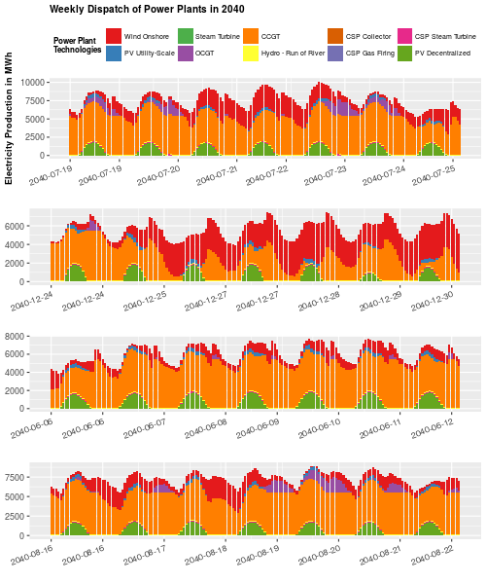Figure 54: Depiction of model output of MR2_2b TSP+. Power plant dispatch for the four weeks surrounding maximum seasonal demand. Source: Own composition.
Sensitivity analysis has been carried out for different developments of natural gas prices according to Godron, P. et al. [Godron, P. et al. (2017)] and low and high electricity demand development. Results are shown in Figure 57. The five model runs on the left hand side were carried out for the BAU scenario while the ones on the right hand side were carried out for the TSP+ scenario. Differences in total system cost are not very sensitive to the assumed natural gas price developments.

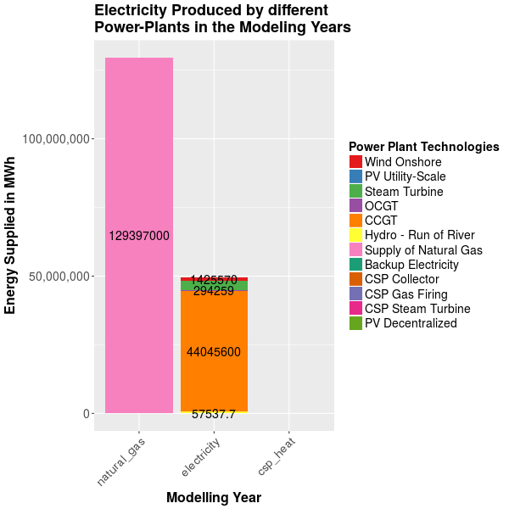Figure 55: Depiction of model output of MR2_2a BAU. Annual energy supply in MWh. Supply of natural gas is given in MWh_th. Source: Own composition.
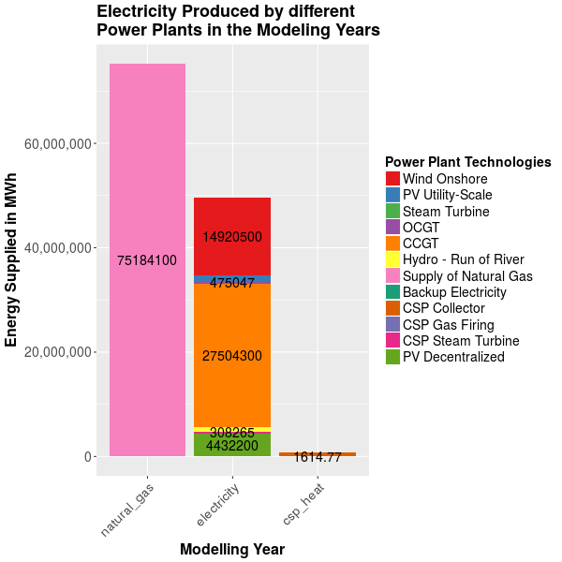Figure 56: Depiction of model output of MR2_2b TSP+. Annual energy supply in MWh. Supply of natural gas is given in MWh_th. Source: Own composition.

Presentation of Results
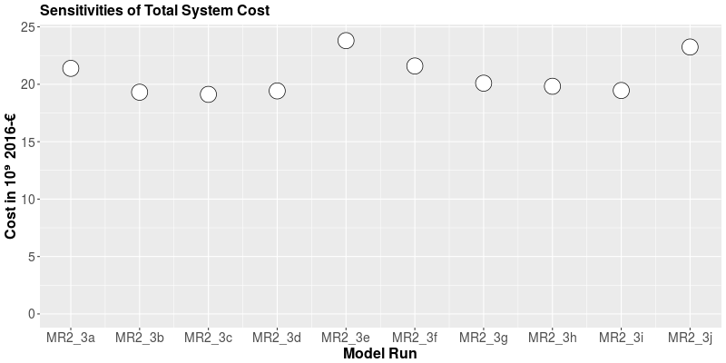Figure 57: Depiction of results of sensitivity model runs. Model runs 3a-e are BAU scenario and f-j TSP+. Model runs 3a-c and f-h vary natural gas prices while model runs 3d-e and 3i-j vary the electricity demand. Source: Own composition.
In Task 1, cost-optimal power plant expansion pathways could be identified showing strong preference for wind and preference for decentralized PV in the long-term future. CCGT power plants will play a major role with high robustness against all tested input parameter variations. While differences in VRE CAPEX have negligible influence on installed CCGT capacities within cost-optimal expansion pathways, the development of total annual electricity demand strongly influences installed CCGT capacities as they supply electricity independently from weather fluctuations. In the long-term future, cost-optimal installed onshore wind capacity is affected by load development but resulting capacities lie within the range of values that were obtained for VRE CAPEX sensitivity runs.
Installed capacities of decentralized PV are only increased because of exogenously set expansion targets except for the low decentralized PV CAPEX scenario where capacity rises to 2.5 GW in 2030 and tap full potential afterwards. Utility-scale PV is not expanded until investment cost drop significantly below 1000 k€/MW. Even though decentralized PV cost are above that threshold utility-scale PV is only expanded in 2040 possibly because excess VRE capacities are available from 2030 where VRE targets were fulfilled mostly by onshore wind. Interestingly, in the low wind CAPEX model run, wind capacities are significantly increased from 2020 to 2025 and the stay between 6 and 7 GW. This is due to residual capacities dropping below 3 GW while annual electricity demand increases to above 6 GW in the peak timeslice (Su36). Wind capacity factor is at 0.48 for that timeslice so decrease of residual power plant capacity and demand increase is almost completely compensated for by onshore wind capacities.
While capital expenditures were almost twice as high for the cost-optimal expansion based on installed VRE capacities given in the Tunisian Solar Plan than they were in the Business-as-usual scenario mirroring todays power plant park, operational expenditures were significantly reduced. Natural gas supply for assumed 2040 electricity demand could be reduced from almost 130 TWh in the BAU scenario to slightly above 75 TWh in the TSP+ scenario.

Interpretation
In task 1 shares of different VRE options could be identified showing strong preferences for onshore wind expansion. Sensitivity analysis underpins this finding for all developments of VRE CAPEX even for conservative onshore wind CAPEX developments. Differences in utility-scale and decentralized PV were evaluated suggesting an increasingly system-friendly decentralized PV integration from 2030 onwards while utility-scale PV is not expanded beneath policy targets. This finding has to be handled with care since assumed utility-scale PV CAPEX developments seem to be very high compared to decentralized PV which might not hold true in reality since financing cost may be higher for decentralized PV.
However some major factors affecting the technology choice for either utility-scale or decentralized PV such as grid expansion, local load correlation or consumer preferences were not evaluated. The first two could possibly be integrated in OSeMOSYS while detailed financing models as well as consumer preferences are outside of the OSeMOSYS modeling scope.
Shown results show the necessity of local assessments especially for decentralized PV as e.g. robust potential assessments for VRE technologies are not publicly available so far.
VRE installed capacities are at 11.8 GW vs. 6.9 GW natural gas power plants for 2040 based on assumed VRE CAPEX developments suggesting Tunisia entering at least phase 3 implying significant changes in power system operations regarding power flows and conventional power plant running times according to Mueller, S. et al. (compare Figure 6) [Mueller, S. et al. (2017)]. Additional cost of grid reinforcements, part-load behavior of natural gas power plants and reduced cycling were not evaluated within the scope of this thesis. Also minimum load constraints and maximum ramping times were not taken into consideration as can be seen in e.g. Figure 53 where during winter times where high wind feed-in occurs, CCGT capacities with the magnitude of 3 GW are shut down within 4 hours. Even though this might technically be possible (ramping rates of 30 MW/min suggested e.g. by Kern, J. et al.) for future CCGT capacities it questions the cost-optimality of this power plant dispatch.
Results also suggest high correlation between PV feed-in and peak load. While almost 2.5 GW of decentralized PV will be installed in the cost-optimal capacity expansion, it has to be assured that these capacities are close to the load centers to be able to reproduce shown patterns in real grids where the simplified singlenode (copperplate) assumption doesn't hold true.
By choosing the days of seasonal peak demand and respective surrounding days unrepresentatively high load situations are put down as a basis for the expansion modeling. This might overestimate necessary VRE capacities up until 2030 where there is a 30% expansion target and definitely overestimates operational expenditures as shown in Table 29. After 2030, capacities with high capacity factors (natural gas power plants at the most, then wind capacities and last PV capacities) during peak load will be expanded which is one of the reasons for the high wind capacity expansions in comparison to PV power plants.
 | Undiscounted OPEX in 2040
MR2_1b | 3242 bn €
MR2_1c | 2066 bn €
MR2_2a | 2660 bn €
MR2_2b | 1856 bn €
Table 29: Differences in annual undiscounted OPEX for 2040 in snapshot (scaled from snapshots) and full year model runs. Source: Own composition.
As depicted in Table 3 and Table 4 and mentioned in chapter 4.3.2 some factors that are important for the choice of different VRE power plant technologies lie out of the scope of this thesis. While Waissbein, O. (2014) imply that the differences in interest rates for different VRE technology choices are negligible, risk seems to be higher when PV panels are installed on rooftops than on a utility-scale. Nevertheless lower revenue expectations of private households may (partly) compensate for additional cost of capital opening up further research needs.
These factors lie outside of the scope of the modeling approach utilized in this thesis. While they can be included within the preprocessing state as an input factor for the calculation for capacity-specific CAPEX (Figure 7), more differentiated modeling approaches (such as utilized in Godron, P. et al. (2012)) can describe different parts of total investment cost with greater detail.

Conclusion
By extending OSeMOSYS to the snapshot functionality and by modeling not all years within the modeling scope the energy model could be ammended to account for characteristics of inflexibly varying renewable energies, at the same time co-optimizing capacity expansion. The developed modeling environment consisting of a PostgreSQL database, interface routines for creation of model input and result depiction routines for output presentation is capable of carrying out model runs and testing results on sensitivity regarding uncertainties of specific input parameters. Nevertheless, further developing the database structure, features and routines is recommended in order to be a valuable tool for development cooperation and researchers in partner countries.
The role of the most influential factors for the two tasks under assessment in the Tunisian case study could successfully be analyzed. Especially the effect of different developments of capital expenditures of renewable energy power plant technologies, different load developments and developments of natural gas prices on cost-optimal capacity expansion and power plant dispatch were evaluated. While onshore wind capacities are certain to contribute as the major renewable energy power plant option, the case study calculations were only capable of representing a few but not all factors differentiating between utility-scale and decentralized PV power plant expansion mainly differences in capital expenditures. Potentially, other differentiating factors such as additional cost for grid expansion, regional specificities and different feed-in profiles can be taken into account.
Cost-optimal expansion pathways with assumed capital cost of power plant technologies suggest rapidly increasing shares of renewable energies. Thus, as outlined in chapters 2.1.1.3 and 2.1.1.4, this increasing share of inflexibly varying electricity producers necessitate adjustments of operational routines calling for increased flexibility of the Tunisian power system. The assessment of different flexibility options was not part of this thesis but is certainly among the most important tasks for energy planning in Tunisia.
Regarding the replacement of the utilization of natural gas for electricity production by varying renewable energy capacities and its respective cost reduction potential, the case study identified cost reduction potentials with regards to fuel cost of the Tunisian electricity system. Variable operating cost were found to differ by approximately one third between two future power plant parks – one that aligns to today's capacities and one that follows cost-optimal expansion based on policy targets for renewable energies set by the Tunisian government. Highest uncertainties that were not covered are implicit cost for reinforcing grids, part-load behavior of natural gas plants and inter-annual variations of renewable energy feed-in. Total system cost were found to be slightly higher for the TSP+ scenario compared to the BAU scenario with fixed natural gas power plants in 2040 corresponding to today's power plant park for all three scenarios of natural gas price development suggested by Godron, P. et al. [Godron, P. et al. (2017)]. Interestingly, total system cost are lower for the TSP+ scenario assuming high load increases compared to the BAU scenario. Nevertheless the influence of total electricity demand on total system cost is much higher than the influence of the assumed natural gas price developments.
Factors affecting the outcomes of the two case study tasks that were not study in detail but are assumed to have a strong influence are inter-annual variability of renewable energy feed-in, regional specificities, power plant flexibilities and cost related with integration of varying renewable energies, differences in the shape of load (only assessed as 2010 load profile inhibits differences in shape), quantitative stakeholder related factors and employment effects, import and export of electricity, non-linear technology advances, CO₂-prices and the role of storage.

Discussion
The development of investment cost is one of the biggest uncertainties even though some modeling results such as necessary dispatchable CCGT capacities and cost-optimal onshore wind capacity expansion were fairly robust regarding the variation of investment cost of varying renewable energy power plant technologies. The strong preference towards decentralized PV in comparison to utility-scale PV stems from the assumed investment cost. For utility-scale PV, numbers given by the Societé Tunisienne de l'Elélectricité et du Gaz from 2014 were taken while developments of capital cost of decentrailzed PV power plant technologies were based on Kern, J. et al. who published their values very recently [STEG (2014) and Kern, J. et al. (2016)]. Values by Fichter, T. (2017) suggest that while lower limits for investment cost developments of utility-scale and decentralized PV systems may develop similarly upper limits may be significantly higher for decentralized PV systems. Both assumptions were not met in this thesis necessitating further assessment of sensitivity of cost-optimal expansion towards investment cost.
As already outlined in chapter 4.1.3 and shown in Figure 24 feed-in profiles of PV feed-in show low intra-annual variability. Pfenninger, S. and Staffell, I. have always put strong focus on the importance of bias-correcting supplied values by renewables.ninja. Because bias-correcting feed-in profiles was out of the scope of this thesis, the authors were contacted in request for running bias-correction-scripts for Tunisia specifically but that never happened. Fairly late during the course of the thesis full inter-annual feed-in profiles for the years 1990-2014 was made available enabling inter-annual analysis of feed-in characteristics and firm capacity of wind and PV in Tunisia.
Especially when assessing total system cost of high shares of inflexibly varying renewable energies, implicit costs such as reduced cycling times of natural gas power plants, increased start-up-costs, increased cost through higher abrasion through higher variations in output and part-load behavior have to be taken into account. The needs of analyzing these factors were already identified for some of the modeling runs. Potentially these factors can be integrated in linear optimization models such as OSeMOSYS although detailed part-load behavior requires extending the mathematical implementation to mixed integer linear programming, thus increasing model run times.
Analyzing technology-specific interest rates may prove relevant in the context of development cooperation where multiple actors with different capital access options seek to invest in a foreign market. Technology-specific has been part of OSeMOSYS before but was excluded in the latest versions so modelers should be able to adjust the model to their needs.
Assumptions had to be made regarding efficiencies and lifetimes of conventional power plants. Since these were modeled aggregated for the whole country and not considering each power plant, differentiating in efficiency wasn't possible but different lifetimes could be given where available, thus further increasing the accuracy of the model. Also, planned CCGT and OCGT capacities were not taken into account which isn't assumed to produce errors since the expansion of at least CCGT power plants is on a cost-optimal expansion pathway anyways.
The extension of OSeMOSYS to calculating snapshots and thus increasing temporal resolution was successfully proven in this thesis. Nevertheless a simple and conservative approach to choosing modeling timesteps was applied, overestimating operating cost (see Table 29). More sophisticated approaches such as described and evaluated in Pfenninger, S. (2017b) could be applied with extreme peak load timesteps included but not being the basis for scaling of operating cost to annual variable operating cost. This basis should in the best case be provided by real days (or consecutive real days) that are closest to representative days.
Modeling Ramadan as a fourth season next to summer, winter and an intermediary season was done corresponding to an oral exchange with colleagues from Ecole National d'Ingenieurs de Tunis (ENIT) in Tunisia. In the load pattern from 2010, Ramadan didn't seem to take a very decisive role. Also because the same national load profile (2010) was assumed for future years and only 2014 feed-in profiles were utilized modeling a Ramadan moving through the year wouldn't have made sense. Nevertheless, when load profiles are available from more sophisticated bottom-up load modeling methodologies and more years are modeled, assessing effects of Ramadan may gain importance.
The degree of demand increase was found to be much more influential for overall total system cost than the natural gas price development, thus necessitating efficiency measures in order to compensate for increasing demand for energy services and possibly if combined with varying renewable energies demand-side management measures.
Regarding the development of the modeling environment, focus was put on maximum flexibility of the database structure in order to be able to adjust structures to modeling demands during the course of the thesis. Especially when the methodologies utilized in this thesis are to be reproduced the database should be further improved by constraining data input from its current flexible form. Depending on, who will use the database this may also be counter-productive since extending the modeling environment to e.g. other sectors, more detailed financial modeling or multi-nodal modeling requires the high degree of flexibility the database has right now. Potential structural improvements on this field are adding a database for storing model outputs (possibly including plots) and model performance, adding a database for raw data containing unit association and conversion functionalities as well as measures for the validity of data and making the database publicly available.
Considering the interface routines between the database and OSeMOSYS increased modularity could be applied by further defining user-defined functions. In a next step, the database could be decoupled from OSeMOSYS and the modeler could be able to choose which optimization framework (GNU MathProg, Pyomo, GAMS etc.) she or he uses.
Model run times were fairly lower throughout the 49 model runs carried out during this thesis ranging from 169 seconds up to 7874 seconds (2.2 h) which is still fairly easy. All calculations have been carried out on a personal laptop that was built in 2010 with a 4GB internal memory. Utilizing commercial solvers such as CPLEX or modeling computers was avoided since applicability and reproducibility without upfront investments was valued to be important. Certainly, extending the model to multi-nodal modeling will significantly increase modeling time and presumably increase the need of internal memory beyond 4GB.

Outlook
Within the scope of this thesis only the power sector is assessed and the transmission and distribution grids aren't modeled in detail. However the transparent and open structure of the model and the low-threshold extensibility of the modeling environment enables the integration with other sectors (transport, heat/cold) and the coupling to other planning tools.
A central role for energy planning will be the targets of the Tunisian government within the Paris agreement. Co-optimizing power plant capacity expansion pathways with regard not only to cost-optimality but also to reduction of CO₂-emissions will be increasingly important. Also, GHG reduction potentials apart from the power generation such as energy efficiency measures have to be considered.
Results suggest that lower variable operating cost come at the price of increased capital cost for power plant capacities stemming from typical cost structure of renewable energy power plant projects. This may necessitate investment sources that lie out of the range of the Tunisian government. For decentralized PV and partly for utility-scale projects these sources can be Tunisian citizens such as in the PROSOL-ELEC program (new initiatives are under way by the BMZ for strengthening citizen engagement in power supply in Africa) but certainly there will have to be foreign investment to some degree. The successful attraction of foreign investors will depend mainly on Tunisian government's securities and policy schemes.
As model results suggest increasing capacities of inflexibly varying renewable energy capacities, increasing power system flexibility will play a major role in mid-term energy planning in Tunisia. Thus, the evaluation of different flexibility sources (flexibilities of existing capacities, storages, grid etc.) will be important in future energy planning in Tunisia. Especially the role of storage technologies may increasingly be important when capacities of inflexibly varying renewable energies increase and investment cost for battery technologies keep decreasing.

Literature
ANME (2015). Le Plan Solaire Tunisien. Decembre 2015. Tunis: Agence National pour le Maitris d'Energie
Barbose, G. (2017). Putting the Potential Rate Impacts of Distributed Solar into Context. Berkely: Energy Analysis and Environmental Impacts Divison, Lawrence Berkeley National Laboratory.
Benbarka, A., Cherif, M., Ben Abdallah, M., Bergaoui, F., Boufares, T., Boussen, M., Chakroun, C., Khalfallah, E., Ounalli, A., Rekik, K., Bali, E., Ben Rahla, L., Bezzaouia, R., Lahoua, M., Moalla, A. & Challouf, A. (2017). Vision stratégique du secteur de l'énergie en Tunisie (Phase II). Le gaz naturel: État des lieux, enjeux, perspectives et options d'ici l'horizon 2030. Washington, Tunis: World Bankd Group, Energy Sector Management Assistance Program (ESMAP) / Societé Tunisienne de l'Électricité et du Gaz (STEG).
Bitar, F. (2017). Benchmarking LP Solvers. Outcome of a late night Google search. Presentation at Open Energy Modelling Workshop – Frankfurt 2017. Online: https://vfs.fias.uni-frankfurt.de/d/221fc0d80d/files/?p=/tech_talks/04_bitar_benchmarking_lp_solvers.pdf&dl=1 [accessed 2017-08-30]. Frankfurt: openmod initiative.
Brand, B., & Missaoui, R. (2014). Multi-criteria analysis of electricity generation mix scenarios in Tunisia. In: Renewable and Sustainable Energy Reviews 39 (2014) 251-261.
Brand, B. & Blok, K. (2015). Renewable energy perspectives for the North African electricity systems: A comparative analysis of model-based scenario studies. In: Energy Strategy Reviews 6 (2015) 1-11. Elsevier.
Breyer, C. & Aghahosseini, A. (2017). Modeling and Energy Challenges of the 21st Century in the MENA Region. Macroeconomic Modeling for Energy Scneario in Tunisia. Tunis: Neo Carbon Energy / Lappeenranta University of Technology.
Cao, K.-K., Cebulla, F., Gómez Vilchez, J.J., Mousavi, B. & Prehofer, S. (2016). Raising awareness in model-based energy scenario studies – a transparency checklist. In: Energy, Sustainability and Society:(2016) 6:28. London: Springer Open.
Castalia (2013). International Experience with Single Buyer Models for Electricity. Castalia advisory group. www.castalia-advisors.com/files/updated_2014/castalia-review-international-experience-single-buyer-models.pdf (Accessed 2017-07-17).
DeCarolis, J., Daly, Hannah, Dodds, P., Keppo, Ilkka, Li, F., McDowall, W., Pye, S., Strachan, N., Trutnevyte, E., Usher, W., Winning, M., Yeh, S. & Zeyringer, M. (2017). Formalizing best practice for energy system optimization modelling. In: Applied Energy 194 (2017) 184-198. Elsevier.
Feldhaus, P, Fürstenwerth, D., Gohl, M., Schröter, B. & Vahlenkamp, T. (2010). Transformation of Europe's power system until 2050. Including specific considerations for Germany. In: Electric Power and Natural Gas Practice. Düsseldorf: McKinsey & Company.
Fichter, T. (2017). Scénarios énergétiques pour le Maroc. Base scenario. Model setup and input data overview. Stuttgart: Deutsches Institut für Luft- und Raumfahrt (DLR).
Fraatz, J., Mutonga, J., Amayo, A. & Telep, P. (2016). Mini-Grid Regulation and Practical Experiences from Kenya. Mini-Grid Workshop. Online available at https://www.giz.de/fachexpertise/downloads/2016-en-kenya-regulation-experiences-jasmin-fraatz.pdf [accessed at 2017-07-19]. Deutsche Gesellschaft für Internationale Zusammenarbeit (GIZ) GmbH.
Free Software Foundation, Inc. (2010). GNU Linear Programming Kit. Reference Manual for GLPK Version 4.45. Draft. Boston: Free Software Foundation, Inc.
Gearhart, J. L., Adair, K. L., Detry, R. J., Durfee, J. D., Jones, K. A., Martin, N. (2013). Comparison of Open-Source Linear Programming Solvers. Albuquerque and Livermore: Sandia National Laboratories.
GIZ (2013). Study on the renewable energy potential for electricity generation for national consumption in Tunisia and export to the EU. Final Report. In the project “Support to the Mediterranean Solar Plan (MSP)”. Tunis: Deutsche Gesellschaft für Internationale Zusammenarbeit (GIZ) GmbH.
Godron, P., Rietz, A. et aliter (2012). Dii/STEG ER Country Study – Tunisia. Final version. Strictly confidential. Munich / Tunis: Dii GmbH / STEG ER.
Heising, K., Reiche, K., Zymla, B. (2014). Towards Adequate National Renewable Energy Planning for dynamic energy sectors. In: vRE Discussion Series – Paper # 01. Eschborn: Deutsche Gesellschaft für Internationale Zusammenarbeit (GIZ) GmbH.
Hirth, L. (2016). The benefits of flexibility: The value of wind energy with hydropower. In: Applied Energy 181 (2016) 210-223. Elsevier.
Howells, M., Rogner, H., Strachan, N., Heaps, C., Huntigton, H., Kypreos, S., Hughes, A., Silveira, S., DeCarolis, J., Bazillian, M. & Roehrl, A. (2011). OSeMOSYS: The Open Source Energy Modeling System. An introduction to its ethos, structure and development. In: Energy Policy 39 (2011) 5850-5870. Elsevier.
Ibrahim, A. (2017). Development of Renewable Energy In Tunisia. Challenges and Prospects. Power Point Presentation. Online available at: www.auptde.org/Article_Files/4-Presentation%20ER%20STEG%202017%20ibrahim%20abdeljelil.pptx [accessed on 2017-08-03]. Istanbul: STEG.
Junne, T. (2015). GIS-basierte Potenzialanalyse Erneuerbarer Energien in Europa – ein neuer methodischer Ansatz zur Aggregation von hoch aufgelösten georeferenzierten Informationen und dessen modellgestützte Anwendung. Masterarbeit. Dresden: TU Dresden, Lehrstuhl für Energiewirtschaft.
Kern, J., Fichter, T., Moser, M., Trieb, F., Seidel, F., Heising, K., Lempp, P. (2016). MOREMix - Power sector optimization for Morocco. Online available at: http://aip.scitation.org/doi/pdf/10.1063/1.4949184 [accessed on 2017-07-18].
Klose, T., Zieher, M., Focken, U. & Lange, M. (2013). Analyse de la valeur des capacités photovoltaiques dans le système électrique tunisien. Strictly confidential. Oldenburg: energy & meteo systems GmbH.
Lambert, A., Grandry, T., Michels, S., Degive, X. & González, J. (2017). GIZ – Thermal Power Plant Flexibility Improvements in Chile. Report on behalf of Deutsche Gesellschaft für Internationale Zusammenarbeit (GIZ) GmbH. Online available at https://www.4echile.cl/4echile/wp-content/uploads/2017/04/Thermal-Power-Plant-Flexibility-Improvements-30.pdf [accessed 2017-07-20]. Belgium, Chile: engie lab.
Lavigne, D. (2016). Initiatives for Teaching Energy Modelling to Graduate Students. In: Universal Journal of Management 4(8): 451-458, 2016. Canada.
Lavigne, D. (2017). OSeMOSYS Energy Modeling Using an Extended UTOPIA Model. In: Universal Journal of Educational Research5(1): 162-169, 2017. Quebec: Royal Military Colleg St-Jean.
Lechtenböhmer, S., Durand, A., Fischedick , M., Nebel, A., Soukup, O., Wane, S., Missaoui, R., Belhouane, M. H., Marrouki, S. & Zarrouk, T. (2012). Etude Stratégique du Mix Energétique pour la Production d'Electricité en Tunisie. Rapport final. Wuppertal/Tunis: Institut Wuppertal du Climat, de l'Environment et de lÉnergie & Alcor.
Miketa, A., Ueckerdt, F., Collins, S., Pantelis, S., Russo, D. & Lean, G. (2017). Planning for the Renewable Future: Long-term modelling and tools to expand variable renewable power in emerging economies. Abu Dhabi: International Renewable Energy Agency (IRENA).
Milbert, S. (2013). Reform of Energy Subsidies in the Arab Countries. Online available at: http://www.atlanticcouncil.org/blogs/menasource/reform-of-energy-subsidies-in-the-arab-countries [accessed 2017-08-12].
Moksnes, N., Welsch, M., Gardumi, F., Shivakumar, A., Broad, O., Howells, M., Taliotis, C. & Sridharan, V. (2015). 2015 OSeMOSYS User Manual. In: Working Paper Serie DESA/15/11. Online at: http://www.osemosys.org/uploads/1/8/5/0/18504136/new-website_osemosys_manual_-_working_with_text_files_-_2015-11-05.pdf (accessed at 07-04-2017).
Möller & Pöller Engineering (M.P.E.) GmbH (2014). Power System Security in Developing and Emerging Countries. In: vRE Discussion Series – Paper #05. Technology. Eschborn: Gesellschaft für Internationale Zusammenarbeit (GIZ) GmbH.
Mueller, S., Frankl, P., Sadamori, K., Bianco, E., Hauptmeier, K., Bi, Y., Guibentif, T., Dubbeling, T. & Philibert, C. (2016). Next Generation Wind and Solar Power. Full Report. From Cost to Value. Paris: International Energy Agency (IEA) / Clean Energy Ministerial.
Mueller, S., Vithayasrichareon, P., Chandler, H., Bianco, E., Frankl, P. & Sadamori, K. (2017). Getting Wind and Sun onto the Grid: A Manual for Policy Makers. Paris: OECD/IEA.
ONE (2016). Conjuncture Énergétique. Rapport mensuel, Edition Juillet 2016. Tunis: Ministere de l'Energie et des Mines, Observatoire National de l'Energie.
Open Power System Data (2017). https://open-power-system-data.org/ (accessed at 07-14-2017).
Pachauri, R.K., Meyer, L.A. & Core Writing Team (2014). Climate Change 2014: Synthesis Report. Contribution of Working Groupös I, II and III to the Fifth Assessment Report of the Intergovernmental Panel on Climate Change. Geneva, Switzerland: IPCC.
Pfenninger, S. and Staffell, I. (2016). Long-term patterns of European PV output using 30 years of validated hourly reanalysis and satellite data. In: Energy 114, pp. 1251-1265. doi: 10.1016/j.energy.2016.08.060
Pfenninger, S. (2017a). Dealing with multiple decades of hourly wind and PV time series in energy models: A comparison of methods to reduce time resolution and the plannin gimplications of inter-annual variability. In: Applied Energy 197 (2017) 1-13. Elsevier.
Pfenninger, S., DeCarolis, J., Hirth, L., Quoilin, S. & Staffell, I. (2017b). The importance of open data and software: Is energy research lagging behind? In: Energy Policy 101 (2017) 211-215. Elsevier.
Pfenninger, S. & Staffell, I. (2017c). Renewables.ninja. Online: http://renewables.ninja.
Praktiknjo, A. (2014). Stated preferences based estimation of power interruption costs in private households: An example from Germany. In: Energy 76 (2014) 82-90. Elsevier.
Reiche, K. & Fraatz, J. (2016). Village Power Toolkit. Using practitioner tools to better navigate the complex universe of access options, on a faster and broader river to SE4All. Power Point Presentation at GIZ's Community of Practice Energy. Eschborn: Deutsche Gesellschaft für Internationale Zusammenarbeit (GIZ) GmbH.
Schinke, B., Klawitter, J., Döring, M., Komendantova, N., Irshaid, J. & Bayer, J. (2017). Working Paper – Electricity Planning for Sustainable Development in the MENA Region. Criteria and indicators for conducting a sustainability assessment of different electricity generation technologies in Morodcco, Jordan and Tunisia. MENA Select.
Schweinfurth, A., Chtioui, A., Kazmierczak, S. & Seidel, F. (2017). Oral exchange at a validation session of central model input assumptions for modeling the Tunisian Power System at GIZ's Conference on Energy and Transport (Date: 2017-06-29). Bad Lauterberg.
Seidel, F. (2016a). Scaling up Clean Energy: Early Actions to facilitate integration of Variable Renewable Energy into existing power systems. Experiences from Partner Countries. Power Point Presentation at Deep Dive Workshop, ADB Clean Energy Forum 2016. Deutsche Gesellschaft für Internationale Zusammenarbeit (GIZ) GmbH.
Seidel, F. (2016b). Energy Planning in LDCs. Introduction, objectives and (some) answers. Based on concepts, project implementation and research by Heising, Suding, Seidel, Kazmierczak. Power Point Presentation at GIZ's Community of Practice Energy. Eschborn: Deutsche Gesellschaft für Internationale Zusammenarbeit (GIZ) GmbH.
Staffell, I. and Pfenninger, S. (2016). Using Bias-Corrected Reanalysis to Simulate Current and Future Wind Power Output. In: Energy 114, pp. 1224-1239. doi: 10.1016/j.energy.2016.08.068
STEG (2014). Production de l'électricité en Tunisie. Une transition énergétique s'impose pour un futur meilleur. Power Point Presentation on 2014-03-21. Societé Tunisienne de l'Electricité et du Gaz.
STEG (2015). Rapport Annuel 2015. Tunis: Societé Tunisienne de l'Electricité et du Gaz.
Suding, P. (2017). National Energy and Power Planning. Challenges for a Sector in Transition (in a new era). A New Draft Guidance Note for Practicitoners and Policy Makers on Urgent Adjustments to Sector Planning Institutions, Processes, Methods and Capacities. Jointly Commissioned by European Union Energy Initiative (EUEI) and GIZ Sector Program “Technology Cooperation in the Energy Sector”. Presentation at GIZ's conference on Energy and Transport. Bad Lauterberg: iidevelopment / Deutsche Gesellschaft für Internationale Zusammenarbeit (GIZ) GmbH.
Taylor, M., Daniel, K., Ila, A. & Young So, E. (2015). Renewable Power Generation Costs in 2014. Bonn: International Renewable Energy Agency (IRENA).
Taylor, M., Ralon, P. & Ilas, A. (2016a). The Power to Change. Solar and Wind Cost Reduction Potential to 2025. Bonn: International Renewable Agency (IRENA).
Taylor, M. & Young So, E. (2016b). Solar PV in Africa: Costs and Markets. Bonn: International Renewable Energy Agency (IRENA).
Thielmann, S. (2017). Impact of Variable Generation on System Operations in South Africa (“Flexibility Study”). Power point presentation at the Themenwerkstatt “Flexibility Matters” at GIZ Conference on Energy and Transport. Bad Lauterberg: Deutsche Gesellschaft für Internationale Zusammenarbeit (GIZ) GmbH.
Tognollo, A. (2016). Energy Demand Analysis within Long-term rural energy planning: A critikal review and simulation for a more appropriate modelling approach. Master Thesis. Milan: skuola di Ingegneria Industriale e dell'Informazione.
United Nations Framework Convention on Climate Change (2015). Adoption of the Paris Agreement. Paris: Conference of the Parties, Twenty-first Session.
Vithayasrichareon, P., Bianco, E., Dubbeling, T., Zinaman, O., Chernyakhovskiy, I., Logan, J., Mather, B., Baritaud, M., Wittenstein, M. & Scott, J. (2017). Status of Power System Transformation 2017. System Integration and Local Grids. System Integration of Renewables (SIR) Unit. Golden / Paris: NREL / OECD / IEA.
Waissbein, O., Deenapanray, S & Kelly, R. (2014). Tunisia: Derisiking Renewable Energy Investment. Selecting Public Instruments to Promote Renewable Energy Investment for the Tunisian Solar Plan NAMA. New York, Tunis: United Nations Development Programme (UNDP), National Agency for Energy Conservation (ANME).
Waissbein, O. (2016). Derisking Sustainable Energy Investment. Cost-effective Public Interventions for Affordable Sustainable Energy. Presentation to the GIZ Renewable Energy and Efficiency Week 2016. Berlin: United Nations Development Program.
WBG & ESMAP (2017). Vision stratégique du secteur de l'énergie en Tunisie (Phase II). Le gaz naturel: État des lieux, enjeux, perpectives et options d'ici l'horizon 2030. Washington: World Bank Group.
Wilson, R. and B. Biewald (2013). Best Practices in Electric Utility Integrated Resource Planning: Examples of State Regulations and Recent Utility Plans. The Regulatory Assistance Project (RAP) and Synapse Energy Economics.
Zinaman, O. et al. (2015). Power Systems of the Future. Golden: National Renewable Energy Laboratory (NREL).
Zymla, B., Reiche, K. & Heising, K. (2014). Erneuerbare in dynamisch wachsenden Energiewirtschaften. Chapter in: Weltenergierat Deutschland e.V. (2014). Energie für Deutschland 2014. Fakten, Perspektiven und Positionen im globalen Kontext. World Energy Council.

Appendix
Model Run Family |  | Model Input File | Function | Value of Objective Function (in 1e3 €) | Non-Zero elements | Solving Time in s | Memory used (MB) | Remarks
Structural Model Preparation / features | MR0 | 1-3 | Starting off | irrelevant | irrelevant | irrelevant |  | Getting to know the model syntax
Structural Model Preparation / features | MR0 | 4 | Area testing | 2.193e06 | 44758 | - |  | Testing multiple area modeling
Structural Model Preparation / features | MR0 | 5 | Single Node testing | 1.021e06 | 195934 | - |  | 96 Timeslices per modeling year
Structural Model Preparation / features | MR0 | 6a-f | Introducing snapshots and depiction of economic output | 11.666e06 | 210604 | - |  | Snapshot costs, emissions, weighing of OPEX, introducing ALL_YEARS etc.
Structural Model Preparation / features | MR0 | 7 | Introducing CSP technology | 10.042e06 | 342154 | - |  | Integration of CSP and csp_heat as third fuel
Calibration | MR1 | 0 | Real data model run | 7.494e06 | 447421 | - |  | Real data (power plants, load profiles, PV and wind capacity factors, cost...)
Calibration | MR1 | 0b-e | Attempts to get storage working | 7.498e06 | 447421 | - |  | Attempt to get plausible storage utilization
Calibration | MR1 | 0f-i | Model calibration (shown for MR1_0i) | 13.859e06 | 446870 | 168.9 |  | Model calibration, testing and setting realistic upper limits for hydro_ror
Calibration | MR1 | 1 | 12 Days calculation | 13.80e06 | 592510 | 895.6 | 873.3
Calibration | MR1 | 1b | 12 Days calculations | 13.75e06 | 592510 | 758.4 | 873.3 | Removed forced csp-expansion for 2035-2040
Calibration | MR1 | 1c | 12 Days calculations | 13.44e06 | 592510 | 1417.3 | 873.2 | CSP expansion targets from TSP
Task 1 | MR1 | 1c | Excluding dummy electricity production | 13.49e06 | 590398 | 2401.6 | 870.8 | Same model input file with different model (see chapter 3.3.1.3)
Task 1 | MR1 | 2 | Full Year 2040
Task 1 | MR1 | 3a | CAPEX Wind Onshore Lower LImit | 12.681e06 | 590398 | 1851.2 | 870.8 | 77606 iterations
Task 1 | MR1 | 3b | CAPEX Wind Onshore Upper LImit |  | 590398 | 2301.2 | 870.8 | 90668 iterations
Task 1 | MR1 | 3c | CAPEX PV Utility Scale Lower LImit |  | 590398 | 2341.2 | 870.8 | 100926 iterations
Task 1 | MR1 | 3d | CAPEX PV Utility Scale Upper LImit |  | 590398 | 2340.1 | 870.8 | 94072 iterations
Task 1 | MR1 | 3e | CAPEX PV Decentralized Lower LImit |  | 590398 | 2763.3 | 870.8 | 99050 iterations
Task 1 | MR1 | 3f | CAPEX PV Decentralized Upper LImit |  | 590398 | 2541.4 | 870.8 | 81760 iterations
Task 1 | MR1 | 3g | Demand Lower Limit |  | 590398 | 3021.2 | 870.8 | 95119 iter.
Task 1 | MR1 | 3h | Demand Upper Limit |  | 590398 | 2631.1 | 870.8 | 100049 iter.
Task 2 | MR2 | 1a | Test run
Task 2 | MR2 | 1b | BAU | 22.61e06 | 411483 | 360.5 | 739.2 | 24107 iter.
Task 2 | MR2 | 1c | TSP+ | 22.38e06 | 471414 | 872.5 | 743.8 | 45028 iter.
Task 2 | MR2 | 2a | Full Year 2040 | 2.98e06 | 1902664 | 7874.0 | 3738.5 | 97429 iter.
Task 2 | MR2 | 2b | Full Year 2040 | 2.70e06 | 2003615 | 5261 | 3746.5 | 81820 iter.
Task 2 | MR2 | 3a | Natural gas price sensitivity | 21.38e06 | 411483 | 464.8 | 739.2 | 26680 iter.
Task 2 | MR2 | 3b | Natural gas price sensitivity | 19.31e06 | 411483 | 549.9 | 739.2 | 33326 iter.
Task 2 | MR2 | 3c | Natural gas price sensitivity | 19.12e06 | 411483 | 419.7 | 739.2 | 24388 iter.
Task 2 | MR2 | 3d | Demand sensitivity | 19.42e06 | 411483
Task 2 | MR2 | 3e | Demand sensitivity | 19.31e06 | 411483 | 321.6 | 739.2 | 23403 iter.
Task 2 | MR2 | 3f | Natural gas price sensitivity | 21.59e06 | 471414 | 765.1 | 743.8 | 44105 iter.
Task 2 | MR2 | 3g | Natural gas price sensitivity | 20.09e06 | 471414 | 751.1 | 743.8 | 40792 iter
Task 2 | MR2 | 3h | Natural gas price sensitivity | 19.82e06 | 471414 | 816.3 | 743.8 | 43275 iter
Task 2 | MR2 | 3i | Demand sensitivity | 19.46e06 | 471414 | 834.2 | 743.8 | 44598 iter.
Task 2 | MR2 | 3j | Demand sensitivity | 23.24e06 | 471414 | 887.8 | 743.8 | 47131 iter.
Table 30: Overview over carried out model runs and some modeling preferences. Source: Own composition.

Statutory Declaration

Hiermit versichere ich, dass ich die vorliegende Arbeit selbstständig verfasst und keine anderen als die angegebenen Quellen und Hilfsmittel benutzt habe. Alle Ausführungen, die anderen veröffentlichten oder nicht veröffentlichten Schriften wörtlich oder sinngemäß entnommen wurden, habe ich kenntlich gemacht.

Die Arbeit hat in gleicher oder ähnlicher Fassung noch keiner anderen Prüfungsbehörde vorgelegen.

____________________________ ____________________________
Ort, Datum Unterschrift

